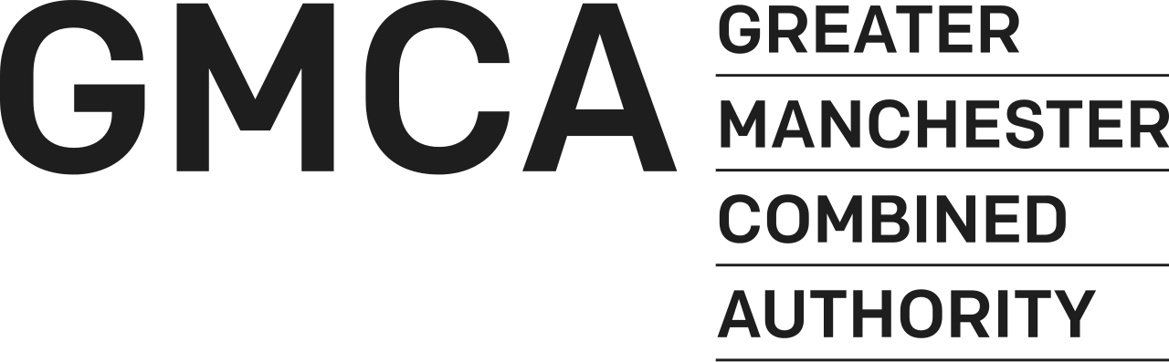

OUR PEOPLE; OUR PLACE

The Greater Manchester Culture
and Social Impact Fund

APPLICATION FORM

2018/2019 – 2019/2020

Name of Organisation

____________________________________________

_______________________________________________________________________________________
BOLTON, BURY, MANCHESTER, OLDHAM, ROCHDALE, SALFORD, STOCKPORT, TAMESIDE, TRAFFORD, WIGAN.

DEADLINE FOR THE RETURN OF THIS FORM

Midnight Friday 3rd November, 2017

Application Form for The Greater Manchester

Culture and Social Impact Fund 2018/2019 - 2019/2020

CAN YOU APPLY?
We can only accept your application if your organisation meets certain conditions.

- Is your group a constituted voluntary and community sector or not-for profit organisation?

- Are you a cultural or arts organisation or does your organisation have demonstrable social impact for residents in Greater Manchester?

You must answer yes to all of the above criteria. If you say no to any of the above questions please do not continue with your application?

PLEASE READ THE ACCOMPANYING GUIDANCE IN FULL BEFORE STARTING YOUR APPLICATION

If you intend to apply email marie-claire.daly@greatermanchester-ca.gov.uk by noon on October 19, 2017 stating your organisation name and amount you intend to apply for

GENERAL INFORMATION

Name of Organisation:
Registered address of Organisation:
Greater Manchester District
Daytime telephone:
E-mail address:
Website Address:
Contact name:
Position Held:
Second contact name:
Position Held:

HOW MUCH ARE YOU REQUESTING FROM GMCA?

 | 2018/19 | 2019/20 | Total
Amount of Grant Requested

ABOUT YOUR ORGANISATION
Q1. What is your primary artform or delivery area?

- Combined arts
- Dance
- Literature
- Music
- Theatre
- Social impact
- Sport
- Visual Art
- Other

If you answered ‘Other’ to Question 1 please describe

Q2. In less than 100 words please describe your organisation’s mission or core purpose

YOUR WORK

What are you applying for funding for? Tell us all about your proposed work over the next two years, why it’s needed and how what you do is going to make a difference.

Q3. Your current work
Please tell us;
- The type of activity or service you currently deliver
- Who currently accesses the activity or service you provide
- Examples of the quality of your work (eg. press, peer or participant reviews)
No more than 500 words

Q4 Your proposed work
Please tell us;
- How you will use GMCA funding (eg core or strand of overall activity)
- What you will deliver over the two year funding period
- Who will benefit from your work and how they will be involved
- How you know there is a need or demand for your work
No more than 500 words

Q5 We expect applicants to deliver against at least two of the priorities of the fund. Please demonstrate your track record in delivery against the particular priority and how funding will be used to support delivery in the future.
PLEASE REFER TO GUIDANCE FOR MORE DETAIL.
Priority 1  Contribute to the recognition of Greater Manchester locally, nationally and internationally to attract new investment, new visitors and new talent to Greater Manchester | Track record (no more than 300 words)
 | Future activity (no more than 300 words)
Priority 2  Make a positive contribution to improving skills and employability of residents in Greater Manchester, including support for the creative education, expression and ambition of young people across Greater Manchester | Track record (no more than 300 words)
 | Future activity (no more than 300 words)
Priority 3  Play a strong role in developing strong and inclusive communities and an improved quality of life for residents, particularly those residents at risk of disengagement or social isolation. | Track record (no more than 300 words)
 | Future activity (no more than 300 words)
Priority 4  Be able to evidence how the project will make a positive contribution to improving residents’ health and well-being. | Track record (no more than 300 words)
 | Future activity (no more than 300 words)

Q6 Which Greater Manchester districts do you work in or do your participants come from?
Track record (no more than 200 words)
Future activity (no more than 200 words)

Q7. Do you work with or reach any of the following protected characteristic groups?

- Age
- Disability
- Gender Reassignment
- Pregnancy and maternity
- Race
- Religion or belief
- Sex
- Lower socio-economic groups*

*While socio-economic status is not a Protected Characteristic group, GMCA wants funded work to reach the widest possible diversity of residents

Q8 Please describe how your work targets or reaches people from any of the groups identified in Q7 and how you might use this funding to engage with them in the future.
Track record (no more than 200 words)

Future activity (no more than 200 words)

Q9 How will you work with other organisations to enhance your work and maximise impact for Greater Manchester residents?
No more than 400 words

Q10 Describe how you will monitor the impact of your work, indicating the type of qualitative and quantitative data you collect, methods for collection and how this information is analysed and incorporated into future plans (No more than 300 words)

Q11 Please outline your approach to risk management (No more than 300 words)

GOVERNANCE

Q12. What is the legal status of your organisation?

A Company Limited by Guarantee |  | Registration No:
A Registered Charity |  | Registration No:
A Registered Friendly Society |  | Registration No:
A Voluntary Organisation |  | Registration No:
Not Registered but Intending to Apply
VAT Registered |  | Registration No:

Other e.g. Trusts (please specify):

Q13 Briefly describe your governance structure – Board, Committees, sub-committees, management committee etc, and how often the Board meets (no more than 200 words)

Q14. Does your organisation have the following policies in place? (Please tick the appropriate box)

Policy | Yes | No
- Financial and Risk Management
ii. Business Plan
iii. Recruitment and Selection
iv. Health and Safety
v. Equal Opportunities Statement
vi. Internal Grievance
vii. Complaints
vii. Induction for new:
a) Staff
b) Volunteers
- Management Committee/
Board papers
viii. Data Protection
ix. Policies on anti-fraud,
corruption and whistleblowing
x. DBS requirements
(previously called CRB checks)
x. Safeguarding policy

PART FOUR: FINANCIAL INFORMATION

Q14. Please identify the breakdown of expenditure for the grant or on your organisation’s core costs as appropriate

Expenditure | Expected Expenditure  2018/19 (£) | Estimated Expenditure  2019/20 (£) | Total (£)
Employees (incl. NIC, Pension, etc.)
Programme delivery
Rent/Services
Business Rate
Overheads
Publicity/Marketing
Insurance
Travel and Subsistence
remunerations paid to non-employees (e.g. board members)
Other (Specify)
Other (Specify)
Other (Specify)
Other (Specify)
Other (Specify)
Other (Specify)
Total Expenditure (X)
Q15 Income

Please state in the box provided, whether any grants and contributions are secured (S) or applied for (A). For any grants/contributions not secured, state in the Budget Explanatory Notes box below the date a decision is expected. Also include here details of other grants that have been secured/applied for and their purpose.

Income | Expected income  2018/19 (£) | S/A* | Estimated Income  2019/20  (£) | S/A* | Total Estimated income
GMCA Grant
Other Local Authority Grants (specify districts)
Other Public:
-Arts Council (regular)
-Arts Council: (project)
-Sport England
-DCMS
-National Lottery
-HLF
-Other public (specify)
EU Funding (specify)
Commercial Sponsorship
Charitable Trusts & Foundations (specify)
Other Income:
-Sponsorship
-Private giving
-Box Office
-Catering
-Sales
-Membership or Participation Fees
-Fundraising
-Any other earned income (specify e.g. project delivery)
TOTAL INCOME (Y)
SURPLUS (DEFICIT) (Y-X)

Q16 Budget Explanatory Notes: Detail any explanatory notes relating to the Expenditure and Income tables in the box below including any additional funding, its purpose and period (max 200 words).

PART FIVE : DECLARATION

The declaration below must be completed by an authorised signatory for your organisation.

On behalf of the organisation, I confirm that:
  - the organisation/project operates on a non-profit basis and provides a service used by, or which is for the benefit of, residents of Greater Manchester, and
  - the information given in this application form is true and correct.

I undertake to inform GMCA of any changes in the project/organisation’s circumstances that would affect this application.

Name (BLOCK LETTERS)
Position in Organisation
Signature
Date

Please note by signing this declaration, you are allowing us to consult with your partners and stakeholders. We reserve the right to ask any applicant to provide additional information or clarification over and above what is submitted in your application as part of our appraisal process.

Thank you for filling in this form. Please check it carefully before returning to the marie-claire.daly@greatermanchester-ca.gov.uk. You must include the following documents and confirm that you have included them by ticking the relevant box(es). If any of these documents are available online please provide a reference link to the website rather than a hard copy.

1. | A copy of your latest Audited /Independently Verified Accounts for your organisation.
2. | Constitution or Memorandum of Articles of Association
3. | Certificate of Incorporation

FORM END

