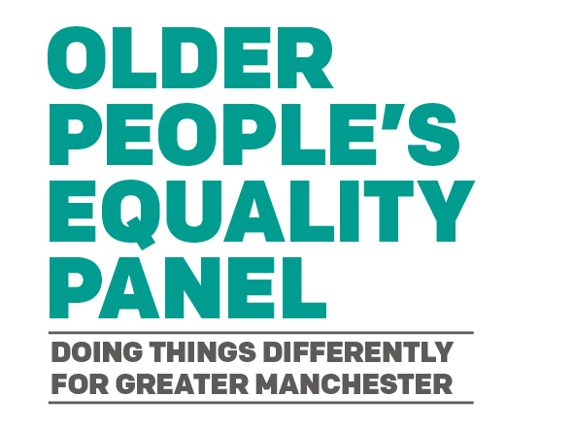

Annual Report, 2021-2022

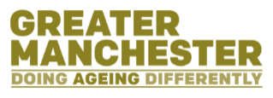
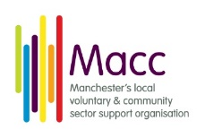
Table of Contents
Introduction 2
Recruitment 2
Membership 3
Our priorities 4
Forward planning 6
Contact details 7

Introduction
The Greater Manchester Older People’s Equality Panel (OPEP) was set up in March 2022 and its first meeting was held in April 2022. It is part of six other equality panels that the Greater Manchester Combined Authority (GMCA) created in response to the Independent Inequality Commission’s Report (find further information on the Report on the Independent Inequalities Commission webpage on the GMCA's website.)
Prior to March 2022, the Greater Manchester Ageing Hub, working closely with the Greater Manchester Older People’s Network (GMOPN), had endeavoured to ensure that the voices of older people within the city-region were heard and contributed to decision making. The work of the OPEP will be to contribute to this ongoing work, as well as generating its own talking points and projects.
The OPEP will work to champion the voices and experiences of older people in Greater Manchester and provide opportunities for them to feed into the development of policies and decision-making of GMCA.
The OPEP’s work comprises of:
- Advising the Mayor and GMCA on key issues and concerns of older people, and help to provide and influence solutions
- Providing a critical voice and scrutinise the work of the Mayor and GMCA
- Undertaking specific pieces of work and focussing on particular issues or projects on an ad-hoc basis

Recruitment
Macc – An organisation providing support to Manchester’s voluntary, community and social enterprise infrastructure – is the facilitating organisation for the OPEP. Macc is responsible for the day-to-day running of the OPEP, responsible for, amongst other things, the recruitment of OPEP members, organising regular meetings, and supporting members’ voices and campaigns.
The initial phase of recruitment to the OPEP included consulting with existing organisations that represent and support the voices of older people across Greater Manchester.
The discussions found that the recruitment of OPEP members should prioritise:
- Representation from each Greater Manchester borough
- Trying to reach marginalised communities
- Being advertised and promoted in different languages
- Recognising and representing the different age ranges within the 50+ population
- Focussing on recruiting at a community level
- Seek to achieve a gender balance.

Membership
Following the recruitment process, the initial membership of the OPEP met in April 2022.
The table below lists the current membership of the OPEP, along with which Greater Manchester borough they are from.
Panel member name | Greater Manchester borough
Steve Sherry | Bolton
Lucette Tucker | Bury
Mary Watson | Manchester
Elizabeth Lynskey | Rochdale
Erica Woods | Salford
Jan Kitching | Stockport
Damayanti Patel | Tameside
Doretta Maynard | Trafford
Ellen Rhind | Wigan
The only borough not represented yet is Oldham, and recruitment efforts will continue until all boroughs are represented on the Panel.
The OPEP’s July meeting will see the election of a chair. The OPEP chair will represent the Panel at external meetings, including the GMCA’s Equality Panel network.

Our priorities
During the consultation with existing organisations that support and work with older people in Greater Manchester, views were also sought on what areas of work the OPEP should prioritise. The below lists the issues highlighted from these discussions:
- Concern about the impending cost of living crisis
- Difficult situations for people living at home receiving care
- Differing views and experiences of digitalisation, particularly since the Covid-19 pandemic
- Valuing of older people was still an issue.
- The age range of who is considered to be an older person
- Experiences of older people in the workplace
- Identifying unmet needs
- Addressing the lack of uptake of appropriate benefits
- Barriers to access of services and advice, such as language and digital exclusion
- Housing experiences and how it differs for different tenures, such as the difference between home owning and renting for older people
- Experiences on public transport.
Following the inaugural meeting of the OPEP, the following themes were agreed to form part of the Panel’s future work. This will define what the current membership will discuss and aim to influence over its tenure.
The table below lists the prioritised themes identified by the OPEP and the discussion points each theme will focus on:
Prioritised theme | Discussion points
Impact of the cost-of-living crisis | - Existing levels of poverty and absolute poverty  - Increasing the take-up of existing older age benefit, such as pension credit and attendance allowance.
Digitalisation | - Barriers to access services and information  - How to make digitalisation ‘age-friendly’  - General impact on daily living, both positive and negative.
Care settings | - Care homes as community assets  - Carers at home.

Forward planning

Continued recruitment
Second phase of recruitment will involve identifying representation gaps around communities of interest, such as ethnic minorities, those receiving care, carers, and the LGBTQ+ community, as well as targeting recruitment accordingly.
All the members recruited so far sit on the panel as individuals, rather than representatives from organisations. Our target is to grow the membership of the OPEP whilst maintaining a majority of individual members. The maximum number of members will be 20.

Engagement locally to build new networks
The panel will continue to work closely with the Greater Manchester Older People’s Network (GMOPN) and other existing networks, alongside seeking to engage with local networks in each borough.
Supported by Macc, the panel will continue to conduct outreach work and identify marginalised groups for the OPEP to engage with across the city region.

Collaborating with other panels
The OPEP will meet its obligations and seek opportunities to work with the other Greater Manchester equality panels.
Initially, there is particular interest in investigating the differing experiences and views of older and younger people by engaging and working with the Youth Combined Authority.

Relationship building and partnership working
The OPEP will develop a close working relationship with the GMOPN and seek to collaborate with its working groups where there are themes that cross over into the OPEP’s prioritised themes.
The Greater Manchester Older People’s Mental Health Network is due to be launched in summer 2022. The OPEP will also work with this network to co-ordinate priorities where relevant.
The panel will also seek to work closely with the Greater Manchester Ageing Hub in the development of their updated Age-Friendly Strategy.

Events
As part of focussing on the prioritised themes (see above on pages 4 and 5) the OPEP will seek to arrange ‘listening events’ to discuss and work on the agreed themes.

Contact details
For further information on the OPEP, please visit the OPEP's webpage on the GMCA website.
You can also contact John Mulvenna, facilitator of the OPEP at Macc, by either:
- Emailing John on gmopep@macc.org.uk
- Calling John on 0161 834 9823 or 07502233182

