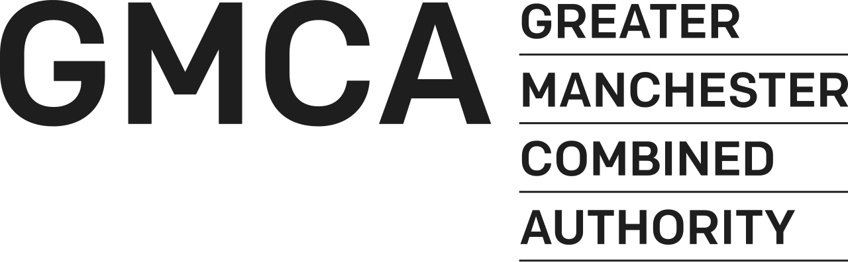

GREATER MANCHESTER CULTURE FUND
2023/2024 – 2025/2026

APPLICATION FORM – SPIRIT



ONLY USE THIS APPLICATION FORM IF APPLYING FOR
BETWEEN £20,000 AND £200,000 P/A

SUBMISSION DEADLINE
5pm, 25th November, 2022

Name of Organisation

____________________________________

BACKGROUND

Greater Manchester’s rich history and culture have developed Greater Manchester into a global brand that speaks of innovation, creativity and social progress. Our international reputation was, and is, built on the creativity of our people. GMCA is committed to investing in culture and creativity, creating the conditions for that creativity to flourish in the future.

In October, 2022, in recognition of the economic and societal changes that have taken place since GMCA launched its Culture & Social Impact Fund in 2017, GMCA agreed to a new investment approach, 2023-2026. This new investment approach splits investment into five strands.

Throughout November 2022, we are inviting applications to our three-year grant funding programmes, SPIRIT and SUSTAIN.
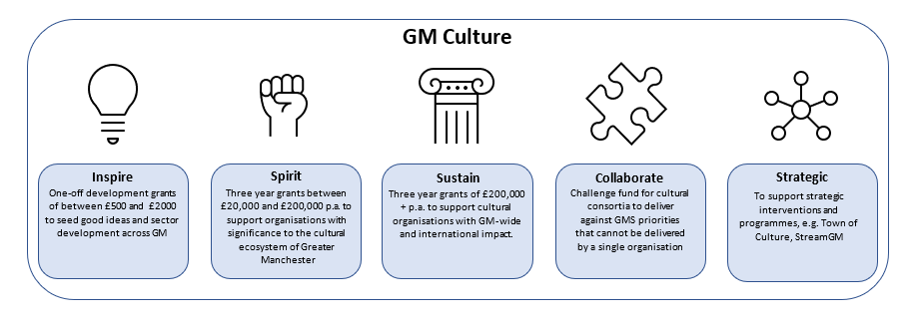

THIS APPLICATION FORM IS FOR THE SPIRIT STRAND OF INVESTMENT

SPIRIT will support locally-loved and important organisations with an award of between £20,000 and £200,000 p/a. Organisations in receipt of Spirit Grants will not need to deliver across all of Greater Manchester, but will be of strategic importance to the cultural ecosystem of the city region.

APPLICATION FORM
GMCA CULTURE FUND 2023-2026: SUSTAIN

Can You Apply?

We can only accept your application if your organisation meets certain conditions.

- Is your group a constituted voluntary and community sector or not-for profit organisation?

Y/N
- Are you a cultural or arts organisation or planning to deliver cultural activity across Greater Manchester?
Y/N
- Are you based in Greater Manchester?

Y/N

You must answer yes to all of the above criteria. If you say no to any of the above questions please do not continue with your application to the Greater Manchester Culture Fund: SPIRIT

DETAILS OF YOUR ORGANISATION

- General Information

Name of Organisation:
(If you are applying as a partnership or consortium please name all partners indicating lead organisation)
Registered address of Organisation:
Daytime telephone:
E-mail address:
Website Address:
Contact name:
Position Held:
Second contact name:
Position Held:

- How Much Are You Requesting From GMCA?

 | 2023/24 | 2024/25 | 2025/26 | TOTAL
Amount of Grant Requested

If currently in receipt of funding from GMCA please outline how much you receive. If you are requesting an increase in investment please outline your reasons for the increased ask.

- YOUR WORK

In less than 100 words please describe your organisation’s mission or core purpose

In less than 1,000 words please describe the type of activity or service you currently deliver. This can include information on who currently accesses the activity or service you provide and information that demonstrates the quality of your work (e.g. press, peer or participant reviews)

- PRIORITIES

Organisations applying to the SPIRIT strand MUST deliver at least two of the five priorities of the GMCA Culture Fund. Which of the priorities of the GMCA Culture Fund 2023-26 will the work of your organisation support?

PRIORITY 1:
Contribute to the recognition of Greater Manchester locally, nationally and internationally to attract new investment, new visitors and new talent to Greater Manchester
PRIORITY 2:
Make a positive contribution to improving skills and employability of residents in Greater Manchester, including support for the creative education, expression and ambition of young people across Greater Manchester
PRIORITY 3:
Play a strong role in developing strong and inclusive communities and an improved quality of life for residents, particularly those residents at risk of disengagement or social isolation
PRIORITY 4:
Be able to evidence how the project will make a positive contribution to improving residents’ health and well-being and meeting our equality duties.
PRIORITY 5:
Provide paid employment and opportunities for freelancers, individual practitioners and organisations within the Greater Manchester

How does your current and planned work meet the outlined priorities you plan to deliver against (no more than 300 words per priority)
Priority 1

Priority 2
Priority 3
Priority 4
Priority 5

- YOUR PROPOSED WORK
Please tell us;
what you plan to do over the next three years
who will benefit from your work and how they will be involved
how you know there is a need for your work
No more than 800 words

How will you work with other organisations (including local authority partners) to enhance your work and maximise impact for Greater Manchester residents?
No more than 800 words

- GEOGRAPHY
In which Greater Manchester Districts will you deliver activity or target audiences or participants and why is your organisation of significance to the local area and communities you serve
No more than 600 words

- IMPACT
How will you monitor the impact of your work? No more than 500 words

- MANAGEMENT
Are there any legal, financial and technical issues/risks that you need to consider to ensure delivery of the activities? What plans will you put in place to ensure that problems are detected and addressed at an early stage?
No more than 500 words

- GOVERNANCE

What is the legal status of your organisation?

A Company Limited by Guarantee |  | Registration No:
A Registered Charity |  | Registration No:
A Registered Friendly Society |  | Registration No:
A Voluntary Organisation |  | Registration No:
Not Registered but Intending to Apply
VAT Registered |  | Registration No:

Other e.g. Trusts (please specify):

Please give names and roles of your Board/Management Committee Members below:

Name | Role

Briefly describe your governance structure – Board, Committees, sub-committees, management committee etc, and how often the Board meets (200 words)?

Briefly describe your approach to risk management (300 words)

Does your organisation have the following policies in place? (Please tick the appropriate box)

Policy | Yes | No | Date  Last  Revised | Comments
Financial and Risk Management
If yes, please send us a copy.
If not, please outline how you
manage your finances on a separate sheet.
ii. Business Plan
iii. Recruitment and Selection
iv. Health and Safety
v. Equal Opportunities Statement
vi. Internal Grievance
vii. Complaints
vii. Induction for new:
a) Staff
b) Volunteers
Management Committee/
Board papers
viii. Data Protection
ix. Policies on anti-fraud,
corruption and whistleblowing
x. DBS requirements
(previously called CRB checks)

FINANCIAL INFORMATION

Please identify the breakdown of expenditure of your organisation’s core costs as appropriate

Expenditure | Expected Expenditure  2023/2024 (£) | Expected Expenditure  2024/25 (£) | Estimated Expenditure  2025/26 (£) | Total (£)
Employees (incl. NIC, Pension, etc.)
Heat and Light
Rent/Services
Business Rate
Telephone
Publicity/Marketing
Repairs and Maintenance (specify)
Equipment/asset purchases
Insurance
Travel and Subsistence
Remunerations paid to non-employees (e.g. board members)
Audit/Legal Fees
Other Budget Headings (Specify)
Total Expenditure (X)

Please identify the breakdown of income for your organisation

Please state in the box provided, whether any grants and contributions are secured (S) or applied for (A). For any grants/contributions not secured, state in the Budget Explanatory Notes box below the date a decision is expected. Also include here details of other grants that have been secured/applied for and their purpose.

 | Expected income 2023/2024 (£) | S/A | Expected income 2024/25 (£) | S/A | Estimated Income  2025/26 (£) | S/A | Total Estimated income
GMCA Grant
Other Local Authority Grants (specify districts)
Arts Council England (regular)
Arts Council England: (project)
Sport England
DCMS
National Lottery
National Lottery Heritage Fund
Other public (specify)
Commercial Sponsorship
Charitable Trusts & Foundations (specify)
Sponsorship
Private giving
Box Office
Catering
Sales
Membership Participation Fees
Fundraising
Any other
TOTAL INCOME (Y)
SURPLUS (DEFICIT) (Y-X)

Budget Explanatory Notes: Detail any explanatory notes relating to the Expenditure and Income tables in the box below including any additional funding, its purpose and period (max 500 words).

Budget Explanatory Notes: The grant period covered is likely to be one of significant financial pressure. Please outline how you plan to mitigate external financial pressures over the funding period (max 500 words).

BALANCING CRITERIA

We want to develop the most balanced investment portfolio possible and the below balancing criteria will be used to inform discussion and decision. Please provide information under the following headings that you think would aid our decision.

B1. We want our investment to benefit organisations throughout Greater Manchester. Which GM District which are you are based in? | NO MORE THAN 150 WORDS
B2. We want our investment to reach the greatest possible diversity of Greater Manchester. How will work to ensure your work reaches and reflects the greatest diversity of GM residents? | NO MORE THAN 150 WORDS
B3. We want our investment to support a variety of artforms. What is your primary artform? How will your work contribute to the development of this artform? | NO MORE THAN 150 WORDS
B4. We want our investment to support organisations of various sizes and scales. What is your total annual income and how will you work with partners to maximise the impact of our investment? | NO MORE THAN 150 WORDS

DECLARATION

The declaration below must be completed by the Chair or Deputy Chair of your Board/Management Committee, not a member of staff.

On behalf of the organisation, I confirm that:
the organisation/project operates on a non-profit basis and provides a facility used by, or which is for the benefit of, residents of Greater Manchester, and
the information given in this application form is true and correct.
I undertake to inform GMCA of any changes in the project/organisation’s circumstances that would affect this application.

Name (BLOCK LETTERS)
Position in Organisation | Chair / Deputy Chair  (please delete as appropriate)
Signature
Date

Please note by signing this declaration, you are allowing us to consult with your partners and stakeholders. We reserve the right to ask any applicant to provide additional information or clarification over and above what is submitted in your application as part of our appraisal process.

Thank you for filling in this form. Please check it carefully before returning to cultureteam@greatermanchester-ca.gov.uk . You must include the following documents and confirm that you have included them by ticking the relevant box(es). If any of these documents are available online please provide a reference link to the website rather than a hard copy.

1. | A copy of your latest Audited /Independently Verified Accounts for your organisation.
2. | Financial Management Policy
3. | One copy of your current staff structure indicating name, job title and hours  (F/T, P/T)
4 | Constitution or Memorandum of Articles of Association
5. | Certificate of Incorporation

