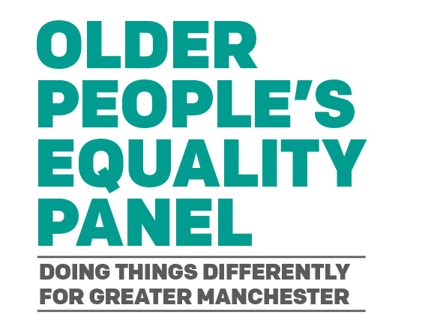

Actions for the panel – autumn 2022

The panel have decided on 3 prioritised issues which lie within or across the three themes for the updated GM Age Friendly Strategy.

Three working groups have been formed to address issues and concerns for older people relating to:

- Impacts of the cost of living crisis
- Care settings
- Digital participation

Care Settings
Priority | Actions for the subgroup
Influence the Social Care transformation across GM | Collaborate at GM level to represent an Age Friendly approach.
Influence how hospital discharge can be improved. | Seek to collaborate with NHS GM Integrated Care on identifying and reducing health inequalities.

Impact of cost of living crisis
Priority | Actions for the Sub Group
Support efforts to maximise financial support for those most at risk. | Collaborate at neighbourhood level to assess success of pension top up campaign.  Liaise with local networks to assess area specific issues.
Set up tool for gathering qualitative data. | Work with GM Older People’s Network and Poverty Truth Commissions to collate examples of how the crisis impacts on older people.

Digital Participation
Priority | Actions for the subgroup
Influence different ways digital exclusion is challenged across GM. | Record examples to illustrate the different ways digital exclusion impacts on older people’s lives.
Influence work investigating how digitalisation increases health inequalities for older people. | Contribute to University of Manchester study on impact on over 65s of NHS digitalisation programme

Ways of working
Priority | Actions for the subgroup
Collaborate with GM Ageing Hub and GM Older People’s Network on the Age Friendly Strategy | Designated panel members to liaise with GMOPN steering group and update to relevant
Identify and support local older people’s networks at neighbourhood level. | Meet with GM Older People’s Network to agree a plan for recruitment and support at a local level.
As GM Strategy is rolled out influence at a strategic level. | Work with Locality Leads to influence at borough level. Seek representation on relevant strategic working groups.

Other issues to be addressed

Consultation also identified the following issues for the panel to address.
- Valuing of older people was still an issue.
- The age range of who was considered to be an older person was discussed.
- Need to reflect the experience of older people in the workplace.
    - Identifying unmet needs.
    - Barriers to access of services and advice – language, digital exclusion
    - Housing options – different issues in different boroughs. Discussed issues for home owners as well as issues for people renting either privately or from a social landlord.
    - Transport issues – experience of public transport varied.

