Information Strategy Delivery Workshops- social media pack

Background
Information, and how it is used, affects everyone. We want to ensure that everyone benefits from how we manage, share, use information in Greater Manchester – our information ecosystem. That is why we created the Greater Manchester Information Strategy, with the vision of creating a better information ecosystem.

Now we need to put that strategy into action. We are developing a delivery plan for the strategy. There are a lot of things we could do – from ensuring we get processes and procedures right, to doing new and innovative things with information. We want to understand people’s priorities for our delivery plan.

What are we doing?
We have conducted a consultation on what actions people think should be taken to implement the strategy which has outlined over 160 actions. The next step is to run a series of workshops to help us to identify what actions should be taken, and which of those actions are most important. The workshops will take place on the following dates:

Date | Time | Link
Mon, Feb 13, 2023 | 1:00 PM | GM Information Strategy Priority Setting - Mission 1 (online)
Wed, Feb 15, 2023 | 1:00 PM | GM Information Strategy Priority Setting - Mission 1 (in-person)
Tue, Feb 28, 2023 | 1:00 PM | GM Information Strategy Priority Setting - Missions 2 & 3 (online)
Wed, Mar 1, 2023 | 1:00 PM | GM Information Strategy Priority Setting - Missions 2 & 3 (in-person)
Thu, Mar 2, 2023 | 10:00 AM | GM Information Strategy Priority Setting - Missions 4, 5 & 6 (online)
Fri, Mar 3, 2023 | 1:00 PM | GM Information Strategy Priority Setting - Missions 4, 5 & 6 (in-person)

The following suggested social media posts have been put together to help promote the workshops. Please share via your own channels where appropriate.

You can access the assets here: https://we.tl/t-W3b0ShuJFi or via GMCA- Communications Campaign Packs and Toolkits
Social media posts
Post content | Graphic
📢Data affects us all. Have your say in how Greater Manchester will deliver the #InformationStrategy  🔗Join @GM_InfoGov with priority setting workshops in Feb (either online or face to face)  Sign up👉https://eventbrite.com/cc/gmis-delivery-plan-priority-setting-workshops-1647859 run by @opendatamcr | 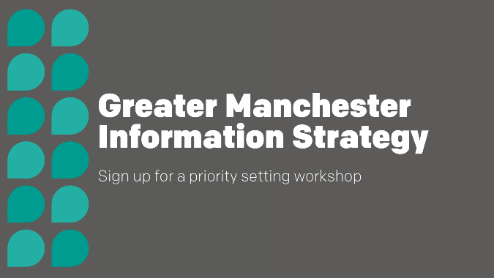  Image: 1 Greater Manchester information Strategy.jpg
Is making information about organisations and what they do available openly online important?  Sign up to an online workshop to help  @GM_Infogov implement Greater Manchester's #InformationStrategy.  👉 https://www.eventbrite.co.uk/e/gm-information-strategy-priority-setting-mission-1-online-tickets-523527684397?aff=odcleoeventsincollection | 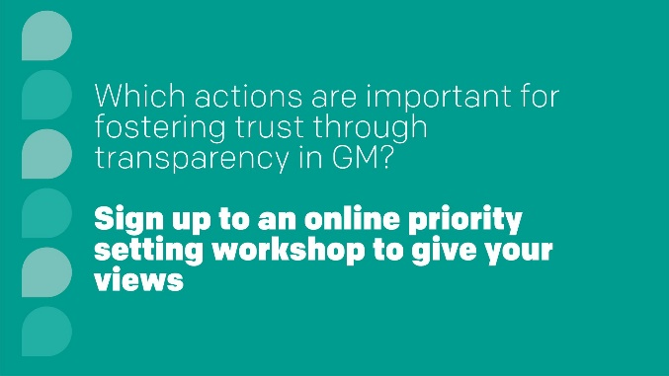  Image: 2 Which actions are important for fostering trust and transparency ONLINE.jpg
Which actions do you think are important for fostering trust and transparency with information and data?  Join an in-person workshop to help  @GM_Infogov implement Greater Manchester's #InformationStrategy.  👉 https://www.eventbrite.co.uk/e/gm-information-strategy-priority-setting-mission-1-in-person-tickets-523546480617?aff=odcleoeventsincollection | 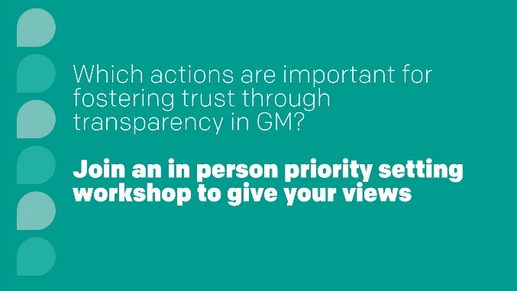  Image: 3 Which actions are important for fostering trust and transparency InPerson.jpg
Post content | Graphic
We want to use information and data to help to tackle Greater Manchester's most serious challenges and support the city region's ambitions  Join an online workshop to help  @GM_Infogov implement Greater Manchester's #InformationStrategy.  👉 https://www.eventbrite.co.uk/e/gm-information-strategy-priority-setting-missions-2-3-online-tickets-523562679067?aff=odcleoeventsincollection | 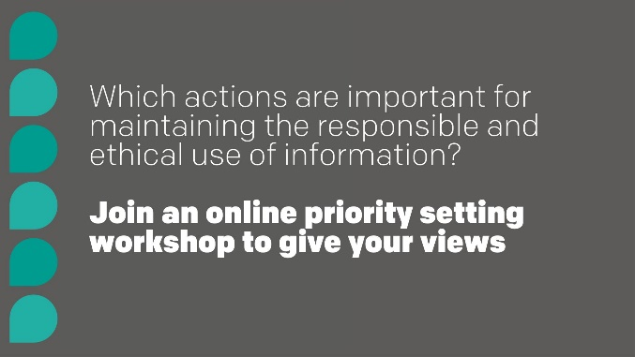  Image: 4 Which actions are important for maintaining the responsible ONLINE.jpg
Effective use of information can allow Greater Manchester to innovate &create new opportunities to provide products, services, & support  We need your thoughts on how to do this. Sign up to an offline workshop to help implement #GMInformationStrategy  👉 https://www.eventbrite.co.uk/e/gm-information-strategy-priority-setting-missions-2-3-in-person-tickets-523552538737?aff=odcleoeventsincollection | 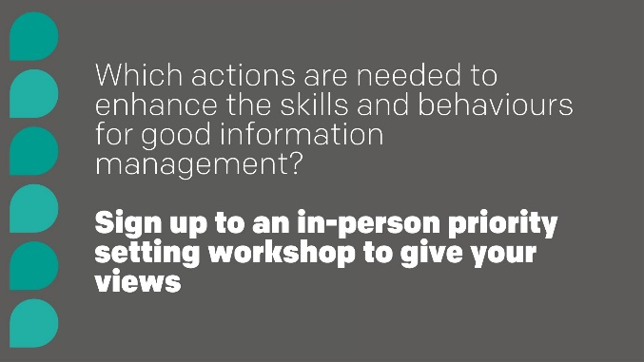  Image: 5 Which actions are needed to enhance the skills and behaviours InPerson.jpg
Better use of data can help frontline workers get the right information at the right time and make better informed decisions  Sign up to an online workshop to help  @GM_Infogov implement Greater Manchester's #InformationStrategy and share your thoughts on what actions need to be done.  👉 https://www.eventbrite.co.uk/e/gm-information-strategy-priority-setting-missions-4-5-6-online-tickets-523566259777?aff=odcleoeventsincollection | 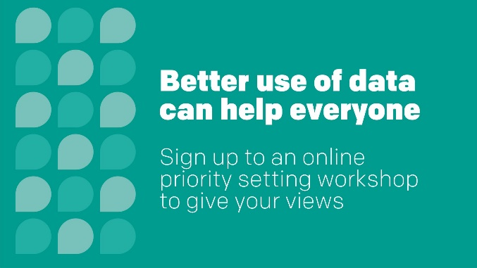  Image: 6 Better use of data can help everyone ONLINE.jpg
Information, and how it is used, affects everyone  We want to ensure that everyone benefits from how we manage, share, and use information in Greater Manchester  Join an in-person workshop to help  implement Greater Manchester's #InformationStrategy.  👉 https://www.eventbrite.co.uk/e/gm-information-strategy-priority-setting-missions-4-5-6-in-person-tickets-523558707187?aff=odcleoeventsincollection | 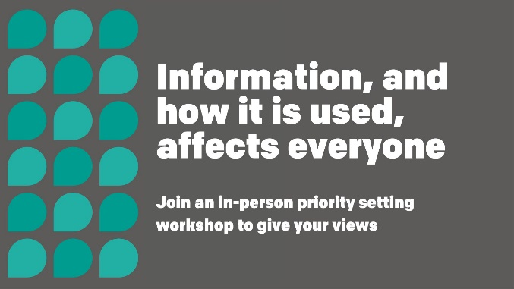  Image: 7 Information and how it is used, affects everyone InPerson.jpg

If you have any questions or suggestions, please email Communications and Engagement Manager for Information Strategy Sammy.alloway@greatermanchester-ca.gov.uk

