Industry Labour Market and Skills Intelligence Report
EMERGENCY SERVICES
Published January 2023

Contents

Purpose of Report 3
Executive Summary 5
Recommendations 6
1. Introduction 8
2. Industry Context 21
3. Labour Market Information 26
4. Skills Demand 40
5. Skills Provision 52
6. Summary 57
7. Next Report 62

Purpose of Report
This report provides an employer-led and current understanding of skills and talent needs required across emergency services in Greater Manchester (GM). The intelligence has been gathered from conversations with colleagues at Greater Manchester Police, North West Ambulance Service and Greater Manchester Fire and Rescue Service. Existing reports, strategies and relevant information have also been considered. GMCA would like to thank everyone involved in the development of this report for their time and insights. Recommendations made will not always lead to GMCA-led work and skills action but will develop understanding in how we can encourage talent growth for the sector. This report supports and feeds in to wider GMCA policy and strategy including:
- The Greater Manchester Strategy
- Greater Manchester Local Industrial Strategy
- Greater Manchester Work and Skills Strategy
- Greater Manchester Resilience Strategy 2020-2030

The report also references and supports many existing policies and publications around this sector including key documents from each of the services:
- GMP - Planning our Future
- GMFRS Fire Plan 2021-2025
- NWAS Workforce Strategy 2020-2023

GMCA will work on wider sharing and translation of this intelligence for varied audiences in GM. We will also look across devolved powers in the work and skills team to see where the skills system can better align to the needs of the sector. The objectives of this intelligence are as follows:
- Provide a better understanding of the progression pathways to roles within the emergency services in GM
- Identify how the emergency services workforce can best serve our residents.
- Better inform and implement existing skills provision for the benefit of GM residents and the wider emergency services.
- Identify opportunities to improve the diversity of the sector to better represent the GM population.
- Understand the future trends within the sector – in particular, how these trends will impact the existing workforce and future skills needs.
- Understand the impacts of COVID-19 on the skills-base within the sector including challenges and opportunities.

GM residents need to be able to understand the occupations and progression pathways, as well as the technical skills and wider attributes required in different areas of the industry and at different levels. There is the need for key stakeholders working with different groups to be able to translate these key skills and labour market messages for the following groups:
- Young people
- Career influencers - teachers, career advisors, parents, work coaches
- People looking to switch careers or looking for work
- Skills providers of all types
- Employers
- Individuals wanting to progress in work

This intelligence was gathered during 2022 and is accurate as of the release date of this report. The report focuses on the paid workforce and does not consider the high number of volunteers within this sector. Their important contribution is acknowledged but is not within the scope. The report is intended as an initial platform of intelligence and research, which will be built on and updated by GMCA.
GMCA understands the need to regularly update this intelligence accordingly. Plans are laid out towards the end of the report for further intelligence gathering and research.

Executive Summary
The 999-call originated in London in 1936 and was the world's first automatic telephone service to call the emergency services. Today over 50,000 emergency calls are made in the UK each day. Of these, more than half asked for police assistance. The next most requested was the ambulance service, followed by the fire and rescue service.
As well as being a vital service to the community, the emergency services are also a large employer in GM. This report contains insight and opinion from many members of this workforce. It looks primarily at the skills and labour challenges in emergency services and aims to better inform and guide responses from GMCA, career leads, training providers and other stakeholders. Whereas Police and Fire operate within the GM boundary, the Ambulance Service covers a wider geographical area and so there has been some wider North West input into this report, but the findings largely reflect GM’s workforce.
Key findings from this report include:
- Emergency services have been affected by repeated financial cuts, which coupled with changing demographics and wider economic challenges, has put the workforce under huge pressure.
- Mental health is a large and growing area of concern, both in terms of employees’ own wellbeing and also in terms of engaging with service users.
- Retention can be an issue with staff leaving due to a variety of reasons. More flexible working conditions are desired by many stakeholders.
- More blue-light collaborative working within the services is needed and has shown to be an effective way of managing resource.
- All GM services are keen to improve the diversity of their workforce to better represent their communities. Progress has been made but work still needs to be done.
- Apprenticeships are being well used by the services and there are clear well established pathways into many roles.
- The wider world is changing fast with climate change, the rise of cyber-crime, and an ageing population affecting each emergency service. This means that the workforces needs different skillsets, particularly better digital skills.
- Soft skills including strong communication (across different communities) and empathy are of increasing importance.

Recommendations
Full and detailed recommendations are given at the end of this report, but a list of the core recommendations can be found below. These recommendations are not likely to be short-term fixes, and several require a long-term system change. They serve to summarise key areas of activity based on the greatest need – activity which will need input from all corners of the sector, including employers, skills providers, and government.
Recommendations from this report include:
- Commissioning activity or training should take place to fill skills gaps in all three functions around performance management, mental health training, resilience and cyber security
- Careers advice should position emergency services careers as the opportunity to make a real difference to people’s lives. They should also highlight the vast range of roles and different specialities beyond just “front-line” roles like police officers, fire fighters and paramedics.
- Employers should ensure that that they are working to improve representation in the sector to better reflect the communities of GM.
- Additional dedicated specialists should be encouraged to work in/with the sector. Those with transferrable skills such as digital expertise will become increasingly in demand.
- Greater mental health awareness and support is needed. This is both for employees’ own wellbeing and for when engaging with GM residents with additional mental health needs.
- Flexible and hybrid working should be considered where possible to open up employment to a broader demographic.
- GMP, GMFRS and NWAS should all aim to join the Good Employment Charter and where possible, offer attractive pay, terms and conditions to all members of their service including apprentices.

CONTACT OFFICER:
Philip Pennill, GMCA, philip.pennill@greatermanchester-ca.gov.uk

Introduction
  - Emergency services and rescue services are organisations which ensure public safety and health by addressing different emergencies. There are three primary emergency services that can be summoned directly by the public: the Police, Fire and Rescue Services, and Ambulance Service. Each of the three will be covered in this work. A fourth service – HM Coastguard – is not found within Greater Manchester and is not discussed in this report. The sector’s importance is obvious; all three are critical to public protection, and it is thought the average adult rings 999 twice during their lifetime. Over 33 million 999 calls were made during 2021.
  - Law enforcement in the United Kingdom is organised separately in each nation of the UK. Most law enforcement is carried out by police officers serving in regional police services (known as territorial police forces) within one of those jurisdictions. These regional services are supported by UK-wide agencies, such as the National Crime Agency and the national specialist units of certain territorial police forces, such as the Specialist Operations directorate of the Metropolitan Police.
  - There are 45 'territorial' forces in the UK and 3 'special' police forces (British Transport Police, Civil Nuclear Constabulary, and Ministry of Defence Police). Northern Ireland and Scotland have national police forces covering the whole region. England and Wales contain the 43 other regional forces covering including Greater Manchester Police.
  - Police officers are granted certain powers to enable them to execute their duties. Their primary duties are the protection of life and property, preservation of the peace, and detection & prevention of criminal offences. Police officers exercise their powers to police with the implicit consent of the public. "Policing by consent" is the phrase used to describe this. It expresses that the legitimacy of policing in the eyes of the public is based upon a general consensus of support that follows from transparency about their powers, their integrity in exercising those powers and their accountability for doing so.
  - Greater Manchester Police was directly created from two amalgamated city police forces, Manchester and Salford Police and parts of what were Lancashire, Cheshire and West Yorkshire Constabularies. In 1974, the Local Government Act created the Metropolitan County of Greater Manchester and with it, Greater Manchester Police. The area GMP polices is split into geographical divisions, with each Metropolitan borough of Greater Manchester being assigned one. In 2021, GMP restructured divisions to form command areas. Each command area is run by a chief superintendent, with each 'division' or 'cluster' being led by a superintendent.
  - In recent years, the Police have faced several challenges and opportunities:
- The growing diversity of communities means there is a need for change within policing for the service to meet the communities’ needs. This is made clear in the Policing Vision 2025 report, set out by the National Police Chiefs’ Council, which envisions attracting and retaining “a workforce of confident professionals able to operate with a high degree of autonomy and accountability”, that will “better reflect communities”.
- New and emerging types of crime are creating new challenges. Online crime has grown dramatically in recent years. The internet presents three challenges - new types of crime, enabling some crimes to be carried out on an industrial scale, and facilitating many forms of “traditional” crime.
- All UK Police Forces have faced major cuts as central government cut budgets over recent years, with knock-on effects on levels of engagement and morale, which in some cases have been significant.
- While they are now easing, COVID-19 restrictions placed additional demands on frontline officers, as well burdening them with the workloads of colleagues absent through sickness or mandatory isolation. Factors that had a notable impact on officers during COVID-19 lockdowns included negative public perception of the police, with concerns that mainstream and social media had distorted the reality of policing during the pandemic, placing them in a difficult ‘no win’ situation.
- In Greater Manchester, GMP was placed in Special Measures by the police watchdog due to poor performance. In its latest police effectiveness, efficiency and legitimacy (PEEL) inspection published in March 2022, Greater Manchester Police was rated adequate in 1 (of 10) areas, “requires improvement” in 6 areas, and “inadequate” in 3 areas.
- However, progress has been made and in October 2022 it was announced that Greater Manchester Police had been removed from special measures and was no longer required to be in the Inspectorate’s monitoring process.
- GMP reported advancement in all areas highlighted as causes for concern by HMICFRS, and in particular the areas in which the public would more immediately see and feel progress:
- In terms of national performance, GMP is now in the top ten of Force performance for 999 answer times, and 8th nationally in terms of percentage of calls answered in under 10 seconds. This performance is the best of any large metropolitan Force.
- Other improvements are shown in a GMP graphic below:
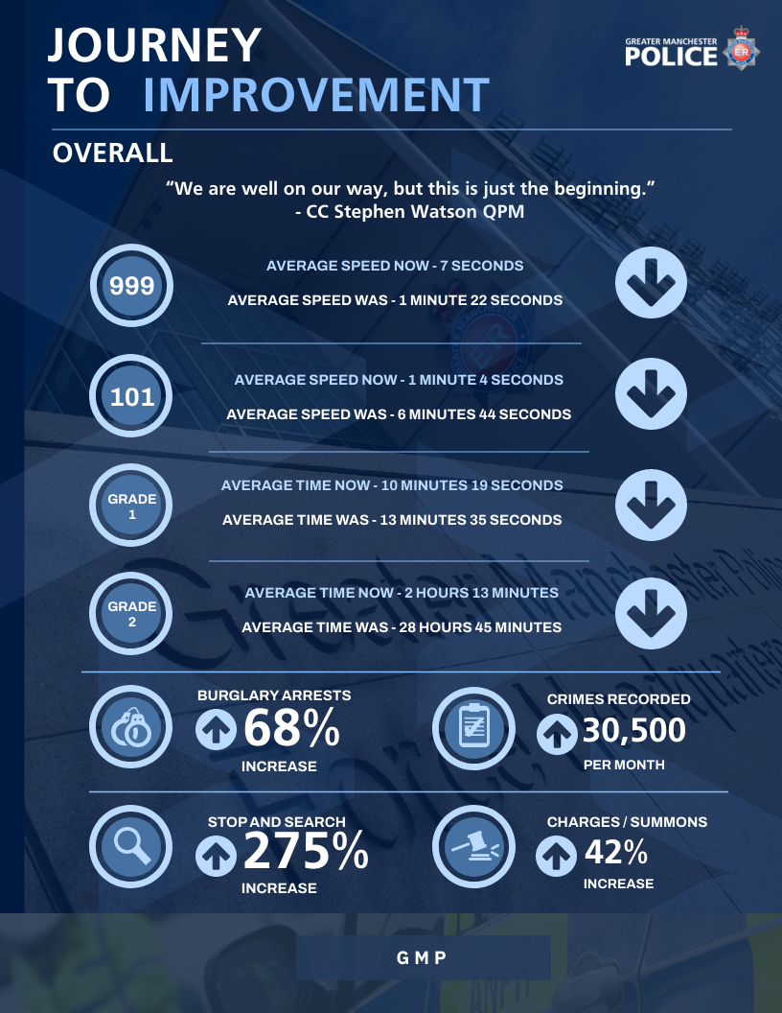
FIGURE 1 – GMP October 2022 Improvement Journey

  - The Fire and Rescue Services Act 2004 sets out the responsibilities of Fire and Rescue Authorities (FRAs). There are four key responsibilities for FRAs that they must ensure that they make provision for including:
- extinguishing fires in their area
- protecting life and property in the event of fires in their area
- rescuing and protecting people in the event of a road traffic collision, and
- rescuing and protecting people in the event of other emergencies.

  - In the early 1900s, the Fire Brigade was a branch of the Police Force, and the rank structure was that of the police force. When the Fire Service was made independent of the police a new rank structure and markings was designed for the uniform which was revamped in 1960’s. Now there are numerous styles used but the insignia remains constant. There are basically two uniforms worn by firefighters, a working uniform and a fire tunic. The modern rank structure is below:
- Firefighter
- Crew Manager
- Watch Manager
- Station Manager
- Group Manager
- Area Manager
- Brigade Manager

  - Since its founding, the role of the fire and rescue service has changed considerably, and the work undertaken by firefighters in the community changed to reflect the new demands made on the service. In a modern fire and rescue service, as well as fighting fires, Firefighters attend other emergencies such as road, rail and air traffic accidents, chemical spills, floods, and terror attacks. There is a firm emphasis on fire prevention, and GM Firefighters spend a great deal of time promoting fire safety within the community. Firefighters carry out building inspections to make sure that local businesses are complying with fire safety regulations. They also work closely with other public services and community organisations to promote important fire and water safety advice.
  - GMFRS is one of the largest fire and rescue services in England, covering an area of 493 square miles, with more than 1,600 members of staff and serving a population of 2.8 million residents. The Service has 45 sites across Greater Manchester, including the Training and Safety Centre, the Training and Development Centre, the Technical Services Centre, the headquarters in Swinton, and 41 fire stations aligned to Greater Manchester’s 10 local councils. Responsibility for the Service sits with the Mayor of Greater Manchester, Andy Burnham. The Service’s assets and employees are part of the Greater Manchester Combined Authority (GMCA).
  - A Fire Plan 2021-2025 forms part the wider Greater Manchester Strategy, which aims to make the city-region one of the best places in the world to grow up, get on and grow old. GMFRS must integrate working with partners across the city-region to enable this ambition. It includes six priorities for the Service and a series of commitments under each one and was written by the Mayor and the Deputy Mayor, in collaboration with the Chief Fire Officer. The priorities for Greater Manchester Fire & Rescue Service are:
- Provide a fast, safe and effective response
- Help people reduce the risks of fires and other emergencies
- Help protect the built environment
- Use resources sustainably and deliver the most value
- Develop a culture of excellence, equality and inclusivity
- Integrate services in every locality with those of partner agencies

  - Across the UK, there are full-time firefighters who work for the fire service full time and ‘retained’ firefighters who are on-call responders. GM Fire and Rescue Service (GMFRS) only has full time firefighters in the workforce. Within GMFRS, there is a rigorous ten step application process for candidates before they start a firefighter role. This includes taster days, psychometric assessments, functional skill and fitness tests.
  - The fire service's Integrated Personal Development System has developed role maps, supported by national occupational standards, for all roles within the UK fire service. Whilst fire fighters accounts for around three quarters of the workforce, a range of managerial and support services jobs exist within various back office functions. At management level, there are extra supervisory activities, which include managing operational incidents and directing the day-to-day tasks of personnel on fire stations. The operational aspects of firefighting, although important, are a minor part of a senior manager's role in a large service.
Fire Service Challenges and Opportunities
  - The primary function of GMFRS is to provide the best emergency response to GM communities. Over the last decade, focus has been on prevention and protection work to try and stop incidents happening in the first place. For example, there are currently more than 600 high-rise residential buildings in the region, the tallest of which stands at 64 floors, with more than 100 further planning proposals for buildings over 20 floors in height. High-rise buildings, new construction methods and limited access due to urban growth require GMFRS to fundamentally change the approach to incidents, and the training firefighters need to do their job safely and effectively.
  - A major fire is not only a threat to life but can create huge disruption and economic losses. Following the fire at Grenfell Tower there has been increasing evidence of construction failures and buildings failing to perform to expected standards in a fire. In response to this increased threat, the Greater Manchester High Rise Task Force was established in recent years. The task force brings together GMFRS, local authorities, landlords, building control, senior civil servants, universities, and other specialists to provide an integrated response.
  - GMFRS’s inspection by Her Majesty’s Inspectorate of Constabulary and Fire and Rescue Services (HMICFRS) in 2018 judged the culture of the service to be inadequate and requiring significant improvement. It specifically identified leadership, staff engagement and the need to engender a culture that is fair, inclusive and promotes professional development. Prior to its inspection, GMFRS and the Mayor had already acknowledged the need for improvement and initiated the Programme for Change. This major review looked at all areas of the Service and was broadly consistent with HMICFRS’ findings. Following station visits from the Mayor and Deputy Mayor, and extensive meetings between staff groups across the Service, the GMFRS Leadership, Culture and People Strategic plan was developed, building on the work that had already begun. These improvements include:
- The development of a new leadership programme based on best industry practice.
- Introduction of the ‘Best Companies’ engagement survey to benchmark engagement and identify priority areas for improvement.
- The adoption of a comprehensive Equality, Diversity and Inclusivity (EDI) Strategy including a new Attraction Strategy to help recruit a more diverse workforce.
- The development of a new Equality Impact Assessment tool.
- Work to update the female and gender-neutral facilities across the estate.
- The development of a refreshed vision, mission and values.

Ambulance Service
  - Ambulances serve a critical role within the NHS, responding to emergencies and safely transporting patients when required. There are 10 ambulance trusts across England. Each trust covers a large regional geography, covering multiple local integrated systems which include hospitals with A&E departments and varying community, primary and social care provision. Emergency 999 calls for an ambulance are prioritised into two categories: emergencies which are immediately life-threatening and emergencies which are not life-threatening. Each year about one in twenty people in the United Kingdom will use the accident and emergency ambulance service. However, responding to 999 calls makes up only 10% of the total number of ambulance service journeys, they are also involved in non-emergency work through the patient transport service.
  - Ambulance services are at the heart of the urgent and emergency care system. In 2017 the NHS introduced new ambulance standards to ensure the best, most appropriate response is provided for each patient first time. The stated aim is that all ambulance services: Meet all targets and deliver all patient outcomes; Are efficient and effective; Have a satisfied, happy and productive workforce; Are integrated into the wider urgent and emergency care system; Are digitally fit for the future. Ambulance services are changing to work in different ways. This means patients being treated by skilled paramedics in their own home, given advice over the telephone, or taken to a more appropriate setting outside hospitals.

  - The North West Ambulance Service NHS Trust (NWAS) is the ambulance service for North West England. It is one of ten ambulance trusts providing England with Emergency medical services, and is part of the National Health Service, receiving direct government funding for its role. Aside from its direct delivery role, NWAS has successfully registered with the Education Skills Funding Agency as an apprenticeship employer-provider to train staff.
  - In July 2006, following the merger of four previous services (Cumbria Ambulance Service; Lancashire Ambulance Service; Cheshire and Mersey Ambulance Service; and Greater Manchester Ambulance Service), NWAS was formed. Based in Bolton, the trust provides services to almost 7 million people in Greater Manchester, Cheshire, Merseyside, Lancashire, Cumbria, and the North Western fringes of the High Peak district of Derbyshire, in an area of 5,500 square miles (14,000 sq. km). NWAS provides emergency ambulance response via the 999 system, as well as operating the NHS 111 advice service for North West England. The trust currently operates from 104 ambulance stations across the North West. It also maintains three Emergency Operations Centres (EOCs) for the handling of 999 calls and dispatch of emergency ambulances, one of which is in Manchester.
  - NWAS was the first ambulance trust to be inspected by the Care Quality Commission (CQC), in August 2014. The CQC found the trust provided safe and effective services which were well-led and with a clear focus on quality, but it was criticised for taking too many callers to hospital and for sending ambulances when other responses would have been more appropriate. The trust was subsequently inspected in 2018 and was found to have improved with a rating of "Good"

Ambulance Service Challenges and Opportunities
  - There is a common misconception that an ambulance is simply 'a blue light taxi' or that ambulances are staffed by paramedics whose main job is to transport someone to hospital. This narrow understanding of what the ambulance service does fails to reflect the broad and evolving role the service has to play within health and care systems, particularly as services become more integrated. One broader challenge for the NHS is to try to shift public perception and increase understanding of the important role ambulance services can play as a front door to the NHS (particularly given many ambulance trusts also manage the NHS 111 service), in signposting and referring frequent and vulnerable patients to other services, and in delivering clinical treatment and care.
  - Similarly to the rest of the health and care sector, the ambulance service has struggled due to large increases in demand, a lack of funding and widespread workforce shortages. The service experiences higher levels of sickness absence than other services and ambulance staff are more likely to be physically assaulted or experience verbal abuse when working.
  - A huge challenge many ambulance services see is a “bottleneck” when staff and vehicles are delayed handing patients over to acute hospitals. This happens when hospitals are running at capacity and there are no beds available. These delays result with the risk to patients being extended from the hospital, out into the community, as ambulances are unable to be re-deployed to people waiting for an ambulance; meaning people have to wait longer due to other parts of the health system.
  - Another concern is the potential loss of more senior and experienced staff to primary care at a time when ambulance trusts are already understaffed and struggling to recruit to the levels they need. The service could lose vital mentoring and supervisory capacity, impacting the quality of the whole Emergency Care system. Appropriate training must therefore be factored in to equip paramedics with the right skills to manage lower acuity cases in primary care.
  - Ambulance Trusts receive funding through annual NHS Service Level Agreements made with primary care trusts and clinical commissioning groups in a particular geographic area. Often this funding falls short; some ambulance trusts also generate income from their attendance at public events like music festivals, and from the provision of commercial training. Many have charitable funds that also receive donations. Each Ambulance Trust has a Board which allocates it annual expenditure.
  - Ambulance service provision has historically been under-funded, with financial settlements not keeping up with ever-increasing demand faced by the sector. This has a negative impact on patient experience and clinical outcomes, as well as the mental health and wellbeing of ambulance service staff. The latest independent demand and capacity review modelling commissioned for ambulance trusts in England forecasts an annual funding gap of £237.5m.
  - The ambulance services made a significant and highly-valued contribution to the COVID-19 pandemic health response across the country. During the first wave, ambulance services received additional funding to enable them to increase capacity to address the challenges they were faced with. Learning from COVID-19 strongly highlights the need for ambulance services to be adequately funded on a recurrent basis, so that their capacity to respond safely to predicted demand can be fully and appropriately resourced with the necessary skill mix all year round. Call demand for NWAS 111 has remained 40% above pre-pandemic levels throughout the past year. Throughout COVID-19, the 111-service expanded rapidly with non-recurrent funding to support a growth in call demand. Unfortunately, the current call volume continues to outstrip the 111 funding.
  - Whilst demand, money and recruitment/retention challenges are in some way consistent across ambulance trusts, there are a range of factors that can impact the operational model and performance of an ambulance service. There is variation in terms of:
- The size of the different geography’s population count
- Population profile – in particular around age
- How rural or urban the geography i.e. spread of densely populated cities and more sparsely populated areas
- The number and spread of A&E departments
- The different health and care systems e.g. the number and type of specialist services,
- The performance and patient flow in local acute hospitals
- The quality of community services, care homes and primary care, other emergency services including the fire service and police service.

Industry Context
(2.1) The Emergency Services are funded directly by central government departments and so as a result, are more vulnerable to policy changes. While the Police and Fire services are overseen by the Home Office, the Department of Health is responsible for the National Health Service, and by extension the Emergency Medical Services. Like many publicly-funded institutions in the United Kingdom, the emergency services have had to cope with years of budget cuts pursued by British governments since 2010. Between 2009/10 and 2013/14, for example, the Police Service expenditure for the UK fell from £19.3bn to £16.35bn in nominal terms and continued to decline until 2017. The amount of public spending on the police service has risen since then and was £24.9bn in 2022. Fire services expenditure also declined during this period, experiencing a net decrease of around £30m between 2009/10 and 2018/19. There have been spending increases in this area since 2018/19, however, rising to £3.1bn by 2020/21.
(2.2) Less funding led to staffing cuts in most areas of the Emergency Services. In 2010, for example, there were over 143,000 police officers in England and Wales, compared with just over 123,000 in 2019. The number of fire and rescue workers in England decreased by approximately 10,000 during the same time period.
(2.3) Unlike the police and fire services, the number of ambulance staff in England saw a large increase in the past decade, reaching a peak of over 21,000 qualified staff in 2019, although this fell again to just 16,700 in 2020. Ambulances in the United Kingdom have also had to contend with rising demand for their services, and in late 2019 less than 69 percent of who people who attended accident and emergency (A&E) departments in England were seen within four hours, missing the target of 95 percent. The last time this target was met was in June 2013, when 95.3 percent of patients were seen within four hours of arriving at A&E.
(2.4) All these factors mean that this is a challenging time for the emergency services. With a growing, ageing, and more diverse population there are new skill needs and the workforce must be equipped to meet new challenges. Almost everyone in a city region like GM will need these services at some point in their life - usually at a time of their greatest stress. There are systemic challenges on each of these services, but this report aims to consider what can be done to adjust skills and work policy within GM.
(2.5) Preventing an emergency from happening altogether is far safer and more effective than responding to one after the fact. Working together addressing local problems is best achieved through integrated working with other agencies and Greater Manchester’s advanced devolved structures afford the region more opportunity to do this than other places. GMFRS, Greater Manchester Police (GMP) and the region’s 10 local authorities share the same Greater Manchester geographical boundaries, supporting the ambition of creating a single integrated public service team. There are already crossovers. GMP’s priorities include keeping people safe; reducing harm; and strengthening communities and places - aims that GMFRS also shares.
(2.6) The locations that demand the most resources from GMFRS, GMP and local authorities are frequently the same. For instance, mapping the location of certain kinds of deliberate fires and the location of anti-social behaviour incidents reveals that the two very closely correlate. A joint preventative approach with these other services is the most effective way of tackling these threats. Some frameworks for joint and integrated working already exists in Greater Manchester. For instance, Community Safety Partnerships bring together different public services to address local problems collectively. Place-based teams exist across the region, tackling local problems together, sometimes in an integrated way, where officers from different organisations serve as a single public service team, with the same priorities, aims and outcomes.
  - GM’s emergency services have various factors which are characteristics of the city region which impact service delivery, including:
- 1.22 million households, a quarter of which are in areas which are in the top 10% most deprived nationally
- 57 towns and city centres
- 130 miles of railways
- 39 Control Of Major Accident Sites
- 62 miles of Metrolink lines
- 600+ high rise residential buildings
- 555,000 people living with long term health conditions
Police
(2.8) Greater Manchester Police had a crime severity score of 19 for all crimes recorded in the year ending 31 March 2021. This was the second highest score across forces in England and Wales. Crime severity scores tell us the amount of harm caused to society by crime for each force area. To calculate this score, all crimes recorded in a force are given different weightings based on their severity. More serious crimes have higher weightings and less serious crimes have lower weightings. Greater Manchester Police has both severe and high crime demand. For offences recorded in the year ending 31 March 2021, only 8.5 percent resulted in action being taken. This is significantly below the average throughout forces in England and Wales of 14.4 percent.
(2.9) Caution is needed with Greater Manchester Police’s crime severity score for the year ending 31 March 2021 due to the findings from victim service assessments for the force. For a review of records from April to June 2020, its estimated that the force was recording 77.7% of reports of crime (with a confidence interval of +/- 3.2%). As such, the force’s true crime severity score for the year ending 31 March 2021 may be higher than reported due to under-recording of crime in this period. For the force’s most recent victim service assessment, records were reviewed from May to July 2021 and estimated that the force was recording 90.6% of reports of crime (with a confidence interval of +/- 2.8%). As discussed earlier in the report though, huge progress has and is being made under the new Chief Constable and stakeholders in GMP have indicated that they expect improved results to be found at future inspections.
Fire and Rescue Service
(2.10) The total number of incidents attended by FRSs in England peaked in the year to March 2004, at over one million incidents. For around a decade, there was a general decline in incidents attended and by the year ending March 2015 there were fewer than half a million incidents. In the year ending March 2022: 577,053 incidents were attended by FRSs, this was an 11 per cent increase compared with the previous year (518,270), a three per cent increase compared with five years ago (560,694) but a five per cent decrease compared with ten years ago (606,941). In contrast to the earlier decreases (caused by a reduction in fires), the increase in total incidents over the four years to March 2019 was driven mainly due to the number of flooding incidents and collaboration incidents attended.
(2.11) Of all incidents attended by FRSs, fires accounted for 26 per cent, fire false alarms 40 per cent and non-fire incidents 34 per cent, compared with fires accounting for 37 per cent, fire false alarms 41 per cent and non-fire incidents 22 per cent ten years ago.
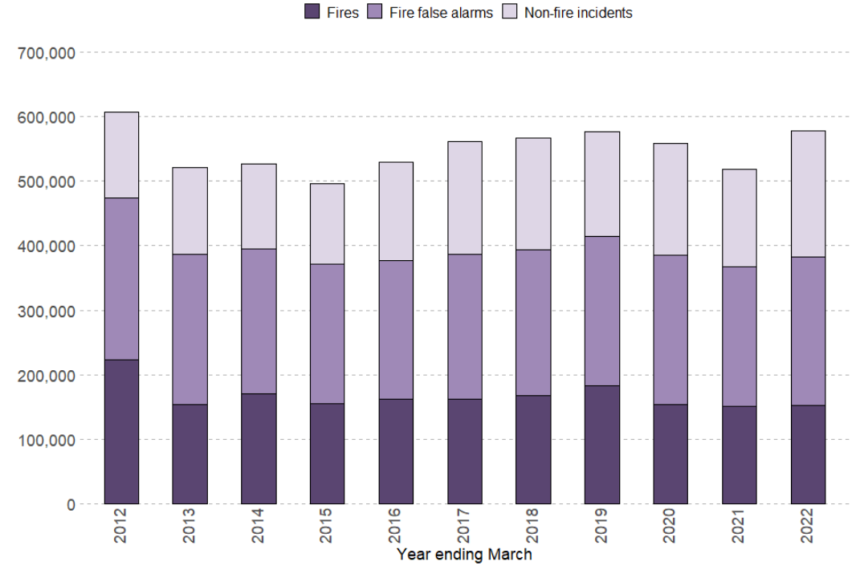
FIGURE 2 – Types of Incidents to which GMFRS responded
Ambulance Service
(2.12) The emergency call volume varied throughout last year, as COVID restrictions and rules changed, but for the total whole year, there was higher than normal call volume with an increase of 21.56% when compared to the previous financial year. With the challenges of hospital handover impacting on availability, it was important to implement Hear and Treat and See and Treat strategies to signpost patients presenting with minor conditions. Through increased triage only 32% of all calls received resulted in a journey to an emergency department

Labour Market Information
(3.1) One of the overriding reasons why people choose a career in the emergency services is the opportunity to make a real difference to people’s lives. Police officers report being attracted by the prospect of reducing crime and the fear of crime. Firefighters can perform life-saving duties by rescuing people from fires, accidents and natural disasters. Paramedics may find themselves saving lives on a daily basis. The idea that no two days are the same in work is attractive for many young people and career switchers.
(3.2) On a national basis, there are around 145,000 police officers in the UK, 50,000 fire and rescue personnel and around 17,000 qualified paramedics and ambulance staff currently employed in the emergency services. Many generally feel there is great respect given to careers in the emergency services and the sector reputation is high. Firefighters and paramedics consistently rank amongst the professions most trusted by the public, in the UK and globally, placing these workers in a unique position to play a wider role in the communities they serve. The services are attractive with good job security, a high standard of training and a perception of professional development and a career pathway.
(3.3) The workforce in emergency services should represent the people they serve. This is not only true for ethical and well-being reasons, but because a service that reflects its communities is more effective at engaging with them. Speaking to stakeholders from each of the services, it is evident that this is an ongoing priority across GM. Creating an inclusive culture where staff feel supported to fulfil their potential and are valued and welcomed for the diversity they bring to their role is essential in delivering our values and encouraging innovation.
Police
(3.4) The total workforce (officers, staff, Police Community Support Officers and designated officers) as of 31 March 2022, was 225,229 FTE, an increase of 2% on the previous year. There were 40,228 full-time equivalent (FTE) officers in post as of 31 March 2022 in the 43 territorial police forces in England and Wales. This was an increase of 4% on March 2021 (up 4,927 FTEs from 135,301 officers).
(3.4) Excluding transfers, 12,789 new police officers (FTE) joined the 43 territorial police forces in England and Wales in the year ending March 2022, an increase of 662 (or 5.5%) on the previous year. This is the second highest number of joiners in a year since records began, just behind the year ending March 2020 when there were 12,883 joiners (excluding transfers)
(3.5) Excluding transfers, 8,117 (FTE) police officers left the 43 territorial police forces in England and Wales in the year ending March 2022, the highest number of annual leavers since comparable records began in the financial year ending March 2003. The police officer leaver rate (leavers as a proportion of headcount at the start of the year) was 6.0%, similar to levels seen between the financial years ending 2016 and 2019 and follows a dip in leaver rate seen in the previous year coinciding with the COVID-19 pandemic.
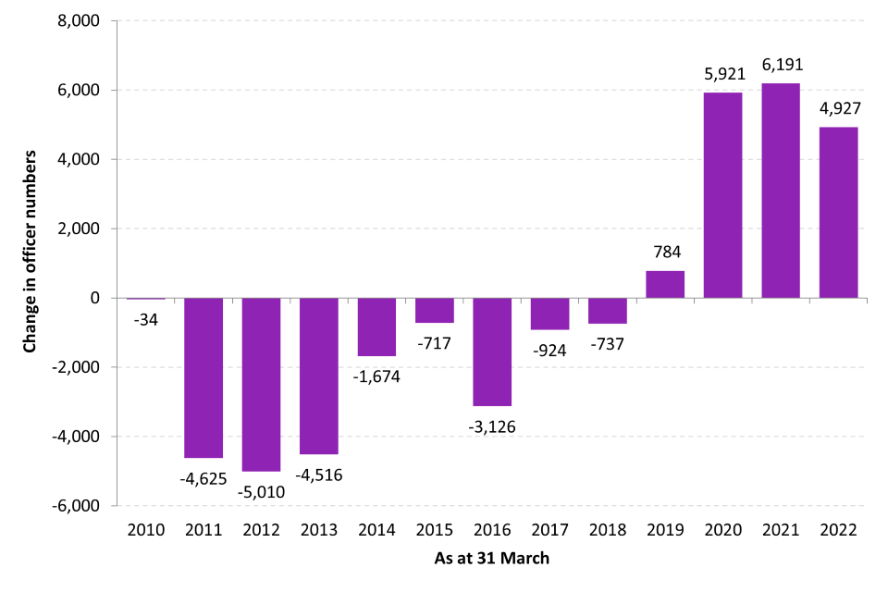
FIGURE 3 – Net UK Police Officer Changes since 2010
(3.6) Throughout the UK, the rank structure of police forces is identical up to the rank of Chief Superintendent. At higher ranks, structures are distinct within London where the Metropolitan Police Service and the City of London Police have a series of Commander and Commissioner ranks as their top ranks whereas other UK police forces have assistants, deputies and a Chief Constable as their top ranks. Within a rank there may be different roles and responsibilities, which reflects skills, knowledge, training and experience in a particular field. For example Detectives work alongside their uniformed counterparts as equals in pay and rank and are accredited police officers who work as Serious and Complex Crime Investigators or Specialist Investigators. These officers are responsible for managing a range of investigations including those concerning robbery, drugs, domestic violence, public and child protection, company fraud, cybercrime, homicide and counter-terrorism.
(3.7) Senior officers in GM are aware that the force has lost experienced members of the workforce through resignations and transfers to other police forces. Working conditions were the top reason provided by those who were willing to share this with the force. The force is now seeking to put measures in place to reduce the number leaving the organisation and even to encourage officers and staff to return to employment in the force. GM’s Chief Constable has invested in additional senior leaders through promotion and the recruitment of experienced senior leaders from other police forces. This is to provide leadership, direction and accountability in each of the policing districts and to fill additional roles in strategic departments.
(3.8) The force understands its recruitment needs for the future and has been maintaining the pace of the recruitment of officers. Some of the traditional attractions of a career in policing — lifelong employment and secure pensions — cannot be relied on to attract and retain the future workforce. The social mission implicit in police work and the broad variety of challenges it offers are more likely to be attractive and to attract a diverse range of recruits. GMP has progressed its plans to achieve the requirements of the policing education qualifications framework (PEQF). Its first cohort of student officers under the framework joined in November 2021, with a new cohort of officers joining every five weeks thereafter.
(3.9) There is some understanding of what the size of the workforce will need to be over the next four years in terms of numbers of staff and officers, but more work is needed to understand the required skill set. The force is aware of its gap in capacity, particularly in relation to the length of service profile, with significant numbers of student officers and a shortage of detectives. Staff are needed in specialist roles that require specialist knowledge. Senior leaders understand the effect this will have and how they need to allocate resources, as do superintendent ranks, as they live with the consequences of skills gaps on a daily basis. For example, they have recently had to move newly trained officers into the control room to cope with demand.
(3.10) GMP external relations and performance branch is now developing reports to better understand current and future demand. Further work is needed on understanding the demand that the frontline generates for the back office. This demand is starting to create some difficult pinch points in the organisation. For example, new student officers are creating a lot of demand for HR services. This type of demand isn’t fully understood throughout the organisation, but it is now being incorporated into the force review and change programmes.
(3.11) The force has previously had a high number of leavers, including a number of experienced officers transferring to other police forces. In the year ending 31 March 2021, of the 364 FTE officers who left GMP, 19%transferred to other forces and 17% resigned from the force. Of those who completed an exit questionnaire, the most common reason for leaving was the working conditions. GMP now has a process to identify earlier those considering such a move and seeks to address any motivating factors to persuade officers to stay. The force is also actively seeking to support officers returning to the force, who bring the skills and experience it had previously lost.
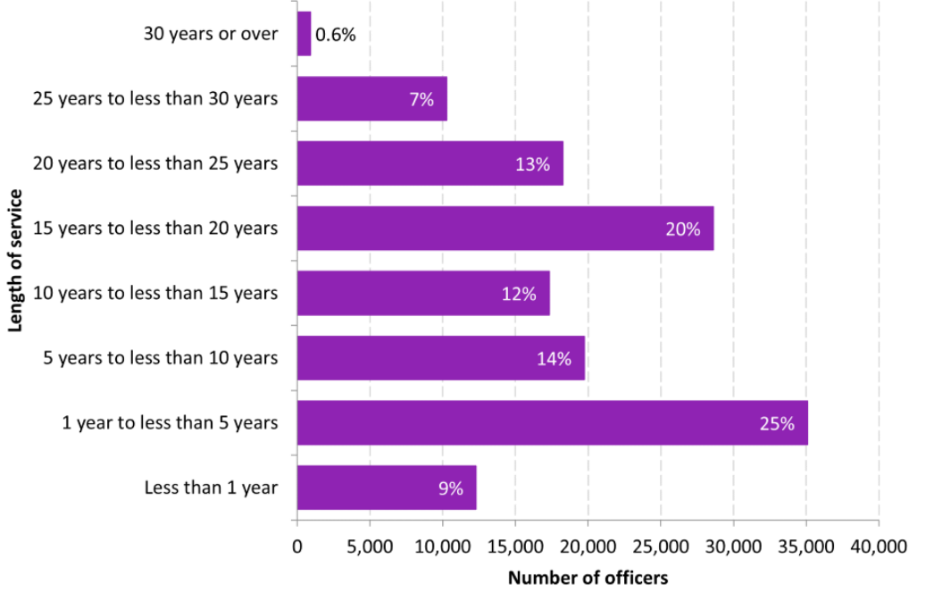
FIGURE 4 – UK Police Workforce Experience
(3.12) One crucial factor in public trust is the extent to which police forces reflect the communities they serve. Today’s police forces are far more diverse than in the past and almost all forces (including GMP) have a workplace diversity and inclusion policy. However, diversity goes beyond issues such as ethnicity and gender and having the right policies. Leaders also need to embrace talent from different educational backgrounds and with different lifestyles, and capitalize on the breadth of ideas, experience, and knowledge this talent can offer. Encouraging a culture of experimentation will be important to be successful in a digital age. This means initiatives such as Police Now, a U.K.-based project that aims to engage with local communities to attract a more diverse group of future police leaders, and direct-entry schemes that enable workers with external experience to join the police at higher ranks.
(3.13) The force has set its recruitment priorities to improve the diversity of its workforce and better reflect the community it serves. It has proactively sought to attract applications from under-represented groups. For the year ending 31 March 2021, the proportion of police officers joining GMP from Black, Asian and other minority ethnic (BAME) backgrounds was slightly higher than the proportion of BAME individuals in the force area (16.8% of those who stated their ethnicity, compared to 16.2% of GM). Should this positive recruitment rate continue, it will increase the force’s total proportion of police officers from BAME backgrounds, which was 9.3 percent as of 31 March 2021.
Fire
(3.14) From 2011 to 2020, the total number of firefighters in the UK went down from around 43,000 to around 35,000. The absolute number of staff leaving FRSs each year has fluctuated between around 3,500 and 4,640 since data become available in 2009 to 2010. In 2021 to 2022, 4,640 staff left FRSs, the largest number in the time series, and a 32% increase on the previous year. This follows two successive years of decreases in the number of leavers - down from 4,294 in 2018 to 2019 to 4,194 in 2019 to 2020 (a 2% decrease) to 3,522 in 2020 to 2021 (a 16% decrease).
(3.15) Since 2010 to 2011, the proportion of FRS staff that left FRSs increased slowly from 7% to 10% in financial year 2018 to 2019. This proportion then decreased slightly to 9% in financial year 2019 to 2020 and again to 8% in financial year 2020 to 2021. During the financial year 2021 to 2022, the proportion of staff who left increased to 10%, the joint largest proportion in the time series.
(3.16) The proportion of firefighters that left the FRSs has followed a similar trend to the proportion of all staff that left. During the financial year 2021 to 2022, the proportion of firefighters who left increased to ten per cent, the largest proportion in the time series. The reason for staff leaving FRSs in 2021 to 2022 varied by staff role. For full-time firefighters, the most common reason was retirement, which accounted for 65% of leavers, as in most of the last five years. However, retirement accounted for 13% of on-call firefighter leavers, 22% of fire control leavers and 17% of support staff leavers.
(3.17) Regarding reflecting the communities in which the Emergency Services operate, the fire service has seen a decrease over recent years in the number of firefighters in every ethnic group except the Mixed and Asian ethnic groups. In 2020, 95.6% of firefighters in England were White (out of those whose ethnicity was known). For comparison, 85.1% of working age people in England (aged 16 to 64 years) were White at the time of the 2011 Census. Overall, the percentage of fire and rescue services staff (including support staff) from Asian, Black, Mixed and Other backgrounds went up from 4.0% in 2011 to 5.0% in 2020.
(3.18) To reduce fires and other emergencies even further, GMFRS must have a positive presence in all its communities. This involves outreach work in all of our communities to demonstrate the fire service can be a career choice for all, regardless of gender, age, race, religion or sexuality. The Service must be able to understand the specific risks in different communities and implement the most effective ways to promote safety advice and guidance to them. The threats facing our region can be complex and this requires a modern, agile and progressive service. Creating a more representative workforce will provide huge benefits for fire and rescue services. This includes greater access to talent and different ways of thinking, and improved understanding of and engagement with their local communities.
(3.19) Improving the diversity of new recruits is the first step, but it is essential it’s in a culture in which a diverse workforce want to stay and progress. The number of women in uniformed leadership roles is particularly low and must be improved. Improving the culture of the Service is vital for the wellbeing and development of staff and GMFRS are working hard to make it better. The Service has appointed an EDI Manager to implement the EDI Strategy and ensure it is effectively embedded. Champions have been created to oversee and promote EDI activity across the Service. Established staff networks currently include the Rainbow Staff Network, and networks for women; ethnically diverse staff members; and people with disabilities. Each network is championed by a member of the senior leadership team. A Reverse Mentoring Programme with senior leaders aims to create a meaningful understanding of the lived experience of employees from different protected groups. Online training to include specific packages on a wider range of EDI topics such inclusive language, allyship, and race bias has also been refreshed. The service carries out positive action initiatives (such as taster days) to promote roles throughout the service.
- 8.2% (2,862) of firefighters employed by FRAs were women compared with 7.5 % (2,644) in the previous year and 5.2% (1,833) five years ago.
- 5.0% (1,582) of firefighters employed by FRAs who stated their ethnicity were from an ethnic minority, compared with 4.7% (1,517) in the previous year and 3.9 % (1,255) five years ago.
- The average age of firefighters employed by FRAs was 41 compared with 42 five years ago.
- Of those who stated their sexual orientation, 3.9% (872) of firefighters employed by FRAs were lesbian/gay or bisexual, compared with 3.4% (750) in the previous year and 2.6 % (451) five years ago.

Ambulance Service
(3.20) Emergency ambulance crews now typically comprise an emergency care assistant and a paramedic. All crews are required to train to a very high level, which enables them to deal with any aspect of emergency care, from minor injuries to cardiac arrest, or multiple casualties sustained in serious road accidents. Emergency ambulances carry a wide range of equipment including intravenous drips, drugs, oxygen and heart defibrillators. There are more than 300 roles within the service – these include.
- Paramedics provide top quality clinical care when responding to patients in emergency incidents. To be a paramedic, you have to be registered with the Health Care Professions Council (HCPC). To be eligible, you'll need a Paramedic bachelor’s degree.
- Advanced paramedics offer a high level of clinical skills and leadership to help patients and support colleagues over and above Paramedics.
- Ambulance care assistant (PTS) support and care for those who need help getting to and from healthcare appointments.
- Senior Paramedic Team Leaders are often the first role with management responsibility, and are the first step on a clinical career ladder.
- Consultant paramedics are highly specialist paramedics who have a very high level of clinical knowledge and skill, often in a core area or subject such as research or education.
- Clinical Hub include nurses, paramedics, pharmacists and mental health nurses are all part of the team.
- Corporate and Support Roles include: Emergency medical advisor (EMA) 999 call handlers are the first point of contact for patients who've found themselves in an emergency situation: MERIT doctors provide advanced medical advice in the event of a mass casualty or major incident in the North West: NHS 111 clinical advisors are responsible for the assessment of the health and clinical needs of a 111 patient.

(3.21) The number of ambulance staff in the UK peaked in November 2018 to reach a total of 21,271 full-time equivalent employees. However, dropped significantly in the following year. Before the COVID-19 pandemic, there were almost 2,000 vacancies across the ambulance sector. The vacancy rate varied between regions, with some areas as high as 10.8% and other areas as low as 0.5%. The interim people plan projected the need for an additional 2,500 paramedics by 2023, but no additional funding was attached to realise this figure. The sector has serious concerns that this figure is insufficient to cover anything more than attrition, nor does it account for the increasing role that paramedics are expected to play within the primary care settings.
(3.22) This concern has grown in the wake of the pandemic, with some ambulance trust leaders reporting that staff are leaving their organisations due to burnout, early retirement, or other effects from working in the pandemic. All staff spoken to report feeling pressures, including those working in emergency operations centres, who are daily facing very visible demand challenges, and delayed responses.
(3.23) Retention of all staff remains a huge challenge, with recruitment also necessary to meet increasing demand and tackle the care backlog resulting from the pandemic. The recruitment programme over 2021/22 was extensive with 241 FTE new frontline staff being recruited and trained between 1 April 2021 and 31 March 2022. Unfortunately, over the past 10 months a rise in attrition rates, particularly in the health advisor skill set, has further increased the need to recruit and train new staff. A fully costed and funded workforce plan is vital to addressing this, but in the interim, ambulance services have been adapting the way they work to begin meeting these challenges.
(3.24) Other large retention challenges are in call centre environments and the projected risks to the NWAS Paramedic workforce mentioned above, arising from the GP contract reform in 2021. NWAS has comprehensive action plans for its call centres focusing on 3 key areas: improving onboarding; supporting career development and early intervention to encourage staff to stay and improving exit intelligence. The plans are focusing on improving the recruitment process to ensure we are attracting the right candidates; reviewing the support offered to staff in post and improving the health and wellbeing offer.

Case study: Ambulance Academy
The Ambulance Academy contains everything the younger generations of our society need to know about careers in the ambulance service, being healthy, learning lifesaving skills and staying safe in three handy sections:
It includes a Children’s area (4-10 year-olds) with lots of information and activities for the youngest members of our communities, from what to do when somebody is hurt, and they need our help to how to stay safe.
Also a Young adult’s area (11-18 year-olds) with all the information in this section they will need to start planning their careers in the ambulance service and what options they may want to start thinking about in school.
Finally an Adult’s area (educators/parents/carers) is designed to be helpful to our region’s teachers, parents, guardians or carers as they are our main influencers for educating our children on the ambulance service

(3.25) As required within the NHS contract, NWAS published the Workforce Race Equality Standard (WRES) data during the summer of 2021. Overall the WRES showed a mixed picture of results with some positive improvements in staff experience and representation but some areas for continued focus in recruitment, disciplinary processes and training. The data shows an increase in the number and representation of BAME staff within NWAS from 304 to 342 staff, which is a shift from 4.6%. to 5.4%. There is a higher BAME 2021/22 representation in clinical roles than non-clinical. The Trust continues to seek to increase the overall BAME representation and as detailed in ED&I Priorities action plan.
(3.26) The same report also showed that the Gender Pay Gap in the hourly rate of pay between male and female staff reduced from 10.89% March 2021 to 9.8% in March 2022 (using the average calculation) and from 9.2% to 8.6% using the median calculation. The average hourly rate for male and for female staff increased during the same period. Progression into the highest paid roles is also dependent on vacancies created through the year which require recruitment and this impacts on the ability to close the gender pay gap.
(3.27) The number of disabled staff within NWAS has increased by 62 individual staff to 314, which now represents 4.63% of the overall workforce by the end of March 2022. For the second year, the trust was required to publish the Workforce Disability Equality Standard (WDES) data, in line with NHS contract commitments. The data did highlight some differences in staff and candidate experience between staff who have a disability and staff who do not. An action plan to address this had been developed and published. The Disability Network launched in December 2021 continues to develop and has clear links to improving staff experience for the future.
(3.28) A recent NWAS staff survey showed a clear disparity in the experiences of some staff from diverse groups, particularly those from BAME and disabled backgrounds, and this is seen in their experiences of bullying and harassment, discrimination and their views of the fairness of career progression opportunities. This shows more drive is required to create a full inclusive environment for NWAS staff.
(3.29) There also remain challenges in the diversity of their workforce representation. Again positive progress is being made in improving levels of representation from diverse groups, but more must be done – particularly in management positions where representation is low. Evidence shows that diversity in leadership is associated with more patient centred care, greater innovation, higher staff morale and access to a wider talent pool and to deliver the ambitions of this strategy we need to ensure that we can deliver leadership diversity.

Skills Demand
(4.1) All three of the emergency services face different scales of skills gaps. It is important to understand the difference between a skills gap and a labour gap. Skills gaps (“proportion of the workforce that were considered to be lacking in full proficiency”) can manifest as an underqualified workforce, with outdated or inappropriate skillsets. It can be caused by a lack of provision, lack of incentive to upskill or retrain, or an unclear qualification picture. In short – a mismatch between existing skills and required skills. Labour gaps tend to manifest as fewer applications for entry level roles.
(4.2) Stakeholders in the emergency services feel that there isn’t a labour gap as such; positions tend to be oversubscribed and the public have good awareness of the jobs available. Career paths are promoted and recruitment campaigns are generally effective. There are however skill gaps and ongoing challenges to keep the workforce upskilled, particularly with changing social factors. An ageing population with people living longer with more health conditions; a shift towards cyber and ‘white collar’ crime and moves towards electrical vehicles and potential increased fire risk are just some aspects of a changing society.

All Emergency Services
(4.3) All services felt that as part of their improved community service it would be beneficial for their staff to have the skills to communicate more diversely. This includes staff being multi-lingual but also those with Basic Sign Language Skills.
(4.4) Emergency Service staff work in challenging environments and also face difficult personal pressures during the employee lifecycle. Engaging and supporting staff to face those challenges and to provide a holistic approach to supporting their wellbeing is crucial to ensure staff can provide the best possible service within GM. Staff can experience unacceptable violence and aggression when carrying out their role. A number of initiatives have been introduced over the last 12 months to support wellbeing. Those that are deemed positive should be used more widely across GM.
(4.5) Digital transformation remains a key enabler to emergency service improvement. New digital ways of working can improve clinical outcomes, crime response, resident safety, the user experience of both patients and staff, and staff engagement more broadly. Digital transformation, and the more effective use of data, also underpins the integration agenda and cross-organisational working which is desired in GM.

Police
(4.6) In a time of rapid change, police agencies will need to develop a more agile workforce and rely on an increasingly expanded ecosystem of partners. Police forces already work with a wide range of partners. Future demands and the changing nature of crime will see existing partnerships deepen and new, non-traditional connections formed with a broad spectrum of organizations from the public, private and third sectors. These could range from partnering with banks to develop joint apprenticeships on financial crime to working with international charities on cross-border issues. The future police workforce may become increasingly involved with other public agencies—health and mental health services, for instance.
(4.7) The Police Federation of England and Wales (PFEW) has called for forces to focus more on proactively supporting their workforce before they reach breaking point. In 2020, more than three quarters of police officers told a survey they were experiencing mental health or wellbeing challenges – 74% were aware of force-provided reactive support services for mental health and wellbeing, but less than half were aware of proactive support services offered.
(4.8) PFEW believes forces should monitor the number of traumatic incidents individual officers have attended to make informed operational decisions on where to deploy them. A Police Traumatic Event Checklist is currently being developed by PFEW and Police Care UK, in conjunction with Cambridge University. More than 1500 officers’ and staff's worst reported incidents on the job were coded to create a system to identify and manage trauma. Over 90% of serving officers and staff report exposure to such events and one in five police officers currently have either Post Traumatic Stress Disorder (PTSD) or Complex Post Traumatic Stress Disorder. Currently, however, there is no gold standard by which trauma exposure is measured in UK policing.
(4.9) Provisions have improved across forces and there is some positive work taking place around mental health and wellbeing, they acknowledged, citing all forces currently have telephone counselling in place, however there is no consistency across the 43 forces with some officers receiving better care than others. High levels of workload, with overtime regularly used to manage demand, mean that the workforce is often fatigued. This also affects the work-life balance of the workforce. Not having resources in the right place to manage demand and not providing the tools to support the productivity of its workforce creates frustrations.
(4.10) Leadership skills for frontline supervision are important – GMP wish to upskill staff to understand and be authoritative practitioners in maximising the productivity and capability of staff and dealing swiftly with poor performance. In addition these staff should have some integrated training which looks to blend leadership training with problem solving and evidence based policing with performance management skills so they know how to interpret crime data to maximise the impact their teams can have on Neighbourhood problems.
(4.11) GMP have an established aim for a culture in which individuals and teams understand what performance management is, and understanding what skills are needed to monitor, review, and improve performance in alignment with the organisation. They highlighted this as a skills gap where staff need to:
- Know what performance management is and how it is relevant to GMP
- Understand the importance of good practice and how to embed it within performance management.
- Recognise how statistical analysis can help in performance management.
- Understand how to create effective data visualisations, including graphs and charts.
- Comprehend analysis of trends and how they are affected by seasonality.
- Realise common pitfalls in performance management and how to counter them.
- Identify barriers to effective performance and how to resolve them.
- Identify the knowledge and skills required for performing a job efficiently.
(4.12) Some stakeholders mentioned a skills need for Response and Neighbourhood PCs and Detective Constables around Civil Orders. They need to have a good awareness as it would feed into the daily business and investigations for the officers. Specific needs include having a clear overview of the type of order and when they would be suitable, which would include the processes to be undertaken, considerations as to evidence and how that would be fed into the application. One desired outcome would be Neighbourhood Policing Training with staff training in the Skills for Justice Level 3 qualification in Understanding Neighbourhood Management. This would:
- Professionalise Neighbourhood Policing
- Develop a corporate approach to Neighbourhood Policing
- Demonstrate the value of NPT officers and address the current lack of formal training and opportunities for continued professional development
- Showcase Neighbourhood Policing as a specialism
- Improve the quality and consistency of community engagement, problem solving and early targeted action

Fire Service
(4.13) Within GMFRS, a significant range of wellbeing support is available to support both physical and mental health, including occupational health services and trauma risk management practitioners. During a 2021 inspection, staff said that they had positive experiences of the current wellbeing support. 92% of respondents to a staff survey (285 of 307) said that they have had a conversation about their health and wellbeing with their manager.
(4.14) GMFRS has a statutory responsibility set out in the Fire and Rescue National Framework, to ensure it understand the risks facing our communities and constantly evolves to respond to these effectively. The Framework recognises challenges such as the continuing threat of terrorism, the impact of climate changes and the impacts of an ageing population. The GMFRS have introduced their first Annual Strategic Assessment of Risk (SAOR) to address this by identifying and assessing all the risks and challenges across the city-region and developing plans to mitigate them.
(4.15) GMFRS have embraced modern technology and procedures to do things quicker, safer, with less people and with less impact on the environment. Recent investments in future firefighting equipment and procedures include; Ultra-High-Pressure Lance on fire appliances, Thermal scanning cameras, Layered PPE and Air Units. GM’s future firefighting capability inclusive of new technologies, new vehicles and water provision is undertaken by an Operational Equipment and Technical Team who ensure that they are providing the right equipment in the right place, to deal with incidents in a safe and effective manner

Ambulance
(4.16) NWAS have highlighted skills development within their strategy and are keen to improve upskilling within the workforce and retention. Priorities include:
- Delivering upskilling of the Paramedic workforce, enabling the ongoing development of clinical practice and supporting improved levels of See and Treat and Hear and Treat.
- Meeting the needs of new and emerging roles by developing infrastructure to support development pathways, designing appropriate training interventions and working with partners to develop appropriate educational frameworks.
- Improving the use of technology to enhance training delivery, simulation and continuing professional development.
- Improving available support for staff by providing a suite of flexible working options that can be discussed and tailored to staff, based on their role and individual needs.
- Continuing to improve staff survey response rates and outcomes, using the data to proactively improve the Trust health and wellbeing offering. Key improvement goals.
(4.17) With rising rates in the population, stakeholders said that it was important to increase mental health expertise within the workforce. The long-term plan made commitments to build the capability of ambulance staff to respond to patients presenting with mental health issues. If adequately resourced, this should help to increase capacity in the system. People with mental ill health are more likely to use emergency care than those without and 46% of people with a mental health condition also have a long-term physical health condition. Given the reciprocal nature of this link, improvements made to mental health provision often improve patients’ physical wellbeing, and vice versa.
(4.18) Resilience is also critical for ambulance staff. Causes of stress highlighted include tight targets, long hours, and physical demands. Stress and anxiety are the greatest cause for sickness absence across all staff groups in the NHS at 25.3% but attributed as the reason for absence in 28% of ambulance workers. Ambulance staff have also been found to have the highest sickness absences of all NHS staff groups. Certain staff groups appear more vulnerable to burnout: male clinicians, lone responders, those aged under 34 years and people who have been in the same job for over 6 years.
(4.19) NWAS have worked with Manchester Stress Institute to develop two bespoke support programmes for their workforce - a six-week staff programme and a four-week 1:1 managers’ programme. These support programmes cover a range of interventions to improve management of stress and build resilience, raise awareness of nutrition, sleep, and fitness, and empower staff to support themselves long term. The feedback received from those who have participated in the programmes has been extremely positive. Employees have reported that their sleep, resilience, and nutrition have significantly improved during the course of the programme.
(4.20) Speaking to stakeholders within the sector, other skill gaps which emerged included:
- Staff with Information, Advice and Guidance (IAG) skills. NWAS have indicated they would like skilled employees able to provide high quality, impartial, information, advice and guidance which will promote the value of learning to other members of the workforce. Those in workforce development/ HR roles would especially benefit.
- Skills to work with and support individuals in the workplace with learning difficulties.

Digital Skills
(4.21) As technology drives significant changes in the workforce, it will be crucial to blend soft human skills with digital skills. They are required across all 3 of the emergency services and came up frequently in conversations with stakeholders across the sector. Predictive analytics technologies, for instance, will have a valuable role to play in helping the police to prevent more crime in the future, but acting on the insight from these tools and developing the appropriate response will require a more nuanced set of skills. Intervening officers need to have empathy, good communication and negotiating skills, and the ethical training to determine what is an appropriate and proportional intervention. Sharing data effectively can mean better service coordination and population health management, a reduction in avoidable waits and better response times across all three services. It is critical that the workforce has the digital confidence and skills for this to be effective.
(4.22) The response to COVID-19 accelerated these digital ways of working. Better sharing of medical records between ambulance trusts and other health and care organisations has improved and quickened clinical decision making. Collaboration between ambulance services and secondary care providers enabled paramedics to provide care to COVID-19 patients remotely, reducing unnecessary admissions and virus transmissions. New innovative ways of working, such as 111 First, were rolled out nationally and supported by cloud-based digital software to ensure seamless clinical handover for patients who needed to visit Emergency Departments.
(4.23) The ambulance service has traditionally been at the forefront of digital developments in the Emergency Services. The nature of ambulance provision – 24/7 care that is delivered as a responsive, connected service – has meant that many ambulance trusts have long placed digital at the heart of their long-term strategies. Long before the pandemic, service delivery often involved remote care, with ambulance staff equipped with the digital skills and technology to carry out their jobs. This was acknowledged in the Carter review, which noted that the adoption of new digital technologies has been a key driver for reducing conveyance rates to hospitals
(4.24) NHS England’s Global Digital Exemplar (GDE) programme has been instrumental in driving some of these initiatives. Examples of new digital practice include establishing live-link video capability with care homes, automating processes related to ambulance dispatch, developing a simulator to be able to model impacts of planned system changes, and streamlining the way ambulance systems digitally pass patient information to hospital and urgent care systems. Understanding how to use these systems is increasingly important to the role.
(4.25) Police forces need to develop new mindsets, skills, and ways of working to maximise their benefits from the digital revolution. The nature of crime means that much of it is now global, borderless and online which means the skills used to catch criminals must also change. For example, Artificial Intelligence can be used to analyse and review large volumes of case data with much greater speed and accuracy than traditional approaches. When this is augmented with analytics tools, there is also the potential for intelligence such as identifying crime hotspots, connecting crimes, and linking associated offenders.
(4.26) Recent research suggests that three-quarters of police professionals expect digital skills to be required over the next three to five years. Most do not fear this: 67% of respondents are motivated to remain in the profession, and this rises to 75% among those who are eager to embrace new digital skills. 76% of police professionals predict that digital skills will be more in demand over the next three to five years, but 60% say there will be a need for more communication and collaboration skills and 53% a need for even “softer” skills, such as empathy, negotiation, and creativity.
(4.27) GMP have committed to providing officers and staff with the digital tools they need. This means a workforce that is digitally enabled, by default, with technology that seeks to replicate the intuitiveness of consumer experiences - increasing their situational awareness and ability to make informed decisions. The force has said it will establish specialist digital service hubs and cross-force networks, with the capability to tackle the most tech-dependent and enabled crimes. It wants to establish new digitally enabled, dynamic workforce models. This means GMP will have more flexible workforce models, allowing us to attract more talent, offer flexible career routes to retain talent, and even temporarily source individuals when surge capacity is needed. It wishes to use digital technologies to have a more accurate and dynamic picture of ‘demand and supply’ to inform deployment decisions.
(4.28) For GMFRS digital solutions may solve some long-term issues. GMFRS does not have the resources to visit every household in Greater Manchester to undertake fire risk assessments. It is vital, therefore, that the Service improves how it targets its home safety visits to the most vulnerable, those most likely to experience a fire. To do this GMFRS needs to develop a clear and accurate understanding of where the most vulnerable residents are. This requires analysis of a range of different information. Local partners in Health and councils also collect their own data on vulnerable residents. It is important the Service improves how it uses this community intelligence and ensures referral processes are as effective as possible. The development of online tools and telephone risk assessments for less vulnerable residents will free up resources to focus on those residents that need face to face visits the most, but this will shift the skillsets needed among GMFRS staff.
(4.29) Digital technology in the fire service covers far more than computers and software and can improve firefighter safety and readiness. Innovative technology has always been an important part of firefighting. From Personal Protective Equipment to fire pumps to radio communication systems, firefighting technology advances all work together to improve firefighter safety and effectiveness. Implementing new firefighter tools may require adjustments to training and operating procedures and can be expensive so it’s important that firefighters are upskilled regularly. For example, drones in the fire service can also be used for search and rescue operations since they can quickly search large areas. They may even be able to deliver food, water, or first aid kits to places firefighters can’t reach.
GM Blue Light collaboration and more flexible working.
(4.30) When speaking to stakeholders from each of the emergency services it is apparent that there is a desire to continue the collaboration and more flexible working. Within the NHS, the long-term plan set out the need for greater workforce flexibility and was followed by the Interim NHS People Plan’s focus on expanding the workforce and ensuring adaptivity and a more varied skill mix. The interim plan talked of moving to a model where teams of professionals from different disciplines work together to provide more joined-up care, stating that this multidisciplinary approach “will become the norm in all healthcare settings over the next five years”.
(4.31) The need for multidisciplinary approaches to workforce is increasingly clear from the more flexible career paths that NHS staff are choosing, and the increase in cross-organisational working. Ambulance trusts increasingly employ multiple professions across their frontline roles including nurse practitioners and mental health nurses. The rotational working model used by many ambulance trusts positive impact on patient experience, workforce retention and reducing hospital conveyance rates. Here, specialist and advanced paramedic practitioners rotate between clinical settings across systems, using their advanced clinical assessment skills to help provide the right response the first time.
(4.32) In a good example of interdisciplinary emergency response, GMFRS was the first fire and rescue service to mobilise all its firefighters to cardiac arrests in support of the ambulance service. The initiative was subsequently undertaken across the country. There are other areas where GMFRS could provide further support to the Ambulance and Police services, including gaining access for paramedics at ‘concern for welfare’ incidents and searches for missing persons. GMFRS has a statutory duty to collaborate with other blue light services and there are opportunities to explore regarding the sharing of estates, procurement, training, development and service delivery.

Skills Provision
(5.1) Given the established nature of many emergency services professions and organisations, there is a strong existing base of skills provision in Greater Manchester. This section covers some of the elements of the existing skills system which support residents to train and upskill in Emergency Services careers.

Schools
(5.2) While schools don’t deliver any direct provision for emergency services professions, it is commonly thought that many young people aspire to roles within the sector. The Greater Manchester Apprenticeships and Careers Service (GMACS) system tracks the “desired” career pathways among schoolchildren across the city region. All 3 Emergency Services feature in the Top 100 most popular, with Detective 22nd, Police Officer 23rd, Firefighter 78th, and Paramedic 81st. The sector benefits from having very “visible” occupations with obvious roles and duties, which children learn about from an early age.

Apprenticeships
(5.3) Since the Apprenticeships reforms in 2017, the three main Emergency Services organisations became Levy-Payers (contributing 0.5% of payroll costs over £3m to a fund which can only be used for apprenticeships). In parallel, pathways were developed to serve the sector. GMFRS received its first apprenticeship contract in May 2017 and teaches standards-based apprenticeships through the employer levy. At the time of the inspection, 195 apprentices were studying operational firefighting at level 3. Apprentices complete a 16-week basic firefighting training programme at the fire and rescue training centres before they are posted to their watch at one of the 41 fire stations located across Greater Manchester. Greater Manchester Fire and Rescue Service was praised by Ofsted in the first full inspection of its firefighter apprenticeship programme and rated as ‘Good’ in overall effectiveness as an Apprenticeship Employer-Provider. An example Firefighter apprenticeship route is shown below:

(5.4) NWAS continues to train their EMT1 workforce through an apprenticeship delivery model. In 2021, the trust was recognised by the National Apprenticeship Service as their Macro Employer of the Year for the North West region and were highly commended at the National Final of the Healthcare People Management awards. In September 2021, a modular delivery model was implemented to ensure baseline, generic, knowledge to practice was delivered. This ensured that knowledge gained during the three modules matched exposure to practice and would encourage more inquisitive learners. NWAS’s paramedic apprenticeship programme commenced in 2021 and a further 95 EMT1s commenced on their paramedic pathway in 2021/22, with a total of 176 EMT1s on this apprenticeship pathway. A further 76 EMT1s are profiled to commence their paramedic journey in April and October 2022. The trust continues to support Advanced Clinical Practice (ACP) Apprenticeship programmes, with 13 clinical practitioners active on programmes.
(5.5) For all of the Emergency Services, effective longer-term planning in coordination with the education sector is essential. This includes ensuring there are sufficient paramedic training places in universities and supported placements within the Emergency Care system during training. Since May 2017 NWAS has recruited more than 400 staff through apprenticeships offered throughout the service. Their latest Ofsted inspection said that the apprenticeship programmes were rated as good. An example paramedic route is shown:

(5.6) There are now two routes into policing with a national policy change meaning that from 2020, new officers are supposed to either hold a degree – in policing or another subject – or undertake a three-year degree apprenticeship course at the start of their career. Greater Manchester Police introduced the Police Education Qualifications Framework (PEQF) in November 2021. In collaboration with the University of Salford and the University of Central Lancashire, GMP implemented two new victim-centred student officer learning programmes: one for degree holders and a second degree apprenticeship pathway
- Degree Holder Entry Programme (DHEP) – A two-year training programme for graduates resulting in a graduate diploma in Professional Policing Practice and a role as a qualified police officer upon successful completion of the course.
- Police Constable Degree Apprenticeship (PCDA) – A three-year apprenticeship resulting in a BSc (Hons) in Professional Policing and a role as a qualified police constable upon successful completion of the course.
- There is then a four-step promotion process for police officers seeking promotion to the rank of sergeant or inspector. This includes a full examination of law and procedure.
(5.7) Within GMP there are a range of entry level Business Admin and Customer Service Apprentices who perform a vital role within Greater Manchester Police, providing administrative support to members of the public, colleagues and partners. Aspiring Police Officers can complete a Police Constable Degree Apprenticeship that focuses on practical learning and is specifically tailored to help start a career in policing. It is a three-year apprenticeship programme for non-degree holders resulting in a BSc degree in Professional Policing Practice.

(5.8) There are many other jobs within the police and the force requires a multi-disciplinary team. Policing is not simply a job for police officers. For example Police Community Support Officers (PCSOs) were introduced following the passing of the Police Reform Act 2002. Also vitally important is the contact management team at GMP whom respond to 2 million calls for help annually. There are a number of roles here including those in call handling, crime recording and resolution, the customer enquiry team and dispatch.

Higher Education
(5.9) Generally, workers in Emergency Services can come from a range of backgrounds – few roles require specific degrees. Areas like Psychology, Sociology, and Criminology are common routes for students interested in roles in law enforcement. GM’s universities offer Criminology degrees, with programmes at Manchester Metropolitan University, the University of Salford, and the University of Manchester (which is ranked 1st in the country for the subject). The University of Bolton also offers a more specific degree in Criminological and Forensic Psychology.
(5.10) Paramedics often require a background in health or biology, with generalist courses available at most universities. The University of Bolton deliver a good example of an occupational specific degree which is linked to the Emergency Services. Offered in partnership with the North West Ambulance Service (NWAS) NHS Trust, the University of Bolton’s BSc (Hons) Paramedic Science degree offers the knowledge and skills necessary to be eligible to apply for registration with the Health and Care Professions Council (HCPC) as a Paramedic.

T Levels
(5.11) T levels in health are a potential route into careers with the ambulance service. This academic year in GM, there are around 150 learners across Health and Science. The vast majority are Health circa - 140. That number is subject to change as some may drop off and a couple of colleges have not supplied data as yet. Currently there is not an obvious route from T Levels into the Police or Fire Services.

Summary
(6.1) This section aims to collate the learnings and challenges for meeting the skills needs in the Emergency Services. Given at the Executive Summary at the start of this report, the recommendations are for a range of stakeholders, including employers in GMP, GMFRS and NWAS.

Deciding on careers in the emergency services

(6.2) It’s important to consider the main challenges for individuals and employers at the early stage of the talent pipeline. The main issues facing the sector at this level are:
- The reputation of the sector among young people, parents, and teachers is generally good. All the services have strong brands and first responders are among the most-trusted professions. There are a number of different youth engagement programmes including the Prince’s Trust, Fire, and Police Cadet schemes. These programmes have different aims, including reducing anti-social behaviour, increasing young people’s understanding of risk, developing life and work skills, and familiarising young people with emergency services work
- Stakeholders in the sector have an impression that people make a deliberate decision to work for the emergency services – it’s difficult to drift in – and many recruits have followed a clear career pathway from school onwards.
- There is a real desire to recruit a more diverse workforce and several positive action strategies taking place. In particular, the sector would benefit from more representative role models.
- Paramedics and Police Officer positions require a degree and it is difficult to be promoted to these positions internally or without the qualification. Fire fighter apprenticeships do not require a degree but from submitting your expression of interest, it can take around six months to complete all the steps and receive a job offer.
- There may be other requirements for roles in this sector including a minimum fitness level, enhanced DBS check, and a thorough medical.

Seeking Training

(6.3) The education provision market generally meets the needs of employers. Whilst entry requirements have changed in recent years, apprenticeships are now well embedded in the sector.
- Across GM, there is a good number of starts on apprenticeships within all emergency services, and programmes have well established trainers and partners. Seeking external training is rare for many positions.
- During lockdown some training was delivered virtually. Whist effective, stakeholders stated that they preferred blended or face-to-face learning.
- All the services include mandatory training that requires regular updating. Provision for this is strong and well established.
Effective training
(6.4) Training is generally good and well established for the emergency services but must remain up to date with wider societal trends.
- Emergency services are subject to frequent political change. Training must also reflect wider changes such as increased cyber-crime or health issues from an ageing population.
- Employers recognise the value of formal skills training, soft skills such as being able to communicate with residents are highly valued.
- The sector is changing, with far greater digitalisation throughout, meaning staff at all levels need increased digital skills.
- There should be opportunities to learn more flexibly to appeal to a broader demographic.
- Apprenticeships should be promoted as attractive ways of entering the sector and the range of different routes should be made clearer, particularly to those from more diverse communities.

Seeking a job
(6.5) The Emergency Services job market is generally clear from a candidate perspective – there are a good number of opportunities and the services recruit directly from their websites. Each follows a consistent and well-established application process.
- The job market is competitive and many positions are oversubscribed. There have been occasions when the services have stopped recruiting locally for certain positions.
- There is some disagreement about whether roles such as Police Officer should require a degree. Whilst some stakeholders felt this ensured quality, others suggested that life experience was more important than academic qualifications. The requirement can make it hard for some career switchers to join the force.
- The need for Maths and English qualifications can be a barrier for some people to access apprenticeships and join the sector.
- Recruitment strategies should reflect the chance to make a difference and be aimed at people with the correct personal values. Organisation implemented values-based recruitment and standards of behaviour in employment have been shown to be effective in getting the right people.
- Where possible recruitment processes and preemployment checks should be streamlined to maintain quality and assurance while moving at pace to improve the candidate experience.

Remaining with employer
(6.6) Retention is an issue across the sector with burnout, long hours, and general wellbeing all factors in employees leaving.
- Support should be provided to employees beyond induction, for example for the first two to three years post-qualifying of joining the organisation. For example, newly qualified employees would benefit from mentoring or pastoral support
- Employers should promote role models – particularly from diverse backgrounds – that may make workers more likely to stay in the sector and attract new and more diverse talent to the services.
- Employers should be encouraged to adhere to the GM Good Employment Charter, with particular reference for entry level positions.
- There should also be career progression opportunities for those wishing to develop including for those without a degree.

Next Report
(7.1) As well as serving the public, emergency services increasingly need to meet the demands of a complex workforce and be prepared to respond to challenging external drivers of change. These drivers will be instrumental in shaping the workforce of the future and will require a strategic approach. Intelligence gathering will be an ongoing activity for GMCA and partner stakeholders. The data and intelligence gathered as part of this report will be enhanced and updated and a revised version of the report released. This should include close consideration of:
- Political events affecting employers and the workforce such as a change in government, new policy development/legislation, and the legacy of Brexit and the COVID-19 Pandemic.
- Recessions usually lead to an increase in crime and increased pressure on emergency services. Currently though, crime rates in the UK are falling which is thought to be due to a multitude of factors. Targeted intervention, high prison population numbers, and socio-economic factors (more people at home/ perhaps less high value items) may be contributory factors. As the financial situation develops, intelligence must be updated.
- Social imperatives relevant to a significant proportion of the workforce such as an ageing population, work/life balance, mental health, and demographics.
- Any advances or changing use of technology that might impact the workforce such as online learning, innovation, digitisation, and artificial intelligence.
- New legislation affecting employers such as employment law, increased regulation, continued implications of withdrawal from the EU.
- Environmental pressures such as recycling, globalisation, the ‘green’ economy, sustainability, and carbon neutrality.

BT data
PEEL inspection of GMP 2022
GMP most improved in the country
Fire and Rescue Services Act 2004
Fire Plan - GMFRS
HMICFRS (justiceinspectorates.gov.uk)
Equality, Diversity and Inclusion - Greater Manchester Fire Rescue Service
CQC 2014
CQC 2018
NHS England
Office for National Statistics
UK police spending
UK police spending
Fire and rescue workforce
NHS England target times
Justice inspectorates GMP
Justice inspectorates GMP
Police workforce, England and Wales: 31 March 2022
GMP Workforce
GMFRS workforce
Fire and rescue workforce
NWAS workforce
Workforce Race Equality Standard 2021/22 data
NHS Staff Survey
Police officers facing mental health crisis
Police officers’ wellbeing
Strategic Assessment of Risk
NWAS staff digital wellbeing programme
NHS 111 First
Global Digital Exemplar programme
Digital policing (npcc.police.uk)
Interim NHS people plan
Ofsted NWAS inspection
Force Contact Centre

