

Towards an Integrated Technical Education, Skills and Work City-Region:
Starting the Conversation

March 2024

Contents

Contents 2
Foreword by Andy Burnham, Mayor of Greater Manchester 3
Towards an Integrated Technical Education, Skills & Work City-Region: Starting the Conversation 5
1 The Case for Change 5
2 Technical education, skills and work and the Greater Manchester economy 8
3 Which qualifications, jobs and sectors? 11
3.1 The five tests 12
4 Opportunities of Devolution 13
5 The Greater Manchester Baccalaureate (MBacc) 15
5.1 At age 14: MBacc, comprising core and optional GCSEs 16
5.2 At age 16: Career Gateways 17
5.3 Access to support and enrichment opportunities 18
5.4 Industry Engagement 19
6 Making technical education work: the role of employers 19
7 The future vision: towards an Integrated Technical Education, Skills and Work city-region 20
8 Join the conversation 21
Appendix: Which sectors and which jobs? Identifying the Greater Manchester sector pathways in technical education 23

Foreword

Andy Burnham, Mayor of Greater Manchester
We have a simple vision for Greater Manchester: a fairer, more equal city-region with all of our residents able to enjoy a good life. We know this cannot be achieved without giving young people the best possible start in their early years and then a clear path in life as they go through their teenage years.
We have spoken to tens of thousands of young people in Greater Manchester about their hopes and plans for the future. We heard many positive things and I never cease to be amazed at how impressive our younger citizens are in so many ways. But we also heard some challenging things too and, in particular, how hard it is for some to make their way in life.
For young people who plan to go to university, there is a clear and well-understood path laid out before them. That clarity is not available to those who want technical qualifications. For them, things are much more confusing and fragmented.
We are lucky to have five great universities in Greater Manchester and we support the idea of helping as many of our young residents to go on the university route – if that is their choice.
But are we doing enough to help those who want to pursue a work-related route? I don't think we are. Too many young people find themselves confused and discouraged when choosing their options at 14. One in four Year 10s say they do not feel in control over their future education, training and opportunities.
This paper outlines our proposals to correct this by creating two equal routes – one academic and one technical – to give a clear path to all young people in Greater Manchester, whatever their interests, ambitions and passions. That is how we will meet our ambition of good lives for all our teenagers.
For those on the technical route, we will create a Greater Manchester Baccalaureate or MBacc to sit alongside the existing English Baccalaureate or EBacc. The idea is that the MBacc will guide the two in three young people in Greater Manchester who do not go into higher education towards subjects which will maximise their chances of getting a good job in our vibrant regional economy. We will give those young people further clarity at age 16 and at 18 – mirroring the clear path guiding those on the university route.
It was as long ago as 1884 when the Royal Commission of Technical Instruction visited Manchester and subsequently reported on the failures of technical education in the UK. They warned that we were at risk of how falling behind other countries such as Germany and France. In the 139 years since, those warnings have never been properly heeded and technical education has remained the poor relation.
Greater Manchester’s new Trailblazer Devolution Deal gives us the powers, finally, to put that right and correct something Westminster has been failed to fix.
Our ideas are the start of a discussion with the Government and others about how, working together, we can move towards the vision of Greater Manchester as an integrated technical education, skills and work city-region.
I look forward to working with you on this journey.


Andy Burnham
Mayor of Greater Manchester

Towards an Integrated Technical Education, Skills & Work City-Region: Starting the Conversation

1 The Case for Change
In setting out the government’s further education reform proposals, the Skills for Jobs White Paper summarised the case for change by noting that the skills system in England has been “very efficient at producing graduates but has been less able to help people get the quality technical skills that employers want”. It went on to highlight research showing that only 4% of young people in England achieve a qualification at higher technical level by the age of 25 compared to the 33% who get a degree or above, and only 66% of working-age graduates are in high-skilled employment. This is despite research highlighting that technical courses can lead to better career and earnings outcomes for those who follow them.
Routes, application processes and the ‘currency’ of academic/university pathways with employers and parents/advisers/influencers are hardwired into the education and employment landscape and culture; for example, through UCAS as the universal point of access, and with most educators having themselves followed a university route into teaching.
The same cannot be said of technical education. While degrees offer a progression ladder, technical routes and their qualifications are a maze and are not as well understood by parents/carers, employers and even some careers/employment advisers. This means our young people cannot explore, navigate and access technical pathways with the same ease and expectation of support.
Using previous devolved adult education flexibilities, we have already begun working with colleges and training providers to place stronger emphasis on the connections between adult skills and jobs in Greater Manchester’s labour market. We want to do the same for young people – tackle systemic issues before they become barriers, offering greater clarity of purpose and ease of access
Nationally, schools are incentivised through the EBacc, a performance measure that recognises a group of qualifications at GCSE that typically lead to A levels and which are considered essential to many degrees, although it is also intended to open the door to other opportunities and encourage young people to stay in education for longer. Achieving the EBacc is dependent on securing a grade 4 or grade 5 in each of the five core subject areas.
While the Government’s ambition is to see 90% of young people with an EBacc by 2025, in 2022, just 36% of GM’s 33,250 16-year-olds left compulsory education with an EBacc. This means that, for almost two-thirds of our young people, there is no equivalent suite of qualifications that align to and support progression into technical pathways, locally valued by the businesses seeking skills and talent.
But what is the impact of this differential approach, which requires young people to make choices at ages 14, 16 and 18 from options that do not offer equal access to academic and technical routes?
First and foremost it is a barrier to informed choice. Both academic and technical routes have merit and labour market currency – this conversation is not about promoting one over the other, or revisiting outdated tropes about ‘parity of esteem’. It is simply about ensuring that there is equal clarity and understanding of the pathways and equal ease of access.
Currently, too many young people can find themselves confused and discouraged when considering their options. Some might even opt for an academic pathway almost by default, only to find later that it was not the best fit for them and their goals. Of those who go on to study a level 3 qualification (such as A-levels, T-levels or other technical qualifications), some 33.3% of 16–18 year-olds don't then progress to university. However, when looked at as a proportion of all young people who don’t progress on to higher education this figure is much higher at 64%.
Secondly, young people who already face labour market barriers are disproportionately affected. Those from disadvantaged backgrounds, for example, are less likely than their peers to attend university, despite efforts to widen participation. Technical options leading to comparable level qualifications and skilled employment, while retaining their distinctive work-related purpose and value, have an important role to play in delivering positive outcomes, social mobility, and good lives for all.
Young people with special educational needs or disabilities (SEND) also face additional barriers. The GM Disabled People’s Panel undertook a survey of disabled GM residents – the GM Big Disability Survey 2022, the largest survey of disabled people in the UK (at the time of writing) – which found that 42% of respondents felt unwelcome in mainstream education. In addition, 80% of respondents who were in work felt they did not get the same career opportunities as non-disabled people. Supported technical education pathways for young people with SEND must play a role in shifting the dial for all of our residents and making sure that there is equal access to opportunity.
Thirdly, businesses struggle to recruit. One of the issues facing employers is that the links between education, the key sectors/occupational areas in GM’s labour market, and lines of sight into those careers have not been strong enough. The language of education and that of business have never aligned. The system is rife with assumptions and differing interpretations – for example, the fact that young people have grown up in a digital world leads to misunderstandings about how far that has supported development of digital literacy for the workplace, and while there is an essential digital skills framework for adults there is no comparable framework for young people.
And the ‘soft’, essential skills valued by business have not been developed sufficiently and systematically. The ability to evaluate options and make informed choices is one of those core functional soft skills, yet in funnelling young people through the E-Bacc route and offering no alternative, we are effectively removing young people’s agency to develop and use their reasoning and judgement, and making choices for them.
Against that challenging backdrop, there has been no consideration of ‘place’ in policy design before the age of 19. A consistent core curriculum designed and implemented nationally can be enriched by more explicit connections with local labour markets and the additionality of locally driven opportunities. Whilst we have been able to take some steps via the Greater Manchester Apprenticeship and Careers Service (GMACS), OurPass and our life readiness agenda, local agency has, until now, been relatively limited.
A more fundamental shift is needed in the interests of our young people and our economy.

2 Technical education, skills and work and the Greater Manchester economy
Skills are at the core of a fairer, greener, more prosperous Greater Manchester.
This is part of a much broader agenda around lifelong learning, and how we can use all the tools at our disposal to foster a mindset and a culture that learning can unlock doors, no matter a person’s age, background or circumstances. That lifelong learning culture can support everything from boosting early years development and school readiness to tackling inequalities and helping residents live active, fulfilling lives as they grow older. It underpins everything from essential everyday skills needed to function in life and work, through to the technical and professional expertise that is the engine-room of a productive economy. It powers the curiosity and thirst for innovation that have shaped some of Greater Manchester’s R&D assets of national and international significance.
There is a well-established connection between skills, good work, better lives for all, and a resilient, high-performing economy – not just in high GVA frontier sectors but in high employment foundation sectors as well.
The term ‘skills’ is, however, a challenge in itself. It is an imperfect but necessary shorthand for the package of knowledge, capabilities and wider attributes needed to perform a job and to function effectively in a workplace, but this simple term underplays the complexity of that package. It is frequently conflated with wider issues about the supply of labour which, in turn, is often about issues such as pay and employment terms, conditions and practices as much as it is about genuine skills shortages. This is why in Greater Manchester a key element of this activity is about good work, not just any work, and the role businesses, employer networks, sector bodies, trade unions and others can play, including through schemes such as the Good Employer Charter.
In a post-pandemic, post-Brexit world, it is more important than ever that the education, skills and work system connects our people and businesses to opportunity. Yet, recent challenges aside, some of the most pressing issues facing us as stakeholders in the world of education, skills and work are long-standing.
The Independent Panel Report on Technical Education (‘the Sainsbury report’) noted in 2016 that it was over a hundred years since the first report was produced highlighting the failures of technical education in the UK. Many attempts have been made to reform the system, albeit unsuccessfully, via a continuous agenda of reform and remodelling without a clear vision or sufficient commitment to ensure reforms took root.
There are three striking similarities between the successive programmes of reform.
First, while the detail may differ, the same fundamental challenges and pledges have been repeated time and time again: levelling the playing field between distinctive but equally valuable routes, ensuring young people are ready for the world of work, and building a workforce with the skills that meet employers’ needs.
Second, for individuals and employers alike, these challenges are compounded by the difficulties of navigating the system. Unlike the well-understood academic route into work via university, the technical route does not offer a comparably clear path into areas of the labour market where emerging talent is most needed, despite technical education being inherently work-related.
Third, and perhaps the main catalyst for the conversation we are opening up, is that programmes of reform have been based on the assumption of a national response rather than exploring the possibilities of an effective local one. It is increasingly clear that there must be a much stronger local dimension to connecting skills and jobs early in the lifelong learning journey.
These observations are no criticism of individual organisations or institutions, but a reflection on a system which, in trying to deliver all things for all people, has lost its way.
The current fragmented way of organising technical education – any learning that draws its purpose from the workplace – has become one of the greatest risks to growth in the regional economies across England.
It risks leaving ever-increasing vacancies in fast-growing sectors, including industries and occupational specialisms linked to GM’s six growth locations. It risks deterring potential investors from coming unless we can inspire sufficient confidence that Greater Manchester can supply a talent pipeline with the right skills, in the right numbers and in the right places. It leaves learners and employers struggling to navigate a course through difficult terrain.
Job opportunities exist across the city-region’s economy and technical skills open doors to them and to economic growth. For example, ahead of the pandemic GVA in the Creative Industries was growing faster than the UK economy. And in Construction – a vital enabler – it has been estimated that GM’s verified pipeline of ongoing projects to 2040 is valued at around £25.5 billion, approximately £14 billion of which is in the five years to 2025. And those estimates are for the construction elements alone, before taking account of consequential economic benefits generated as a result. Technical skills are at the heart of these opportunities.
The imperative goes beyond the economic. Our Net Zero commitments, for example, rely on activity such as large-scale decarbonisation of buildings and infrastructure. The annual domestic renovation market alone is worth an estimated £610m-£830m a year and, once again, technical skills are the foundations of not just this market but the wider retrofit agenda and ‘green economy’. And with almost every penny of the £5bn+ a year that GM spends on energy leaving the city-region, any savings in this space are doubly beneficial.
However, none of this potential can be realised without a suitably skilled workforce. The economy should be in the driving seat of commissioning the skills system; it is not the system’s role to tell the economy what it can have.
In pursuit of a strong, productive and resilient economy, it is more important than ever that public, private and third sectors work together to support inclusive growth through the creation of good jobs and a skills system to match. How do we effect change that tips the balance towards opportunities for our people, supports growth and investment, and adds value for ‘GM plc’?

3 Which qualifications, jobs and sectors?
To best understand how and where to begin driving change though the system, the GM Skills Observatory – an intelligence partnership between GMCA, the GM Chamber of Commerce and The Growth Company – have been working together to build a bank of employer and industry intelligence. Through a range of research and commissioned workforce development programmes we now have a rich source of evidence about the jobs and sectors where both labour and skills are needed.
That evidence base, together with other data and intelligence gathered from the ground up, will help to inform Greater Manchester’s Local Skills Improvement Plan (LSIP). Whilst not intended as a comprehensive education, skills and work strategy, the LSIP will be a core component of the strategic landscape, providing a granular, timely articulation of GM employers’ skills needs, making clear connections between those needs and the education and training required to meet them, and recommending specific actions needed to better align skills provision with the needs of the local labour market.
Based on the available evidence, we have focussed on seven broad areas of employment in Greater Manchester, linking to the Institute for Apprenticeships and Technical Education’s occupational maps but built out from there with application to the make-up of Greater Manchester’s labour market, to identify potential technical pathways through to in-demand jobs:
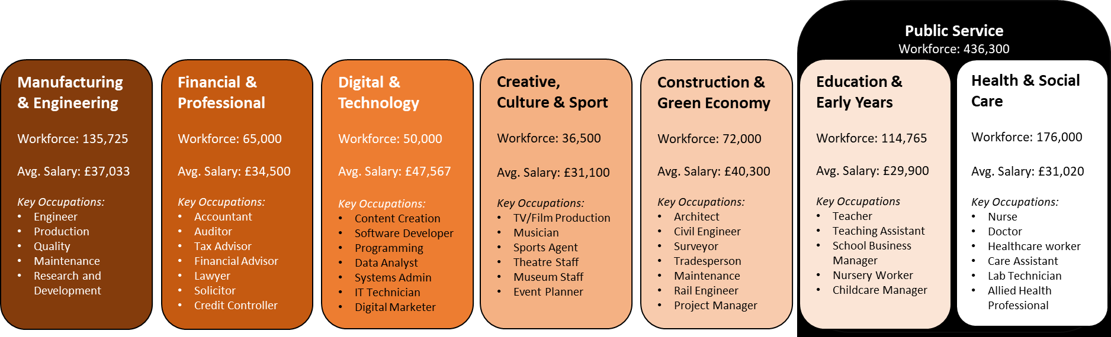
Taken together, these seven sector clusters cover more than half of the total jobs available in GM’s labour market. They are a starting point rather than an end-point; in time the ambition is to clarify technical routes through to jobs in all sectors.

3.1 The five tests
These sectors have been chosen based on five tests, which have guided the judgement but are not a hard-and-fast set of rules:
- Do employers in the sector currently have shortages of staff?
- Do available employment forecasts suggest these sectors are likely to continue to need people in the future?
- Is the sector well aligned with the social and economic goals of Greater Manchester, as set out in the Greater Manchester Strategy (GMS)?
- Is the sector a significant economic ‘player’ that can offer ‘good jobs’ and multiple future possibilities?
- Where are technical routes available that lead to recognised occupations within the sectors?
It is important to understand that there is some overlap between sector clusters and that not all of them currently meet all of the five tests. For example, the engineering and manufacturing sector is in long-term decline in terms of employment volumes, but it remains important for strategic economic reasons and productivity growth. Whilst employment volumes have reduced, its technical pathways to good jobs are relatively well-established which is important in the context of an ageing sector workforce and changes in the nature of jobs as the industry evolves. Similarly, the creative, culture and sport cluster has major economic significance – not least to Greater Manchester’s visitor and night-time economies – but it does not have a full range of technical qualifications currently available (for instance, a T-level in catering is due in 2024).
The expectation is that technical pathways will become clearer in the coming years, and that both awareness of and support for them will grow as the pathways become better established and understood.
This is not about redesigning qualifications, or introducing new complications to an already busy space. Schools, colleges, training providers and a host of other local partners do a remarkable job in a constantly evolving landscape. There is no intention to increase the burden on them. Rather, the intent is to simplify the system by reframing the way we approach the technical route.

4 Opportunities of Devolution
When setting Greater Manchester’s priorities for the Trailblazer Deeper Devolution negotiations with Government, one of the first areas agreed by Leaders was that any deal without a substantial skills and work element was, in fact, no deal.
The Deal sent a clear signal that, perhaps for the first time, central government recognises the case we have made. Namely, the value of a strong ‘place’ connection between people, skills and jobs at a much earlier stage, the need to think beyond qualifications to the wider package of support and opportunity available locally, and the amplifying potential that exists within place-based networks and partnerships.
Greater Manchester’s Trailblazer Devolution Deal unlocks new opportunities to explore new ideas on how this can be done, and to start the discussion about how, working together, we can move towards the vision of Greater Manchester as an integrated technical education, skills and work city-region.
This conversation is about the needs and ambitions of our residents and communities, of our employers and our economy, and how best to meet them. It is about building on the best of the national model and adding value to it, especially for those whose needs, interests and aspirations are not fully met by that national approach. It is about ensuring that there are parallel pathways on a lifelong learning journey that lead to comparable but distinctive career outcomes. It is about how we as stakeholders across GM’s education, skills and work landscape can marshal all of the collective assets, resources and levers at our disposal, including our devolved functions and flexibilities, to create something greater.
There is an opportunity under the banner of the Integrated Technical Education City Region (ITECR) and via our new role working with DfE and DWP on strategic oversight of post-16 technical education, careers and employment support, to explore new ways to bring greater clarity in the system and to offer the key elements of an all-age technical education pathway that works for all, whether aged 14 or 44.
This could be achieved through a (conceptual) toolkit for 21st-century citizenship and work, driven by the ‘whole person, whole system’ approach that underpinned our devolution deal.
There are already excellent examples of where this is being done really well, but it needs to be more systematic and part of the fabric of the education, skills and work landscape across the city-region. Therefore, our proposal is to bring these elements together, firmly grounded in the needs and opportunities of GM’s labour market, through the development of a virtual toolkit: the Greater Manchester Baccalaureate.

5 The Greater Manchester Baccalaureate (MBacc)
The MBacc is proposed as an ambitious pathway for young people from the age of 14 who want to take high quality technical qualifications and pursue a work-related route that meets their aspirations, feeds their passions, and leads them to the job roles the GM economy needs.
Alongside the EBacc, it could provide a range of high value choices, offering two interconnected, equal routes for young people to consider at age 14 – one academic and one technical:
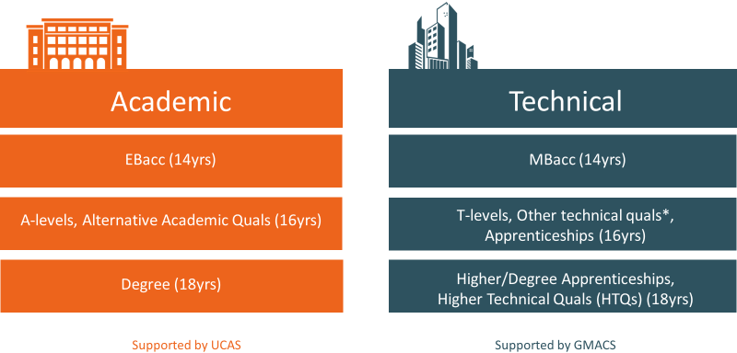
* ‘Other technical quals’ encompasses the range of technical occupational qualifications (TOQs) that deliver the knowledge, skills and behaviours students need to progress into or within skilled employment. They are offered by different awarding organisations and include, but are not limited to, qualifications such as BTECs, City & Guilds Technical Quals, and OCR’s Cambridge Technicals.

The MBacc could be part of a ‘virtual toolkit’ that provides a supported technical pathway into the labour market. Alongside the MBacc and career gateways would be a wraparound package of enrichment to support the development of soft skills that employers are looking for and that are essential for adult life. This wider package will be particularly important to ensuring that there are tailored supported pathways available for young people with disabilities and special educational needs, learning lessons from, and building upon, some of the activity already underway in Greater Manchester around supported employment, apprenticeships and internships.

5.1 At age 14: MBacc, comprising core and optional qualifications
First, a set of subjects that would maximise young people’s chances of getting a good job and a rewarding career in the growing success story that is the GM economy. It could steer students towards good T Levels, apprenticeships, and other technical occupational qualifications just as the EBacc does for A Levels.
Key to this would be supplementing the essential core subjects of English language, maths and digital/technology (the collective importance of which is recognised for adults by the statutory entitlements post-19yrs) with a range of other subjects with a different emphasis from, but deserving the same focus as, EBacc subjects. We have identified subjects that, first and foremost, help young people develop the skills that are required to meet the 21st century needs of the local economy and, second, where there are skills shortages and vacancies in industries that these subjects are most closely aligned to. They are linked not only to high GVA returns for the economy but also to social mobility for individuals.
The illustration below shows the core and gateway relevant subjects we think should form the MBacc, together with an additional range of subjects that we consider might have a place in it. We would welcome views on whether these are the right subject areas on which to focus as the starting point of a technical pathway:

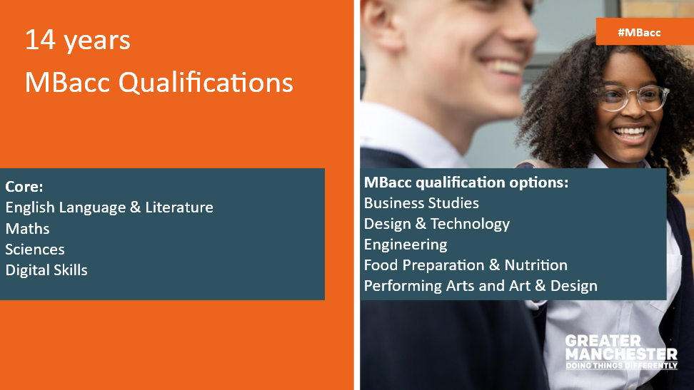

5.2 At age 16: Career Gateways
The second aspect would be the creation of a career gateway at age 16 so that young people can explore and choose a route into the economy and apply for the most appropriate technical qualifications on offer. This can be achieved through GMACS and by improving the strength of advice and guidance under GM’s new mandate around careers.
Based on the available evidence/industry intelligence, the IfATE occupational pathways, and applying the five tests outlined above, seven sector clusters are considered pivotal to that gateway to opportunities at age 16:
- Digital & Tech
- Engineering & Manufacturing
- Financial & Professional
- Creative, Culture & Sport
- Construction & Green Economy
- Public Services, particularly:
  - Education & Early Years
  - Health & Social Care.

There are employer-led occupational standards available in all seven clusters, supporting progression from the MBacc subjects through T-levels, intermediate/ advanced apprenticeships and other technical occupational qualifications (TOQs) at age 16, and on to the range of higher technical qualifications and higher/degree apprenticeships at age 18 that support skilled technicians and professionals - what has been called the ‘missing middle’ of the labour market.
The diagram below illustrates how this could look in practice:
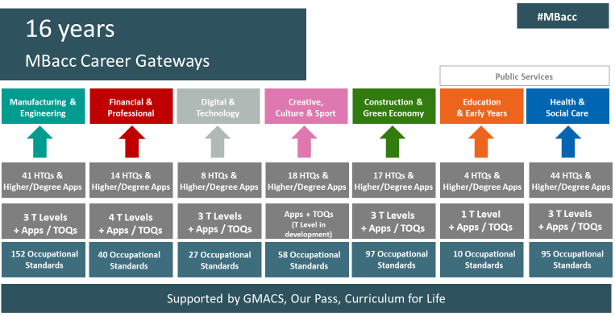
(NB: The employer-led occupational standards – ie descriptions of an occupation, containing a profile and setting out the knowledge, skills and behaviours needed – underpin all technical qualifications, both work-based (e.g. apprenticeships) and classroom based (e.g. T-levels, HTQs). There are over 600 in total; the number of standards approved for delivery in each pathways is evolving as new ones are approved, but numbers shown were correct at the time of writing. See above (p15) for full explanation/examples of technical occupational qualifications.)

5.3 Access to support and enrichment opportunities
The third component would be access to support for young people (on both technical and academic pathways) through:
- GMACS, a navigation tool to explore options and hear from GM businesses
- Curriculum for Life, accessing information as young people navigate into adulthood
- Our Pass, which enables travel to anywhere in the city-region for all 16-18 year olds, regardless of their learning pathway to access training, study, and opportunities like sports and cultural/leisure opportunities.

This support component could also encompass:
- reforms to the careers education landscape through the new GM mandate under the trailblazer devolution deal for oversight of all publicly funded careers services and an all-age careers strategy for Greater Manchester
- a digital literacy framework. Currently, while there is a digital skills framework for adults linked to the statutory entitlements at age 19+, there is no equivalent for young people, yet workplace digital literacy is a vital part of a young person’s ‘work readiness toolkit’ and has been highlighted by employers as a universally in-demand skillset
- a call to action for those organisations that offer enrichment opportunities and activities for young people to support this ambition by integrating their offer into this wrap-around package.

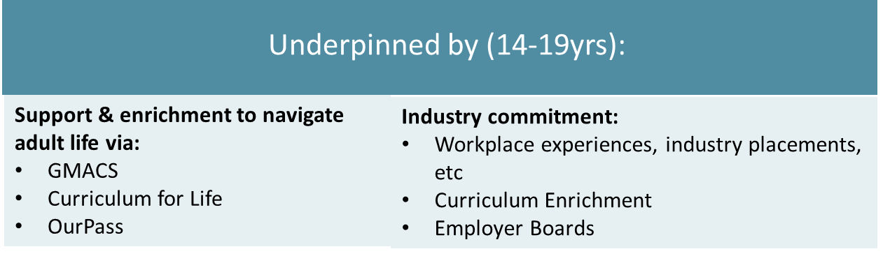

5.4 Industry Engagement
The final component would require include a robust commitment from industry partners, through Employer Boards linked to each route, inspiring young people and offering opportunities such as first-hand experiences of the workplace and work placements, and supporting curriculum enrichment across MBacc subjects and T levels.
This role for employers and industry, playing a proactive part in developing the talent that their businesses will rely on to thrive and grow, is central to the vision of an integrated technical education, skills and work city-region.

6 Making technical education work: the role of employers
The concept of ‘employers at the heart of the system’ is not a new one. Greater Manchester already benefits from a large number of active and engaged employers, representative bodies, and networks that are committed to sharing their insights and challenges, and investing in the current and future talent pool, recognising that this is how individuals, businesses and the economy will grow and thrive. Many already work closely with schools, colleges and training providers, including through the GM Careers Hub, the Enterprise Advisor Network, and other activities.
It is expected that GM’s LSIP (outlined above), which is being led by the GM Chamber of Commerce and due for publication in early summer 2023, will also include reflections aimed at employers themselves, making recommendations around how they too can shift their own practices and behaviours to contribute. For example, workplace experiences and industry placements will need to be scaled up substantially if we are to have enough of the right opportunities for all young people who want to pursue the technical pathway, as well as enrichment and inspiration activities such as mentoring and shadowing.
By working in this way more systematically, employers will not be passive consumers of a skills system in which the onus is on the public sector to deliver all things for all employers. Rather, they will be proactive stakeholders within that system, whose interest in making technical education work will be matched by their willingness to be a part of making sure that it does. We would look to Employer Boards, building on existing employer networks, to be key partners in supporting the MBacc and career gateways as part of the industry response to GM’s LSIP, ensuring that the actions identified in the Plan around aligning the skills and technical education offer to the needs of the local labour market are a live, ongoing conversation.

7 The future vision: towards an Integrated Technical Education, Skills and Work city-region
What would this look like in practice? This integrated ambition would extend the approach GM is already applying to adult skills to all learning that draws its primary purpose from the workplace. It would help to build a virtual toolkit through:
- A core cluster of qualifications that are valued by employers and open doors into key GM sectors and industries
- A wide range of workplace experiences, curriculum enrichment and other opportunities that support the development of soft skills and entry to the world of work
- A clear, trusted platform through which to explore and apply for technical education pathways and wider support and enrichment, together with the tools needed to access them.

If we can work together to deliver this ambition, it could represent an important step forward in considerations of how the skills system needs to change to better meet needs. It will also help to ensure that GM can grow and compete in a rapidly changing global marketplace in which the jobs of the future look very different to the jobs of the past.
We recognise that these are challenging times in which to ask businesses to look beyond the current environment, to ask education and training partners to shift the technical education offer and how it is framed, or to ask more of the wider stakeholder community, including voluntary, community and social enterprise organisations. We recognise, too, that school performance and inspection frameworks might drive particular institutional priorities and behaviour, and that balancing those with responsiveness to local needs would be a challenge.
But this is too important for us not to act. In years to come, when future reviews of technical education and the skills system are announced, we do not want to be reflecting on the same questions and identifying the same systemic barriers. Rather, if those questions are still being posed, we want policy-makers to be able to look to Greater Manchester, not just overseas, at a blueprint for an integrated technical education and skills system that works.

8 Join the conversation
This is the opening act in exploring how we might think differently to drive better outcomes.
We would therefore welcome views on the proposals set out. In particular, we are keen to understand:
- Does the overall ambition for an integrated approach to technical education, skills and work feel right?
- Do the issues that have been identified resonate with your experience of the system, whether as a young person, a parent/carer, an educator/trainer, employer, or other stakeholder?
- Are the components of the technical pathway, including the MBacc and career gateways, the right ones? Are there elements missing that would help shift the dial in offering clear technical pathways into the labour market, wraparound support, and ease of access into them?
- The gateway routes have been identified based on meeting some or all of the five key tests. Are these a reasonable starting point (bearing in mind the intention to apply the same approach to all sectors)? Does the package of GCSE subject areas identified in the MBacc offer a good pathway into those areas or are there gaps?
- Recognising that this is the beginning of this discussion, we also need to understand any unintended consequences of the approach, along with possible mitigations or alternatives.

It will be a challenging but exciting conversation and we look forward to exploring new thinking about how to achieve the shared ambition for Greater Manchester: an integrated technical education, skills and work city-region.

To submit views please go to www.gmconsult.org.
We look forward to hearing from you.

Appendix: Which sectors and which jobs? Identifying the Greater Manchester sector pathways in technical education

Greater Manchester is not alone in seeing an urgent need to simplify technical education routeways; the goal is current government policy. The Institute for Apprenticeships and Technical Education (IfATE) – an Arms-Length Body of the Department for Education - has devised a series of “occupational maps” that aim to help navigate the system by providing simple visual guides connecting specific qualifications and occupations. There are currently over 600 employer-led standards across 15 occupational routeways.
Those IfATE routeways have been an important point of departure; Greater Manchester is seeking to complement this work and build on it in a city-regional context.
As described in the discussion paper, five tests have been applied in this process, drawing upon a range of evidence:
- The first of these tests establishes that vacancies are currently available at volume in the city region of Greater Manchester using Lightcast (a system for analysing online job vacancies). As is well-known many employers need staff in the wake of the Covid pandemic.
- The second criterion uses forecasts from Working Futures, the labour market forecasting vehicle used by some government departments. No forecast is perfect; and as is also well known, pandemics and major economic events can throw the most detailed forecasts off-course. Still, the thinking here is that there is an evidence base that looks beyond the immediate time-horizon.
- The Greater Manchester Strategy 2021-2031, Good Lives for All (GMS), establishes a set of over-arching general objectives for the entire city region (not just GMCA). The GMS is the touchstone for a variety of other strategies including skills strategies, economic and industrial strategies. The GMS is underpinned by a major economic evidence base exploring sectors, jobs and productivity. The GMS supplies a vision of GM’s economic future in which technical education will play a significant role.
- The quality of jobs is a major theme within GM’s economic strategy – present in such initiatives as the Good Employment Charter and the Living Wage City Region campaigns. So it is essential that technical education leads to good jobs (well-paying, secure jobs that enable opportunities for people to develop further) rather than just “any job”. In keeping with this emphasis, the fourth test speaks to this judgement. The simplest approach is to measure average salaries within the sector (again using Lightcast). Any major sector will have a wide array of occupations within it, but the median salary offers some (albeit imperfect) insight into the central tendency. Also noteworthy here is that some currently evolving “good jobs” run throughout all individual sectors - digital roles and “green jobs” for example – as well as sitting within their own sector.
- Finally, the fifth test is whether there is a range of non-University, technical pathways available. Pathways include many FE courses at different vocational levels, as well as apprenticeship routes and the T levels that are increasingly coming on stream. The role that GMCA is aiming to play here is in clarifying and simplifying routes through a bewildering labyrinth of potential learning avenues so that young people (and others) can see how learning routeways connect ultimately to jobs. Research is increasing that shows that not all university degrees generate significant “economic returns” (for instance, Department for Education/Institute for Fiscal Studies, 2018; Department for Education, 2023 ). “Better” (as in higher paying) options for many young people would have been high quality technical education. But the labyrinth can be off-putting.

Technical pathways
Clarifying routeways through the technical education system is challenging. There are many different types of qualification and learning options available at different levels - and which one is “best” for any individual will depend on several factors. The intention here is to simplify the pathways to assist young people in navigating their way.
The key groupings are:
- Higher technical qualifications (occupational standards at levels 4/5, such as higher national certificates/diplomas and foundation degrees)
- Apprenticeships – including degree apprenticeships (practical training in a paid job, but with 20% of the working week spent learning)
- Other Technical Occupational Qualifications (TOQs) – classroom based qualifications that deliver the knowledge, skills and behaviours students need to progress into or within skilled employment. They are offered by different awarding organisations and include, but are not limited to, qualifications such as BTECs, City & Guilds Technical Quals, and OCR’s Cambridge Technicals.
- T levels (two-year classroom based Level 3 qualifications for 16-19 year olds, including a substantial industry placement of a minimum 45 days. Equivalent in size to three A levels, a T Level focuses on technical skills and can help students into skilled employment, higher study or apprenticeships).
Apprenticeships and FE are relatively well known (though not nearly as generally understood as universities). However, many people – including employers and parents/carers have yet to hear about T levels. T Levels form one of the technical pathways available for young people in Greater Manchester to develop the skills and attributes that employers have identified as required. They will form an increasingly important pathway for the development of young people in the years ahead.
Currently 16-18 year-olds in Greater Manchester can take T levels at 24 approved providers that are closely aligned to the sectors identified above and more T levels will become available over the next few years. They aspire to be flexible: as well as offering progression into employment across a range of occupations they also allow a young person to access further learning (such as higher-level apprenticeships, higher technical qualifications, and even degrees if that is the direction young people wish to head).

The #BeeWell survey, which builds on the GM Life Readiness Survey (2018-2020), is a large-scale longitudinal survey gathering feedback on young people’s optimism for the future, as well as views on skills, careers education and plans post-Year 11. In two years, the #BeeWell survey has heard from 60,000 young people across 187 secondary schools in GM.
Skills for Jobs: Lifelong Learning for Opportunity and Growth (Jan 2021) Skills for jobs: lifelong learning for opportunity and growth - GOV.UK (www.gov.uk)
The EBacc comprises English language and English literature, maths, sciences (either GCSE Combined Science which awards two GCSEs incorporating biology, chemistry and physics, or three single science GCSEs selected from biology, chemistry, physics and computer science), geography or history, and any ancient or modern foreign language.
GM Big Disability Survey (Oct 2022) GM Disabled People's Panel (gmdisabledpeoplespanel.com)
Greater Manchester Strategy 2021-2031: Good lives for all (GMCA, 2022) The Greater Manchester Strategy 2021-2031 (aboutgreatermanchester.com)
Report of the Independent Panel on Technical Education (‘the Sainsbury report’, April 2016) Post-16 skills plan and independent report on technical education - GOV.UK (www.gov.uk)
Skills for jobs: lifelong learning for opportunity and growth - GOV.UK (www.gov.uk) (the government’s further education reform White Paper) used the following definition: Technical education encompasses any education or training… that focuses on progression into skilled employment and requires the acquisition of both a substantial body of technical knowledge and a set of practical skills valued by industry. Technical education covers provision from level 2 (the equivalent of GCSEs at A* to C or 9 to 4) to higher education (level 6), but it differs from A Levels and other academic options in that it draws its purpose from the workplace rather than an academic discipline
See appendix
See appendix for further detail on the methodology applied in selecting the seven gateway sectors.

