# Census 2021 Briefing

# Health

NHS Greater Manchester and GMCA Research Team

December 2023

**Dataset: General health and disability: Census 2021**

**Datalink**: The data used in this briefing can be found at <https://www.ons.gov.uk/releases/thegeographicdivideinhealthdisabilityandunpaidcarecensus2021>. Data can also be found at <https://www.nomisweb.co.uk/sources/census_2021_ts>

**Definition**: This briefing explores and summarises multiple census releases on general health and disability across England and Wales using data from the 2021 (and 2011) census.

**Census day**: The 2021 census was held in England and Wales on 21 March 2021. The 2011 census was taken on 27 March 2011.

**Key points**

* Some 6.6% of residents said their health was ‘bad’ or ‘very bad’ in Greater Manchester in 2021 compared with an average for England of 5.3%.
* Meanwhile, 9.3% of Greater Manchester residents said they had a health condition or illness which limited their day-to-day activities ‘a lot’. The average for England was 7.5%.
* Responses to the questions asked in the 2021 census on health-related topics are likely to have been affected by the circumstances of the time-period when the census was taken. In March 2021 the Covid-19 pandemic and its associated lockdowns were severely affecting society while ill-health was much in the news.
* Six of the ten Greater Manchester districts were within the worst 20% of localities in England and Wales for respondents reporting ‘bad’ or ‘very bad’ health. Manchester ranked at number six.
* Nevertheless, compared with the census results of 2011, lower proportions reported ‘bad or very bad health’ or activity-limiting health conditions in 2021 than in 2011, suggesting that some general health improvements in the population may have occurred.

## Greater Manchester findings

The 2021 census took place during the Covid-19 pandemic. Therefore results relating to perceptions of health and ill-health need to be understood with that context firmly in mind. The situation of 2021 may not be directly comparable with previous results on health questions. The data used in this briefing uses age-standardised estimates which are regarded by the Office for National Statistics as preferable for comparing populations across different geographical areas over time. The briefing reports on two health-related questions: first in relation to general health; and second in relation to illnesses or health conditions that limited day-to-day activities.

The 2021 census found that 6.6% of Greater Manchester residents (169,929) said their health was ‘bad’ or ‘very bad’. Meanwhile, 9.3% (240,977) said they had a health condition or illness that limited their day-to-day activities ‘a lot’[1] (it is worth remembering that the lockdown of March 2021 meant that few normal social activities were legally permitted).

The following table reports results in each district of Greater Manchester on these two health-related questions. Manchester was the district that had the highest proportions of residents who said they experienced bad or very bad health (8.8%) and an activity-limiting health condition or illness (11.4%). Only Trafford performed better than the average for England on both questions.

**Proportions reporting poor health or health conditions and illnesses that limit day-to-day activities, 2021[2]**

|  |  |  |
| --- | --- | --- |
| Area | Respondents reporting Bad or Very Bad health | Respondents who report that a health condition or illness limits their day-to-day activities a lot |
| Bolton | 6.7% | 9.3% |
| Bury | 5.8% | 8.5% |
| Manchester | 8.8% | 11.4% |
| Oldham | 7.1% | 9.5% |
| Rochdale | 7.0% | 9.8% |
| Salford | 7.4% | 10.3% |
| Stockport | 5.2% | 7.6% |
| Tameside | 7.0% | 9.6% |
| Trafford | 4.8% | 7.0% |
| Wigan | 6.3% | 9.4% |
| **Greater Manchester** | **6.6%** | **9.3%** |
| England | 5.3% | 7.5% |

Source: Office for National Statistics – Census 2021

Nationally, Greater Manchester localities tend to rank poorly in these two key health statistics. Six of the ten districts were within the worst 20% of localities in England and Wales for respondents reporting bad or very bad health; Manchester ranked at number six.

Seven localities were in the worst 20% for respondents reporting activity-limiting health conditions or illnesses. Bolton, Manchester, Oldham, Rochdale, Salford and Tameside were in the worst 20% of localities for both of these health statistics.

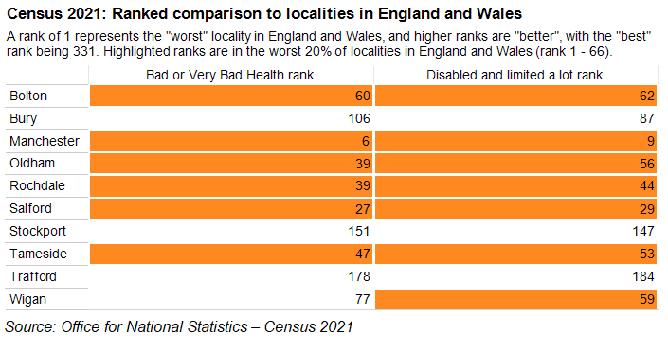

## Change since 2011

Although the circumstances of the 2021 census were unusual, and Greater Manchester generally compares poorly on the health of its residents, nevertheless the general pattern suggests improvements in the proportions reporting poor health since the previous census may have occurred. In all localities, lower proportions of respondents reported being in bad or very bad health in the census of 2021 compared to the 2011 census. The greatest improvement was in Manchester (a 2.1 percentage point improvement, although it remains the locality with the highest proportion of respondents reporting bad or very bad health). The inequality between best and worst localities for this statistic has also reduced.



Source: ONS - Census 2021. GM Avg. = Greater Manchester Average, Manc. = Manchester

Similarly, in all localities, a lower proportion of residents reported being limited ‘a lot’ by a health condition or illness in the census of 2021, compared to the census of 2011. The largest improvement was again in Manchester, with a 3.3 percentage point reduction. Once more, the inequality between Greater Manchester localities was smaller in the results from the census of 2021 than in 2011.

Chart showing proportion of residents who say they are limited "a lot" by a health condition or illness. Across all areas health appears to have improved since 2011.

Source: ONS - Census 2021. GM Avg. = Greater Manchester Average, Manc. = Manchester

## Reflections

The 2021 census was carried out during the Covid-19 pandemic and during the third national lockdown. This may have affected respondents’ answers to questions on health. The main impact of this is that any analysis created from this data must be treated with caution, as it may not accurately represent the population of Greater Manchester in the post-lockdown period.

Taking these caveats into account, more of the population of Greater Manchester was in poor health than the average in England. Similarly, more people are limited by a health condition or illness. In some parts of the conurbation – notably in Manchester – health appears to be among the worst of all local authority areas in England and Wales. Manchester ranked at number six in the table of local authorities with the worst self-reported health.

Still, the census data reported in this briefing also suggests there may have been some improvements in health over time - despite the relatively poor performance of Greater Manchester districts on health metrics in general. Scores on both the questions explored in this briefing were consistently lower across all areas in 2021 than in 2011. Therefore, the census data does not offer support to a narrative that health is generally worsening over time. It may also be worth noting research which found that devolution may have had a positive impact on life expectancy[3].

1. The 2021 census did not have a question on disability. Rather, it phrased the question to refer to health conditions and illnesses that limited day-to-day activity.
2. These statistics are “age standardised proportions” which are preferred by ONS to population proportions for comparisons between areas over time. This is because they take into account differences in population size and age structures. The statistics cited here are the same as in the ONS publication *The geographic divide in general health, disability and unpaid care: Census 2021*. See [here](https://www.ons.gov.uk/releases/thegeographicdivideinhealthdisabilityandunpaidcarecensus2021). This briefing does not report on unpaid care.
3. Britteon, P., Fatimah, A., Lau, Y.S., Anselmi, L., Turner, A.J., Gillibrand, S., Wilson, P., Checkland, K. and Sutton, M., 2022. The effect of devolution on health: a generalised synthetic control analysis of Greater Manchester, England. *The Lancet Public Health*, *7*(10), pp.e844-e852.