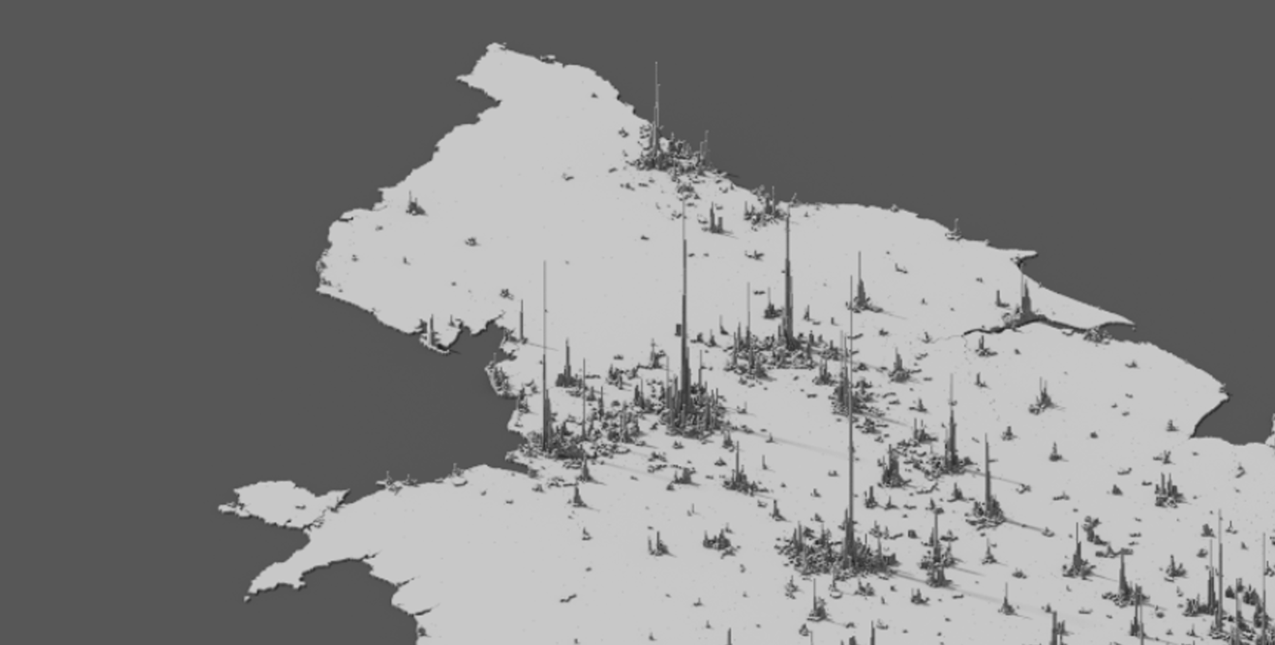

The Northern Arc

Working Paper 28.04.2025

*This short working paper sets out an understanding of the economic opportunity for the Northern Arc, a growth corridor with the potential to drive prosperity across the North of England and beyond.*

Executive Summary: The Northern Arc

What is the “Northern Arc”?

The Northern Arc stretches from the Mersey to the Pennines, uniting Liverpool City Region, Cheshire and Warrington and Greater Manchester, and is economically intertwined with West and South Yorkshire. Growth in the Northern Arc matters across the North of England and beyond, with close trading links with Lancashire, North Wales, and across to Hull and the North East. The Northern Arc plays a key role in this wider economic ecosystem; encompassing the Port of Liverpool and Manchester Airport, the Northern Arc is the international gateway to the North of England.

Because of the room for growth based on the economic assets of the Northern Arc (the untapped potential of the Northern Arc’s people, innovation and international assets, and complex economies), the potential of this growth corridor represents a major opportunity to deliver **growth in the medium term,** complementing longer-term UK-wide growth opportunities such as the expansion of Heathrow.

Why can the **Northern Arc deliver growth**?

1. **A highly developed industrial ecosystem, primed for sector-led growth**: From Life Sciences to Energy and Advanced Materials, the region already has the core and complementary capabilities that can drive technological advances and commercialisation in cutting-edge fields including from energy innovation to AI and sustainable aviation fuels.
2. **World-leading innovation and internationalisation assets**: The Northern Arc is home to the innovation excellence that will drive future high value economic activity, and to the vital gateways for the UK’s trade with growing international markets.
3. **But untapped economic potential relative to size.** Home to 5.4m people with an annual GVA of £150bn (and with 9.3m and £240bn as part of the broader economic corridor with West and South Yorkshire), the Northern Arc has the scale to compete on international markets, and to turn the dial on UK-wide growth, with the right support to unlock the potential of the region’s people through agglomeration benefits.

Why can theNorthern Arc deliver those growth benefits **in the medium term**?

1. **Capacity to deliver.** There is a strong track regional record of delivery and this capacity has been enhanced by its place at the forefront of the mayoral revolution, with two long established MCAs and a proposed MCA in Cheshire and Warrington.
2. **Depth and maturity of local partnerships**. The Northern Arc has strong collaborative working relationships between government, business, universities and civil society, working across boundaries to advance new ideas and boost the region’s potential.
3. **Appetite for growth and to work together to deliver that growth across the Northern Arc.** The Northern Arc’s political and civic leaders, businesses, and institutions have a shared appetite to work together to deliver economic growth, innovative housing delivery models and key sector development projects.

What is the **size of the prize**?

Due to the size and economic importance of the Northern Arc, small improvements in key economic indicators result in large growth benefits for the UK.

The economic corridor comprising Greater Manchester, Cheshire and Warrington, and Liverpool City Region has already been delivering comparatively strong growth for the UK, with a Compound Annual Growth Rate (CAGR) of 2.00% between 2013 and 2022, ahead of the UK average at 1.46%.

Between 1950 and 2019 the UK averaged annual growth of 2.5% but has not experienced growth above this average twice in the decade after 2010. Since 2011, the Northern Arc has averaged growth of 2%, above the national rate but below the longer-term historical trend. **Strengthening the growth trajectory to the UK’s long run trend could add £90bn in cumulative GVA to the UK economy by 2040** and double the size of the region’s economy in less than 30 years.

How could the Northern Arc get there over the medium-longer term?

1. **In the short term, to accelerate investor confidence with clear Government backing,** with Northern Arc partners currently working to put together the pipeline of investment projects and key assets that underpin the Arc.
2. **In the medium-term, through major private and institutional investment in sectoral growth projects**: More work will be needed with the private sector, institutions and investors in developing and delivering the pipeline of investable propositions under the banner of the Northern Arc.
3. **In the longer term, through ongoing investment in infrastructure:** Growth in the region has been enabled by infrastructure, but future growth faces constraints, accelerated growth will be enabled by responding to place based and regional needs, improving public transport, supporting housing growth and transforming regional connectivity through the Liv-Man rail line.

2. An Economic Growth Corridor for the North

**Introducing the “Northern Arc”**

The Northern Arc stretches from the Mersey to the Pennines, uniting Liverpool City Region, Cheshire and Warrington and Greater Manchester, economically intertwined with South and West Yorkshire. It is a growth corridor with the scale and capacity to deliver transformative increases in living standards across the UK; with close trading links with Lancashire, North Wales, and across to Hull and the North East.

Bringing together the Port of Liverpool (the UK’s primary route for transatlantic trade with 45% of trade from the USA, and a pioneer in maritime innovation and decarbonisation) together with Manchester Airport (the UK’s largest non-London-serving airport), the **Northern Arc is the international gateway to the North of England, with the deep and complex industrial ecosystem to compete in rapidly evolving global markets**. The universities and research assets of the Northern Arc are engines of innovation, with world-leading research strengths ranging from tropical medicine to nuclear civil engineering.

National growth propositions like the Ox-Cam Arc and Heathrow expansion offer huge growth potential for the UK. The Northern Arc represents a complementary opportunity to deliver sustained growth, bringing forward a programme of projects across the short, medium and long term. By building on the strong existing track record of collaboration with national centres of innovation, like the Manchester-Cambridge innovation partnership, the **Northern Arc has the potential to complement longer-term growth opportunities in the Greater South East in the medium-term**.

1. The Northern Arc and the Ox-Cam Arc: Driving UK Growth

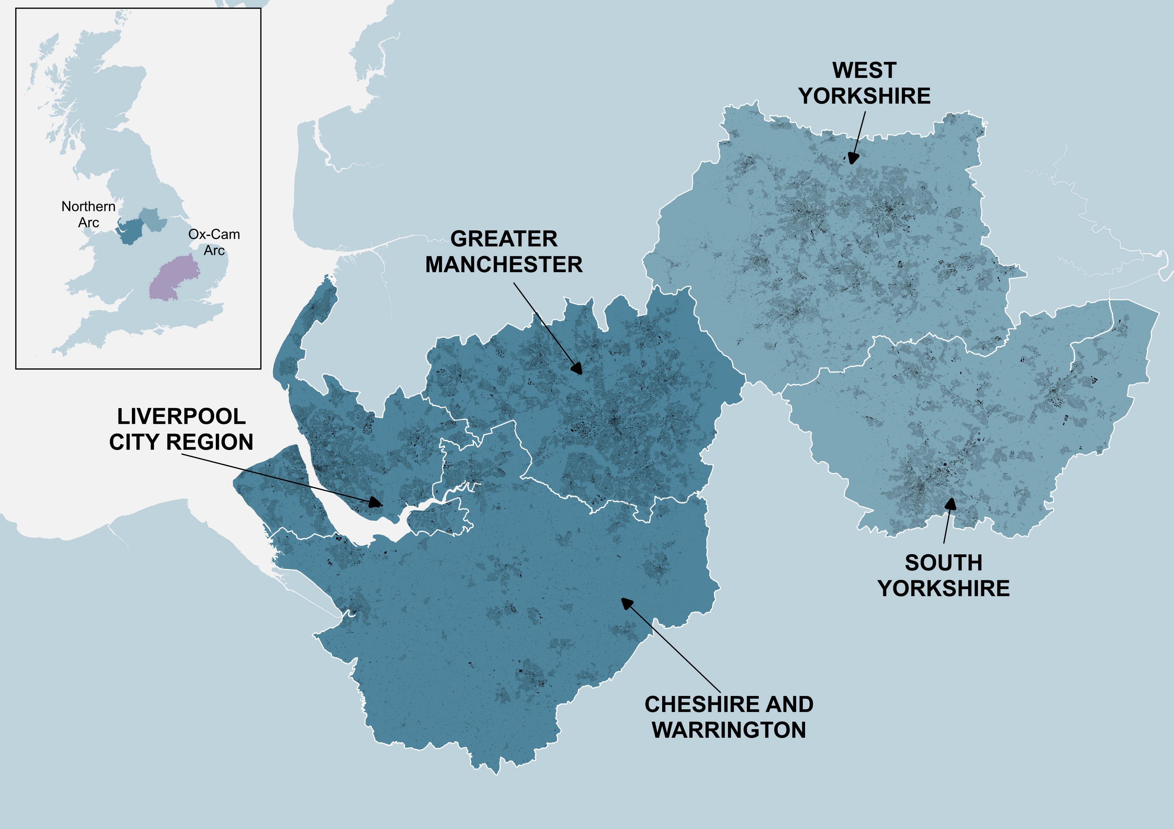

**The rationale for intervention**

Despite sector and innovation strengths, and the potential of the millions of people in the Northern Arc, the UK’s cities [systematically underperform](https://sites.harvard.edu/uk-regional-growth/) their economic potential [relative to their size](https://www.centreforcities.org/publication/cities-outlook-2025/). With the growth of new large scale industrial regions in the developing world, economies of scale are crucial in ensuring international competitiveness. Knowledge-based sectors and major investors operate across wider geographies shaped by sectoral strengths, infrastructure, and market access. With an economy operating at this scale, the Northern Arc can grow into a leading international centre for new industries and sectors, leading the way once more in economic transformation.

|  |
| --- |
| Mobilising around assets: The Dutch ‘Mainport’ model |
| In the late 1980s, following a prolonged economic downturn, the Dutch government introduced the ‘[mainport policy’](https://www.erim.eur.nl/fileadmin/default/content/erim/research/centres/smart_port/admin/c_news/mainports%202040%20rapport%20definitief.pdf), which marked a step change in national spatial and economic planning to focus on building up areas of comparative advantage, directing investment towards assets with the greatest potential to support national economic growth. Mainport policy aimed to consolidate and expand the international role of the **Port of Rotterdam** and **Schiphol Airport** as strategic economic gateways, building on their existing market positions.  Major projects advanced under the Mainport banner included a dedicated freight rail corridor to Germany, a high-speed rail line linking Rotterdam and Amsterdam with each other and with key European cities, and a significant expansion of port capacity through coastal land reclamation. In parallel, governance arrangements such as Schiphol’s ‘Golden Triangle’ partnership with KLM and the Civil Aviation Authority were developed to align public and private actors around a shared strategic vision.  The Mainport policy has been widely recognised as a [cornerstone of Dutch economic strategy and success](https://www.eur.nl/upt/media/2018-12-rapportrotterdameffectpdf) since its introduction and the policy objective set out in the 1980s – to establish the Netherlands as a leading logistical hub – has been accomplished. Today, Rotterdam is the largest cargo port in Europe, and Schiphol ranks among the top five airports in Europe, with both in the top fifteen worldwide. Beyond their scale of their assets, Mainport policy has played a [pivotal role](https://wp.kennisbanksocialeinnovatie.nl/wp-content/uploads/2020/08/pdf_mainport.pdf) in supporting the Dutch business climate by enhancing international connectivity, attracting investment, and reinforcing the country’s economic competitiveness. |

Taken together, the assets of the Northern Arc could combine to become much more than the sum of their parts. This region offers a transformative growth opportunity for the UK, and to help meet the Government’s national growth mission, delivering rising living standards in the medium-term. And it can deliver at scale; home to 5.4m people with an annual GVA of £150bn (rising to 9.3m and £240bn across South and West Yorkshire), **a relatively small improvement in key economic indicators results in substantial UK-wide economic benefits**.

The rest of this working paper sets out some of those primary growth opportunities for the Northern Arc, and for the UK.

1. A highly developed industrial ecosystem, primed for sector-led growth

The development and complexity of the Arc’s industrial ecosystem is one of the main comparative advantages of the Northern Arc, which has as rich an industrial history as anywhere in the world, and well-established networks of firms, clusters and assets. As the map below shows, the Arc stands out on measures of economic complexity, a key explanatory factor in productivity and which demonstrates cross-sector complementary (see more below).

1. Relative Economic Complexity in the North and Midlands

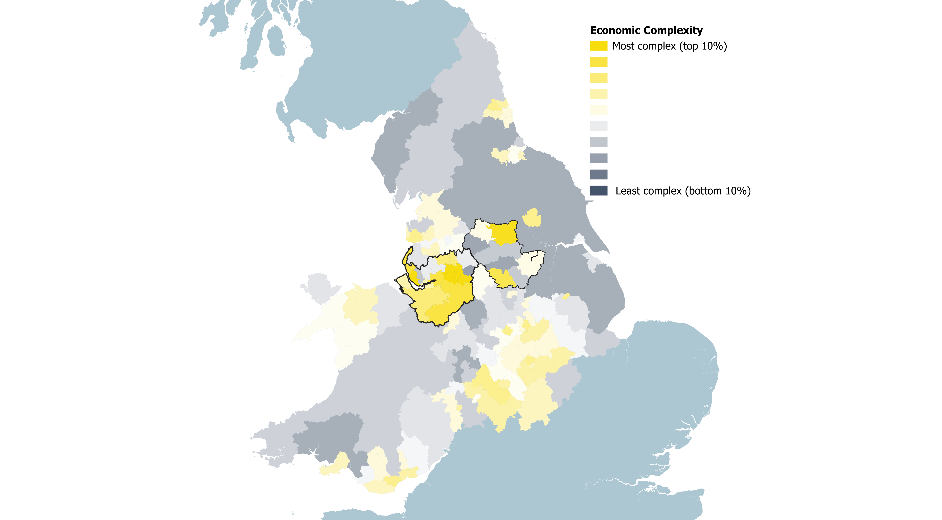

*Metro Dynamics analysis of BRES (2024 release), weighted to North, Midlands and Wales only*

|  |
| --- |
| Economic complexity and productivity |
| Economic complexity is a metric of how highly developed a local (or national) economy is, in generating a wide range of niche and specialist economic activity for residents. Measured relative to national or international comparators, economic complexity is strongly associated with high productivity and international competitiveness; a wide range of niche activity tends to be associated with high value products. However, unlike other metrics of economic specialisation, such as location quotients, a high level of economic complexity demonstrates resilience to changing international market trends, and an ability to adapt quickly to technological advances in generating new goods and services.  As the map above shows, the places of the Northern Arc demonstrate highly complex economies, with the local authorities of Manchester and Liverpool respectively representing the first and third most complex economies outside the Greater South East, and high levels of, reflecting the depth, maturity and inter-relatedness of the Arc’s industrial ecosystem. |

**The growth of key sectors across the Arc**

The Arc economies are strong and broad based with large professional and scientific services, manufacturing, public sector, retail, logistics and entertainment sectors. Continued growth and productivity in these sectors is a major part of the economic future for this region.

But looking ahead, the region also has major opportunities to build on existing strengths to scale up activity in emerging and high value sectors, with the right backing. The sectors with a strong presence across the Arc include AI and cyber; Creative and Media; Business and Professional Services, Advanced Materials and Manufacturing, Life Sciences, and Energy. The map below demonstrates the opportunity by illustrating the clusters present in **Life Sciences**, **Advanced Materials & Advanced Manufacturing**, and **Energy sectors** – the energy sector includes clean energy, which will play a crucial role in supporting the UK’s decarbonisation goals and sustainable economic growth, and the decarbonisation objectives of places within the Northern Arc, which hosts nationally significant renewable opportunities like the proposed Mersey tidal barrage, and the UK’s first decarbonised industrial cluster in Ellesmere Port with Hynet North West and Origin.

1. Selected sector clusters and distribution across the Northern Arc (Metro Dynamics analysis of Data City Real Time Information Codes)

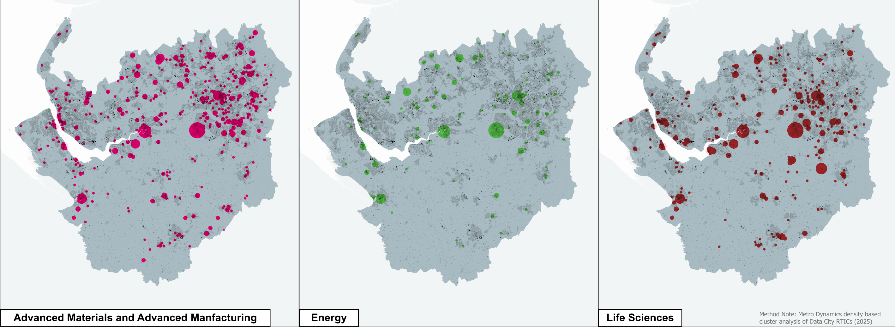

These are sectors where the scale of the opportunity, and what is likely be needed to realise them calls for real ambition and co-ordinated effort across the Northern Arc;

* They are **high value sectors that can drive wider prosperity**
* They are **shared areas of strategic priority within the Northern Arc**, and in the UK’s national industrial strategy.
* **They are shared areas of strength** with internationally significant assets, major companies, significant projects underway and examples of collaboration already in place
* **They have areas of overlap and complementarity** that can drive commercialisation in cutting-edge fields including AI and sustainable aviation fuels.
* And they are sectors where the value potential is large in scale but **where realising the opportunities requires significant investment up front**

**Conclusion I: Delivering against the potential of the Northern Arc for sector-led growth is a major opportunity for UK-wide growth and to deliver the UK industrial strategy**

2. Internationally significant innovation and international trade assets, with capacity for growth.

From the Universities and innovation assets of the Arc to the Port of Liverpool, Liverpool John Lennon Airport and Manchester Airport, the Arc has a huge base and depth of assets that stand ready to support growth and international competitiveness. **Crucially, there is an opportunity to unlock the capacity of existing assets to deliver medium-term growth**.

By way of example, take Manchester Airport. Alongside Heathrow, Manchester Airport is the only UK airport with two fully functional runways, supporting the North’s other excellent airports with a depth of choice and international accessibility. But currently, good public transport access to Manchester Airport is limited almost exclusively to Greater Manchester. This is constraining growth, with the capacity to service many more flights than it does currently; recent [research by Arup](https://gmbusinessboard.com/news/report-shows-manchester-airport-has-potential-add-16-3bn-per-year-to-uk-economy-by-2050) found that with the right strategic interventions, the airport could serve over 60 million passengers annually by 2050, tripling its GVA contribution to £16.3 billion and supporting over 165,000 jobs across the wider region.

1. Access to Manchester Airport across the Northern Arc

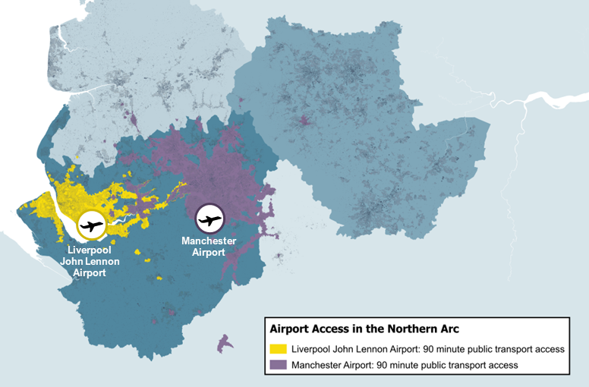

*Metro Dynamics analysis of TravelTime API data, 9am starting point used from main terminal buildings of relevant airports. Please note that Travel Time generates an isochrone (shaded travel area) based on timetable data at that point in time, and may not represent the fastest possible route overall.*

Alongside international trade, innovation represents a major growth opportunity for the Northern Arc. The innovation assets of the Northern Arc have cutting edge research specialisms; from civil nuclear engineering at the University of Manchester, infectious diseases research at Liverpool University or artificial intelligence research at the Hartree Centre at Sci-Tech Daresbury. They are also substantial assets for firms within the Northern Arc area, both directly generating a high volume of spin-outs and scale ups, and indirectly providing positive spillover benefits through research engagement, while a range of FE and HE institutions build up a strong pool of highly skilled workers. If existing partnerships can be built on - [like the University of Manchester and Liverpool’s recently announced collaboration agreement](https://mancunion.com/2025/02/06/universities-increased-collaboration/#:~:text=Professor%20Duncan%20Ivison%2C%20the%20University,need%20to%20deliver%20economic%20growth%E2%80%9D.) – then the impact of innovation assets can be maximised.

**Conclusion II: Maximising the potential of existing innovation and international assets in the Northern Arc offers a route to tangible growth in the medium term**.

3. But the Northern Arc has untapped economic potential relative to its size

In the 21st century, and with the growth of new large scale industrial regions in the developing world, economies of scale are crucial in ensuring international competitiveness and knowledge-based sectors and major investors operate across wider geographies shaped by sectoral strengths, infrastructure, and market access at the scale of international footprints. And outside of London, the Northern Arc represents one of the strongest concentrations of economic activity, as the below map demonstrates.

1. Employment density in England and Wales (MSOA, 2024 BRES release)

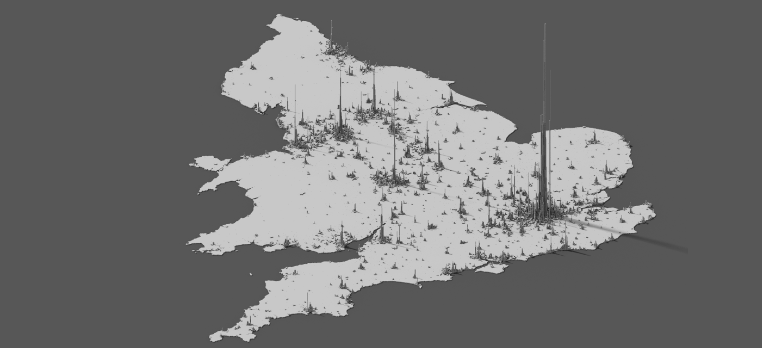

But the fact must be confronted that the UK’s cities, including Manchester and Liverpool, [systematically underperform](https://sites.harvard.edu/uk-regional-growth/) their economic potential [relative to their size](https://www.centreforcities.org/publication/cities-outlook-2025/). A major factor which accounts for this is that poor transport links reduce the true size of labour markets and are a barrier to **agglomeration effects** taking hold, the learning, collaboration and innovation benefits that arise when large numbers of firms and people interact and share resources.

Part of this challenge is intra-city, the difficulty in commuting from residential areas to the centres of economic production, like city centres, industrial areas, and research labs. Northern Mayors and Leaders are working with Government to improve local transport networks, from franchising bus networks to the construction and renewal of mass transit networks but to unlock the cities potential continued working with government will be needed to drive growth forward, and to ensure that transport networks grow to meet changing needs.

But another major part of this challenge is inter-city; the economies of the Arc are not benefitting as much as might be expected from their proximity to one another. The UK’s future international competitiveness will depend on innovation intensive work; despite the rise of remote work, the collaboration that powers breakthroughs continues to benefit best from physical proximity. The Northern Arc has shared strengths across materials, life sciences, energy and other key sectors. Addressing poor connectivity will build larger ecosystems which can generate agglomeration effects, to the benefit of the UK as a whole.

**Conclusion III: The Northern Arc has the potential to turn the dial on UK-wide growth, due to the size and untapped economic potential of the places and people within.**

**3. Towards a growth ambition for Northern Arc**

**The size of the Northern Arc mean growth increases can have a transformative impact.**

The economic corridor comprising Greater Manchester, Cheshire and Warrington, and Liverpool City Region has already been delivering growth, with a Compound Annual Growth Rate (CAGR) of 2.00% between 2013 and 2022, ahead of the UK average at 1.46%.

Between 1950 and 2019 the UK averaged annual growth of 2.5% but has not experienced growth above this average twice in the decade after 2010. Since 2011, the Northern Arc has averaged growth of 2%, above the national rate but below the longer-term historical trend, although parts of the Northern Arc have continued to demonstrate strong growth in line with the UK’s former growth trajectory. **Strengthening growth across the Northern Arc to the UK’s long run trend could add £90bn in cumulative GVA to the UK economy by 2040** and double the size of the region’s economy in less than 30 years.

1. The scale of the growth ambition for the Northern Arc by 2040.

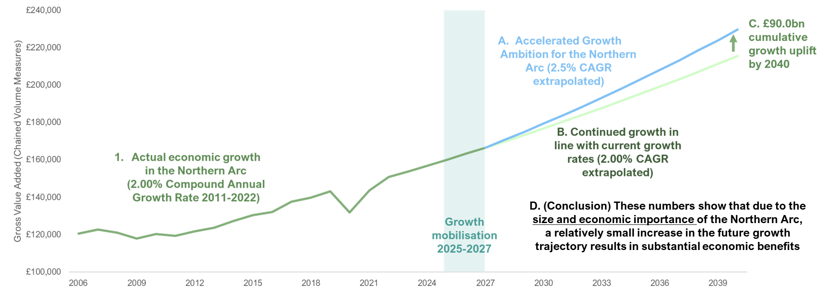

*Metro Dynamics analysis of ONS 2024 release of sub-regional GVA data. This assumption includes a two-year window where growth continues at current rates, reflecting the time required to accelerate a pipeline of investment in infrastructure and sector growth.*

These figures are illustrative of the potential economic benefit from expanding prosperity at this scale, and more work is in progress to understand the detailed implications of growth levers such as delivering increased transport connectivity.

The Northern Arc has substantial assets, but it also faces some key barriers, including poor connectivity, entrenched health inequalities and the long-run socio-economic impacts of deindustrialisation. To realise these benefits, there is a need to draw on local experience of delivery, strong partnerships and the shared commitment across the region to drive higher growth.

**The benefits of wider transformative growth beyond the Pennines**

The economies of the North are closely linked and aligned, and there is substantial potential for economies of scale and agglomeration benefits through closer economic integration with West and South Yorkshire. The potential of this region was identified as long ago as 2014 by the [City Growth Commission](https://www.thersa.org/events/), but progress on realising this potential has been slow.

To demonstrate the scale of the opportunity, if the **economies of South and West Yorkshire** were to also move from current growth rates to achieve a 2.5% CAGR rate, then the result would be a **cumulative addition of £183.5 billion to the UK economy by 2040**.

**4. Delivering against a growth ambition**

The Northern Arc demonstrates a unique ability to deliver growth benefits at pace, based on three key enabling capabilities:

**Capacity and experience to deliver growth enabling interventions:**

The Northern Arc has been and continues to be at the forefront of the mayoral revolution, with the two of the longest established MCAs in Liverpool City Region and Greater Manchester, and an emerging MCA in Cheshire and Warrington as part of the Devolution Priority Programme.

This gives the Northern Arc a distinctive level of locally-led capacity and delivery expertise, which is now translating into policy leadership at the national level. From Liverpool City Region’s pioneering use of battery powered trains to expand the Merseyrail metropolitan railway network, to the world-leading industrial decarbonisation cluster taking shape at Ellesmere Port, and Greater Manchester’s integration of the transport system as well as health and employment support through the GM Model, Northern Arc places are pushing the boundary of innovative policy design and implementation.

**Depth and maturity of local partnerships**.

The Northern Arc has strong collaborative working relationships with business, civil society and non-governmental institutions. The Northern Arc’s emerging pipeline of investable propositions demonstrates this, representing a foundation for us to build on over the next phase of the work.

So too does the close links between universities and innovation assets - who already work closely together across and beyond local boundaries - as demonstrated by the [groundbreaking collaboration agreement recently signed by the University of Liverpool and Manchester](https://mancunion.com/2025/02/06/universities-increased-collaboration/#:~:text=This%20is%20an%20initiative%20backed,to%20produce%20medicines%20and%20vaccines.), and as with pioneering collaborative research projects like the [Industrial Biotechnology Innovation Catalyst](https://www.n8research.org.uk/work-with-us/regional-growth/kickstart-economic-growth/industrial-biotechnology-innovation-catalyst/), and the £12m AI for Chemistry collaboration between University of Liverpool and Imperial College London.

**Appetite for growth and to work together to deliver that growth across the Northern Arc.**

Northern Arc local leaders, businesses and institutions strongly support economic growth, innovative housing delivery and sector development projects. For example, Liverpool City Region and Greater Manchester are the two city-regions most advanced with spatial planning, aligning employment land use, housing and infrastructure needs into a coherent package for investors.

They will continue to work together, as they have done in the development of this report, to identify, progress and accelerate key opportunities for growth with significance for the wider region.

**How could the Northern Arc reach a new growth path?**

A £90bn growth ambition is illustrative of the potential economic benefit for the UK economy as a whole, given the size and importance of the Northern Arc. While achieving this ambition will require significant intervention at a regional level, the underlying shift in economic growth indicators needed is modest relative to the UK’s long-term economic trajectory.

With the right support from Government to accelerate business and investor confidence in the growth opportunities of the Northern Arc in the short term, there is the potential to set the Northern Arc on a new growth trajectory;

1. A potential roadmap to a new growth path for the Northern Arc

|  |  |  |
| --- | --- | --- |
| Sequencing | Action for growth | Owner |
| **Longer-term** | **Through investment in infrastructure**. Both through the modern housing delivery required to support and retain the benefits of economic growth, and through the improvements in public transport and transformed regional connectivity through the Liv-Man railway. This will link two vibrant city centres to Manchester Airport and with key economic assets in Cheshire and Warrington, while unlocking capacity across the network. | Co-investment and co-development between the places of the Northern Arc alongside Government. |
| **Medium-term** | **Through partnership working to unlock major investment in sectoral growth projects.** By working closely with the private sector, institutions and investors in developing and delivering the pipeline of investable propositions under the banner of the Northern Arc. | Lead by the places, partnerships and institutions of the Northern Arc |
| **Short-term** | **Through accelerating investor confidence with the vocal backing of Government.** Clear Government backing in the short-term can send a clear signal to investors and businesses that the Northern Arc will deliver growth and investment opportunities. | Co-delivery with the backing of Government and of regional leaders |

***In the longer term: delivering growth******through investment in our infrastructure***

One of the major constraints on growth within the Northern Arc is the inadequacy of local infrastructure, and in particular with the transport connectivity challenge which holds back the functioning of the region as a cohesive economy and labour market (particularly important for the highly skilled work at the forefront of innovative activity)

Meeting this challenge would deliver substantial economic benefits. Modelling carried for the Liverpool-Manchester Railway Board has suggested that the **delivery of a new Liverpool-Manchester rail line could boost GVA[1] through**:

* **The direct impacts of the Liverpool-Manchester Railway** in increasing through services and connectivity between Liverpool and Manchester, and releasing capacity for inter-city services on a congested railway network.
* **Additional development** **impacts** with growth in office space requirements driven by new jobs resulting from the railway, housing requirements of these workers (with major developments like Warrington Bank Quay), and associated secondary commercial spaces (ie retail and locally consumed services) as a result of the direct impacts of a new Liverpool-Manchester railway.

This intervention on infrastructure shows one clear route and mechanism to accelerating economic growth within and across the Northern Arc area, and one with a clear leadership role for the public sector: by Government working in partnership with devolved leaders.

***In the medium-term: delivering growth by catalysing private investment in sector-led growth projects***

In the medium-term, there is a need to catalyse private sector investment, and in particular in those projects that will support the growth of the innovation-oriented sectors. These are not projects that are directly resulting from the increased economic activity generated by public infrastructure investment – note that these would be covered under the additional development test outlined above – but that could be supported and accelerated as part of a comprehensive, public-private partnership led approach to growth.

The economic benefits of this investment potential can be delivered at pace, based on the unique delivery capacity, investment pipelines, and strong partnership working already evident within the Northern Arc. Building on these strong foundations to meet the scale of our growth ambition will require a new approach to partnership in and across the Northern Arc.

**In helping to meet the scale of the growth ambition for the Northern Arc, local leaders will need to work closely with the private sector, institutions and investors in developing and delivering the pipeline of investable propositions, and to meet the scale of our growth ambition for the Arc. This will be the essential next task for the places, people and businesses of the Northern Arc.**

*In the short term: delivering the current growth pipeline and accelerating confidence in growth with the backing of Government*

There is an opportunity to turbocharge existing work, at a moment where there is a national imperative for a new growth trajectory. The growth ambition for the Northern Arc represents a step change in growth for the region (and given the size and economic significance of the region, for the UK as a whole).

Government will need to be a close and committed partner in this. With clear Government backing in the short-term, a clear signal to investors and businesses can be sent that the Northern Arc will deliver growth and investment opportunities.

In the short-term, local partners should continue to work to put together the pipeline of investment projects and key assets that underpin the Arc. There is a diverse set of projects - from new housing developments in urban centres and in their hinterlands, major commercial developments creating new hubs across the North for key opportunity sectors and innovation projects - that will allow this region to lead the way for a new industrial future, developing the processes, materials and technologies required.

1. [Initial modelling](https://www.greatermanchester-ca.gov.uk/media/nptlqofu/lmic-report-final.pdf) found that the new railway line could add £7bn in annual GVA by 2050