GM Early Education and Childcare Campaign
Launching w/c 21st October
The Early Education and Childcare campaign aims to raise awareness of the importance and value of the sector through celebrating the existing workforce as well as driving recruitment into the sector through promoting different roles and pathways available.
The campaign will last for 12 months and consists of video case studies and static assets. The below toolkit outlines copy to be used across social media. Please use this pack to promote our campaign to residents of Greater Manchester.
Website: GM Early Education and Childcare Workforce Campaign - Greater Manchester Combined Authority (greatermanchester-ca.gov.uk)
Contact: polly.barr@greatermanchester-ca.gov.uk
Key messages
Early education builds foundations for a child's development and lifelong learning journey. | We want all children to have the best start in life and start school ready to thrive. | Working in early education and childcare is rewarding, but challenging. | It's a great career with lots of progression. | You have the chance to make a real difference in children's lives.
Key campaign assets/videos
The campaign focusses on sharing real stories/case studies of members of our early education and childcare workforce. There is a case study from every borough, covering several different settings, roles and stages of careers. We’re launching the campaign with a hero video, before sharing a case study every week from then (schedule below).
Within the comms pack, we’ve also provided static assets (including quotes from the case studies as well as some information-based assets). Copy to accompany these assets can be found within this pack and these can be used and shared at your discretion throughout any point of the campaign.
Video schedule and copy
We will be launching the campaign with a hero video on Monday 21st October. Following on from this, we will be releasing a case study video every Wednesday commencing 23rd October. Please do not share that case study video until the date outlined below so it aligns with our release of the video. Each case study has a main landscape video and 2 x shorter form vertical videos.
Videos can be downloaded below (access to WeTransfer required, please contact us if this is an issue). Subtitle files are within the comms pack zip file.
Date | Video | Copy
Mon 21st Oct | Hero/launch video  DOWNLOAD HERO/LAUNCH VIDEO | Today, @greatermcr are launching their Early Education and Childcare campaign, aiming to celebrate the workforce and shine a light on difference they make for children and families ⭐️  Each week, they'll be sharing videos from a range of settings across the whole of the city-region.
Find out more about the campaign and the world of early education and childcare 👉 https://bit.ly/GMEarlyEd
#GMEarlyEducation
Weds 23rd Oct | Salford (Kathryn, Nursery Manager, Rainbows Nursery)  DOWNLOAD SALFORD VIDEOS | Kathryn is a nursery manager who started at Rainbows Nursery doing work experience when she was 15, before being offered an apprenticeship!  "There's no such thing as just playing, playing builds on everything we do, and you can teach so much through play."  #GMEarlyEducation
Weds 30th Oct | Rochdale (Scarlet, Early Years Educator Apprentice (Level 3), The Nursery: Special Educational Needs and Disability Childcare Ltd)  DOWNLOAD ROCHDALE VIDEOS | "You're just so proud because they learn new things every day... it's just amazing, the way that they can make you feel so loved and appreciated"  - Scarlett, an apprentice at the Nursery of Special Educational Needs and Disability Childcare  #GMEarlyEducation
Weds 6th Nov | Trafford (Reanne, Childminder)  DOWNLOAD TRAFFORD VIDEOS | "There really is a learning opportunity in everything that we do, even the simplest of tasks. You're building the foundations for their later development."  We spoke to Reanne about her experience of being a childminder for 12 years!  #GMEarlyEducation
Weds 13th Nov | Oldham (Amy and Harley, Buttercup Corner Nursery)  DOWNLOAD OLDHAM BC VIDEOS | We chatted to Amy and Harley, who both work in a nursery👶  "As an apprentice, you're learning... you're getting taught new skills, you're getting taught how to do new things, I've basically grown up here!" – Amy  #GMEarlyEducation
Weds 20th Nov | Manchester (Kristiana, Early Years Foundation Stage Teaching Assistant (Level 3), Chorlton Park Primary School)  DOWNLOAD MANCHESTER VIDEOS | "I started as an apprentice, and I think I found my calling and just decided to carry on with the education and got my Level 3 and went to get on to do my degree!"  We spoke to Kristiana about her journey to becoming a teaching assistant and how much she loves it.  #GMEarlyEducation
Weds 27th Nov | Bury (Charlie, Early Years Apprentice (Level 3), Tiddlywinks Nursery Group)  DOWNLOAD BURY VIDEOS | "It's a different world when you come into a nursery. The children, their imaginations - it's just happiness".  Charlie works in the baby room at Tiddlywinks Nursery and spoke to us about how much she loves her job and the impact she has 👩‍🍼  #GMEarlyEducation
Weds 4th Dec | Tameside (Christopher, Deputy Manager, The Yellow Door Day Nursery)  DOWNLOAD TAMESIDE VIDEOS | Christopher has worked in early education and childcare for over 20 years.  "You can see the progression that the children have made from being very, very unsure about themselves to then not wanting to leave us!"  #GMEarlyEducation
Weds 11th Dec | Oldham (Reesa, Managing Director, Golden Petals Pre-school)  DOWNLOAD OLDHAM GP VIDEOS | "Seeing the children grow itself is a miracle. It’s the foundation stage and I really wanted to make a difference; I wanted them to learn today to build tomorrow.”  - Reesa, Managing Director at Golden Petals Pre-school  #GMEarlyEducation
Weds 18th Dec | Stockport (Milli, Childminder)  DOWNLOAD STOCKPORT VIDEOS | "I've always been quite curious and passionate about early years brain development... I've always wanted to create this home from home environment"  Milli is a childminder based in Stockport and shared with us how much she loves her job 👩‍👧‍👦  #GMEarlyEducation
Weds 8th Jan | Wigan (Sonia, Teaching Assistant (Level 2), Hindley Nursery School)  DOWNLOAD WIGAN VIDEOS | "You see the parents crying because they never realised [their children] could do such a thing, and we were part of that"  Sonia is a teaching assistant in a nursery and shares her experience of working with children with special educational needs. #GMEarlyEducation
Weds 15th Jan | Bolton (Millie, Nursery Practitioner, Little Lambs Nursery)  DOWNLOAD BOLTON VIDEOS | Millie is an Early Years Educator, caring for children from six weeks to four years 👶  "Honestly, it's one of the most rewarding jobs ever because you get to see that little baby grow into a toddler and then grow into a preschool child“#GMEarlyEducation
Asset bank copy (please click to jump to that section)
- Bolton – Millie, Nursery Practitioner, Little Lambs Nursery
- Bury – Charlie, Early Years Apprentice (Level 3), Tiddlywinks Nursery Group
- Manchester – Kristiana, Early Years Foundation Stage Teaching Assistant (Level 3), Chorlton Park Primary School
- Oldham – Amy, Early Years Practitioner, Buttercup Corner Nursery
- Harley, Early Years Apprentice (Level 2)
- Oldham – Reesa, Managing Director, Golden Petals Pre-school
- Rochdale – Scarlet, Early Years Educator Apprentice (Level 3), The Nursery: Special Educational Needs and Disability Childcare Ltd
- Salford – Kathryn. Nursery Manager, Rainbows Nursery
- Stockport – Milli, Childminder
- Tameside – Christopher, Deputy Manager, The Yellow Door Day Nursery
- Trafford – Reanne, Childminder
- Wigan – Sonia, Teaching Assistant (Level 2), Hindley Nursery School
- General campaign messaging
For insta change last line to: Find out more about early education and childcare by heading to @greatermcr

Bolton – Millie, Nursery Practitioner, Little Lambs Nursery
Short form copy | Long form copy (if applicable) | Asset | Alt text
"It's lovely because you've been a part of their life." - Millie a Nursery Practitioner at Little Lambs Nursery in Bolton 👶  Find out more about early education and childcare👉 https://bit.ly/GMEarlyEd  #GMEarlyEducation |  | 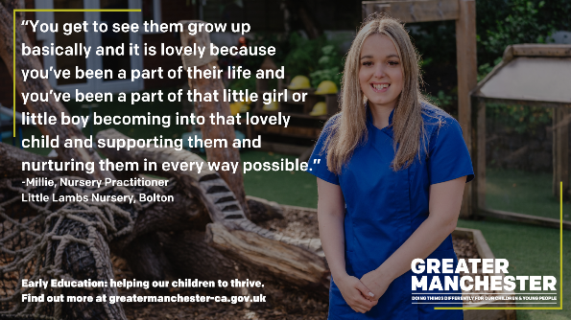 | “You get to see them grow up basically …and you’ve been a part of that little girl or little boy becoming into that lovely child and supporting them and nurturing them in every way possible.”  Early Education: helping our children to thrive. Find out more at greatermanchester-ca.gov.uk  Over image of nursery practitioner standing outside.
"Since coming to Little Lambs nursery, my confidence has gone up and up"  Millie started as an Early Years Educator when she was 16 and plays a key role in helping children develop from as young babies 👦  #GMEarlyEducation | "Since coming to Little Lambs nursery, my confidence has gone up and up"  Millie started as an Early Years Educator when she was 16 and plays a key role in helping children develop from as young babies 👦  High quality early education and childcare supports our youngest children to be safe, happy and grow ✨  Find out more about the world of early education and childcare 👉 https://bit.ly/GMEarlyEd  #GMEarlyEducation | 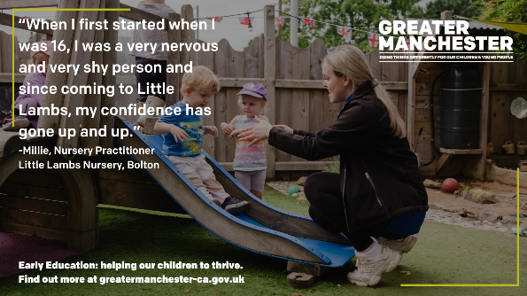 | Early Education: helping our children to thrive. Find out more at greatermanchester-ca.gov.uk  Over image of nursery practitioner playing with children on a slide.
Follow up tweet: High quality early education and childcare supports our youngest children to be safe, happy and grow ✨

Find out more about the world of early education and childcare 👉https://bit.ly/GMEarlyEd

#GMEarlyEducation
"You get to see that little baby grow into a toddler and then grow into a preschool child ready for school." -Millie, Nursery Practitioner  A career in early education allows you to play a vital role in a child's life ✨  👉 https://bit.ly/GMEarlyEd  #GMEarlyEducation |  | 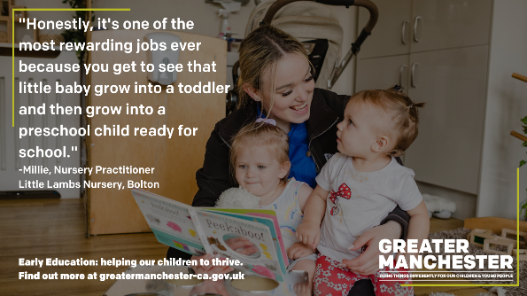 | "Honestly, it's one of the most rewarding jobs ever”  Early Education: helping our children to thrive. Find out more at greatermanchester-ca.gov.uk  Over image of nursery practitioner reading a book to two young children.

Bury – Charlie, Early Years Apprentice (Level 3), Tiddlywinks Nursery Group
Short form copy | Long form copy (if applicable) | Asset | Alt text
"The children, their imaginations - it's just happiness."  - Charlie, an Early Years Apprentice (Level 3) at Tiddlywinks Nursery Group in Bury 👩‍🍼  👉 https://bit.ly/GMEarlyEd  #GMEarlyEducation |  | 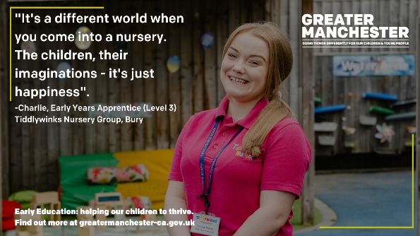 | "It's a different world when you come into a nursery”.  Early Education: helping our children to thrive. Find out more at greatermanchester-ca.gov.uk  Over image of adult standing outside.
“There's never a bad day with babies." 👶  Charlie, an Early Years Apprentice works in the baby room at a nursery. Her role includes playing and interacting with the babies, caring for them, communicating with families and supporting their development to help them thrive. | “There's never a bad day with babies." 👶  Charlie, an Early Years Apprentice works in the baby room at a nursery. Her role includes playing and interacting with the babies, caring for them, communicating with families and supporting their development to help them thrive.  Find out more about the importance of early education and childcare 👉 https://bit.ly/GMEarlyEd  #GMEarlyEducation | 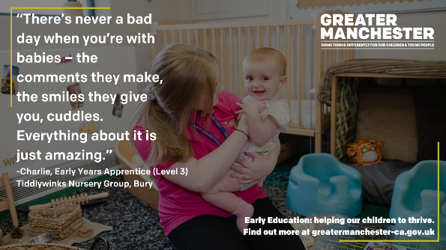 | “The comments they make, the smiles they give you, cuddles. Everything about it is just amazing.” -Charlie, Early Years Apprentice (Level 3)  Tiddlywinks Nursery Group, Bury  Early Education: helping our children to thrive. Find out more at greatermanchester-ca.gov.uk  Over image of adult hugging a baby.
Follow up Tweet: Find out more about the importance of early education and childcare 👉 https://bit.ly/GMEarlyEd

#GMEarlyEducation
Have you ever considered a career in early education and childcare?  You can play a key role in the development of babies and young children, building the foundations to help them develop and thrive ✨  👉 https://bit.ly/GMEarlyEd  #GMEarlyEducation |  | 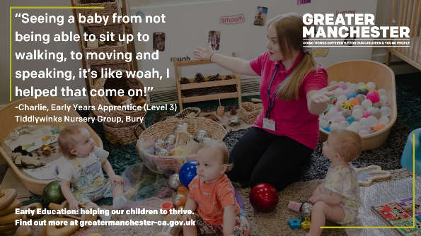 | “Seeing a baby from not being able to sit up to walking, to moving and speaking, it’s like woah, I helped that come on!”  -Charlie, Early Years Apprentice (Level 3)  Tiddlywinks Nursery Group, Bury  Early Education: helping our children to thrive. Find out more at greatermanchester-ca.gov.uk  Over image of adult playing in a nursery setting with three babies.

Manchester – Kristiana, Early Years Foundation Stage Teach Assistant (Level 3), Chorlton Park Primary School
Short form copy | Asset | Alt text
"The difference you can make to children's lives at such as young age is quite a privilege."  - Kristiana, Early Years Foundation Stage Teaching Assistant (Level 3), Chorlton park Primary School, Manchester 🐝  👉 https://bit.ly/GMEarlyEd  #GMEarlyEducation | 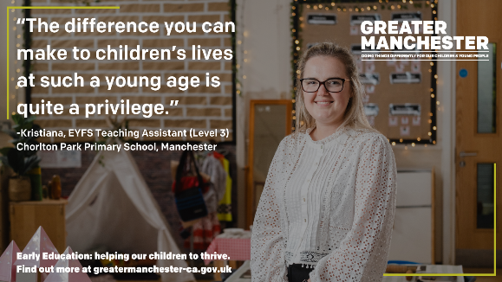 | Early Education: helping our children to thrive. Find out more at greatermanchester-ca.gov.uk  Over image of adult standing in a classroom setting.
"The sense of pride you get at the end of your working day is like no other." -Kristiana, Teaching Assistant  A career in childcare and early education is challenging yet rewarding; no two days are the same.  👉 https://bit.ly/GMEarlyEd  #GMEarlyEducation | 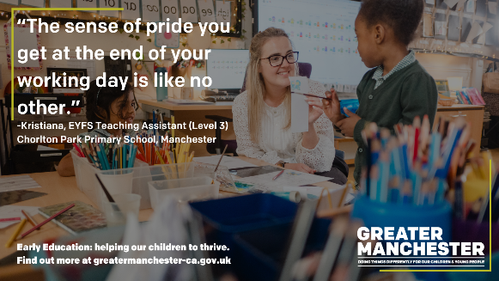 | Early Education: helping our children to thrive. Find out more at greatermanchester-ca.gov.uk  Over image of adult sitting at a table and drawing with two young children.
"I started as an apprentice, and I think I found my calling." -Kristina, a Teaching Assistant in Manchester  There are several different routes and pathways to a career in early education and childcare, find out more about where to start 👉 https://bit.ly/GMEarlyEd  #GMEarlyEducation | 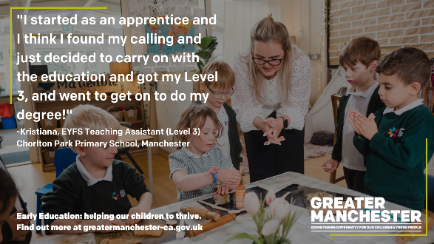 | "and just decided to carry on with the education and got my Level 3, and went to get on to do my degree!" -Kristiana, EYFS Teaching Assistant (Level 3)  Chorlton Park Primary School, Manchester  Early Education: helping our children to thrive. Find out more at greatermanchester-ca.gov.uk  Over image of adult at a table with a group of children doing crafts.

Oldham – Amy, Early Years Practitioner, Buttercup Corner Nursery
Short form copy | Asset | Alt text
"You're teaching them basically life skills from day one, it's a very rewarding job."  - Amy, an Early Years Practitioner at Buttercup Corner nursery in Oldham 🌼  👉 https://bit.ly/GMEarlyEd  #GMEarlyEducation | 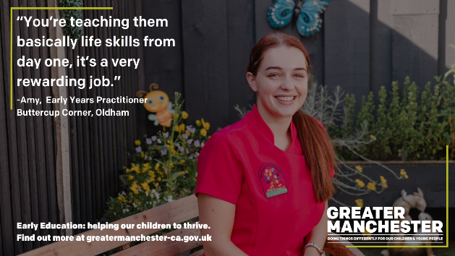 | Early Education: helping our children to thrive. Find out more at greatermanchester-ca.gov.uk  Over image of adult sat outside.
Early education supports the development of our youngest children; it helps children to build resilience, develop relationships and understand emotions👩‍🍼  Members of our early education workforce make a real difference 👉https://bit.ly/GMEarlyEd  #GMEarlyEducation | 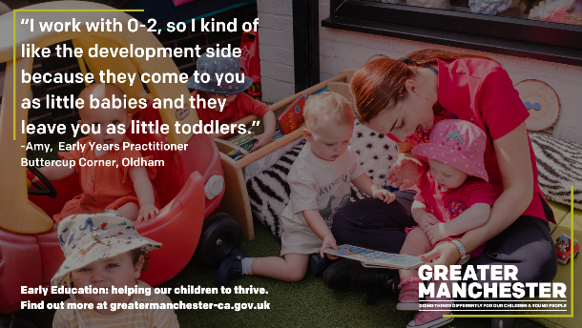 | “I work with 0-2, so I kind of like the development side because they come to you as little babies and they leave you as little toddlers.” -Amy, Early Years Practitioner. Buttercup Corner, Oldham.  Early Education: helping our children to thrive. Find out more at greatermanchester-ca.gov.uk  Over image of adult sitting and reading a book to a group of children.
There are several routes into a role in early years, including apprenticeships.  Becoming an apprentice enables you to earn while you learn - you’ll be paid a salary while gaining the qualifications needed for a career in early years.  👉https://bit.ly/GMEarlyEd  #GMEarlyEducation | 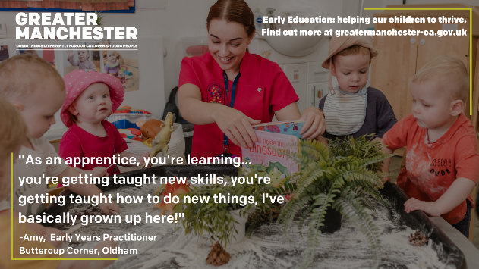 | "As an apprentice, you're learning... you're getting taught new skills, you're getting taught how to do new things, I've basically grown up here!" -Amy, Early Years Practitioner  Buttercup Corner, Oldham  Early Education: helping our children to thrive. Find out more at greatermanchester-ca.gov.uk  Over image of adult playing with four children at a table.

Oldham – Harley, Early Years Apprentice (Level 2), Buttercup Corner Nursery
Short form copy | Long form copy (if applicable) | Asset | Alt text
"I get so much out of it, I feel inspired" 💡  - Harley, an Early Years Apprentice (Level 2) at Buttercup Corner nursery in Oldham  👉 https://bit.ly/GMEarlyEd  #GMEarlyEducation |  | 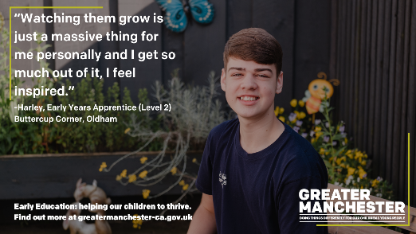 | “Watching them grow is just a massive thing for me personally.”  Early Education: helping our children to thrive. Find out more at greatermanchester-ca.gov.uk  Over image of young adult sitting outside.
Early education is the first step in a child’s education and helps develop the cognitive, social and emotional skills that set them up for life.  Although challenging, it's a fun and rewarding job where apprentices get to see children learn and grow thanks to their support. | Early education is the first step in a child’s education and helps develop the cognitive, social and emotional skills that set them up for life.  Although challenging, it's a fun and rewarding job where apprentices get to see children learn and grow thanks to their support.  There are two entry-level early years apprenticeships: level 2 early years practitioner and level 3 early years educator, both apprenticeships are suitable for those with no previous experience 💡  Find out more about apprenticeships 👉 https://bit.ly/GMEarlyEd  #GMEarlyEducation | 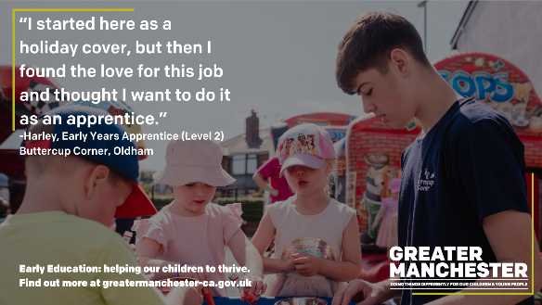 | “I started here as a holiday cover, but then I found the love for this job and thought I want to do it as an apprentice.” Harley, Early Years Apprentice (Level 2). Buttercup Corner, Oldham  Early Education: helping our children to thrive. Find out more at greatermanchester-ca.gov.uk  Over image of young adult playing outside with three children.
Follow up Tweet: There are two entry-level early years apprenticeships: level 2 early years practitioner and level 3 early years educator, both apprenticeships are suitable for those with no previous experience 💡

Find out more about apprenticeships 👉 https://bit.ly/GMEarlyEd

#GMEarlyEducation

Oldham - Reesa, Managing Director, Golden Petals Pre-School
Short form copy | Long form copy (if applicable) | Asset | Alt text
"I've lived in Oldham all my life. I really wanted to make a change in this area” - Reesa, Managing Director of Golden Petals Pre-School in Oldham  Reesa set up her business mid-pandemic and went on to win the Young Entrepreneur Award at the Oldham Business Awards 🌟 | "I've lived in Oldham all my life. I really wanted to make a change in this area” - Reesa, Managing Director of Golden Petals Pre-School in Oldham  Reesa set up her business mid-pandemic and went on to win the Young Entrepreneur Award at the Oldham Business Awards 🌟  Early education and childcare is an amazing choice of career, with a wide range of roles, routes and opportunities 💡  Find out more about careers in childcare and early education 👉 https://bit.ly/GMEarlyEd  #GMEarlyEducation | 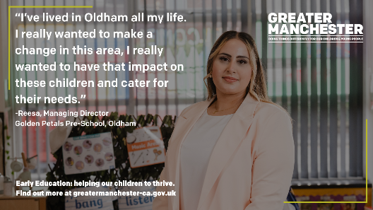 | “I really wanted to have that impact on these children and cater for their needs.” Early Education: helping our children to thrive. Find out more at greatermanchester-ca.gov.uk  Over image of adult stood inside pre-school setting.
Follow up tweet: Early education and childcare is an amazing choice of career, with a wide range of roles, routes and opportunities 💡

Find out more about careers in childcare and early education 👉 https://bit.ly/GMEarlyEd

#GMEarlyEducation
"It's a tough, demanding job; your passion can drive you a long way." - Reesa, managing director of Golden petals Pre-School  Find out more about careers in Early Education 👉 https://bit.ly/GMEarlyEd  #GMEarlyEducation |  | 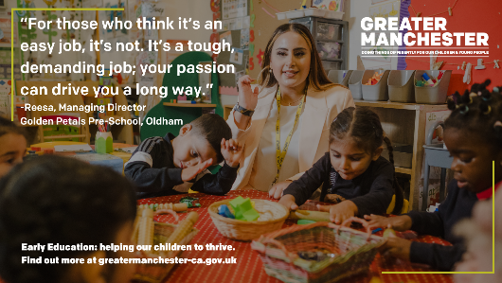 | “For those who think it’s an easy job, it’s not.”  Early Education: helping our children to thrive. Find out more at greatermanchester-ca.gov.uk  Over image of adult playing with a group of children at a table.
"Working with these children, they make your day." - Reesa, Managing director of a Pre-School 👩‍👧  Working in early education and childcare, no two days are ever the same 👉 https://bit.ly/GMEarlyEd  #GMEarlyEducation |  | 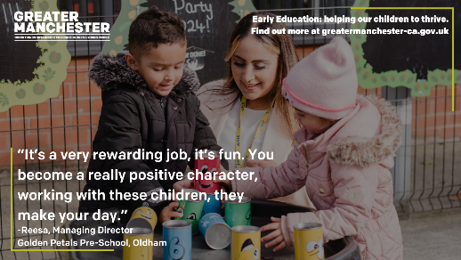 | “It’s a very rewarding job, it’s fun. You become a really positive character” -Reesa, Managing Director  Golden Petals Pre-School, Oldham  Early Education: helping our children to thrive. Find out more at greatermanchester-ca.gov.uk  Over image of an adult playing stacking cups with two young children.

Rochdale – Scarlet, Early Years Educator Apprentice (Level 3), The Nursery: Special Educational Needs and Disability Childcare
Short form copy | Long form copy (if applicable) | Asset | Alt text
"It is really hard, but just realise it's all part of making these children who they are."  - Scarlet, an Early Years Educator Apprentice (Level 3) at The Nursery: Special Educational Needs and Disability Childcare Ltd in Rochdale ✨  👉 https://bit.ly/GMEarlyEd  #GMEarlyEducation |  | 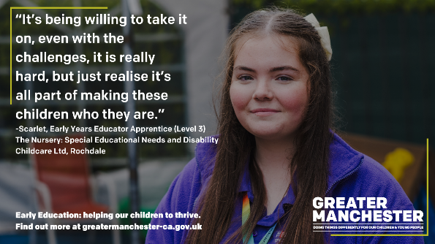 | “It’s being willing to take it on, even with the challenges”  The Nursery: Special Educational Needs and Disability Childcare Ltd, Rochdale  Early Education: helping our children to thrive. Find out more at greatermanchester-ca.gov.uk Over image of adult stood outside.
"You're just so proud because they learn new things every day... it's just amazing, the way they can make you feel so loved and appreciated" 💝  -Scarlet, an Early Years Educator at a SEND nursery in Rochdale | "You're just so proud because they learn new things every day... it's just amazing, the way they can make you feel so loved and appreciated" 💝  -Scarlet, an Early Years Educator at a SEND nursery in Rochdale  The sector plays an important role in providing inclusive early education that meets the needs of all children in Greater Manchester 🌟  Find out more 👉 https://bit.ly/GMEarlyEd  #GMEarlyEducation | 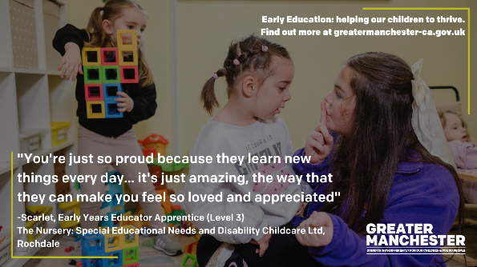 | Early Education: helping our children to thrive. Find out more at greatermanchester-ca.gov.uk  Over image of adult talking to a child with another child playing in the background.
Follow up tweet: The sector plays an important role in providing inclusive early education that meets the needs of all children in Greater Manchester 🌟

Find out more 👉 https://bit.ly/GMEarlyEd

#GMEarlyEducation
Every child is unique, with different needs and some may need additional support to help them meet their developmental milestones 🧒  Our amazing early education and childcare workforce play a vital role in making a difference and helping our young children to thrive 🌟 | Every child is unique, with different needs and some may need additional support to help them meet their developmental milestones 🧒  Our amazing early education and childcare workforce play a vital role in making a difference and helping our young children to thrive 🌟  Find out more👉 https://bit.ly/GMEarlyEd  #GMEarlyEducation | 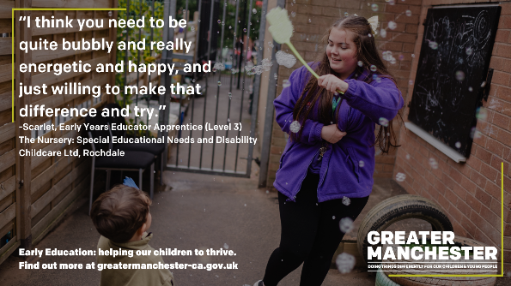 | “I think you need to be quite bubbly and really energetic and happy, and just willing to make that difference and try.” -Scarlet, Early Years Educator Apprentice (Level 3)  The Nursery: Special Educational Needs and Disability Childcare Ltd, Rochdale  Early Education: helping our children to thrive. Find out more at greatermanchester-ca.gov.uk  Over image of an adult playing with a young child outside and waving bubbles.
Follow up tweet: Find out more👉 https://bit.ly/GMEarlyEd

#GMEarlyEducation

Salford – Kathryn Nursery Manager, Rainbows Nursery
Short form copy | Long form copy (if applicable) | Asset | Alt text
"There is no such thing as just playing" - Kathryn, Nursery Manager at Rainbows Nursery in Salford  Early education is essential for building foundations for a child's lifelong learning journey. Playing with adults helps children learn about the world and understand others 👶 | "There is no such thing as just playing" - Kathryn, Nursery Manager at Rainbows Nursery in Salford  Early education is essential for building foundations for a child's lifelong learning journey. Playing with adults helps children learn about the world and understand others 👶  Early Education can support communication and language development; an essential life skill that directly impacts on a young child’s ability to learn, make friends and their future life chances.  👉 https://bit.ly/GMEarlyEd  #GMEarlyEducation | 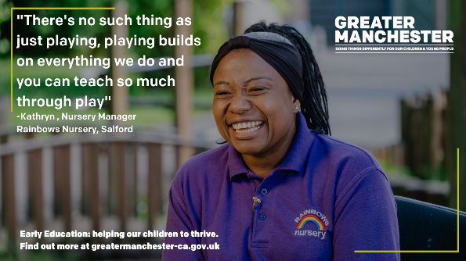 | "Playing builds on everything we do and you can teach so much through play" -Kathryn , Nursery Manager  Rainbows Nursery, Salford  Early Education: helping our children to thrive. Find out more at greatermanchester-ca.gov.uk  Over image of adult sat outside on a bench.
Follow up tweet: Early Education can support communication and language development; an essential life skill that directly impacts on a young child’s ability to learn, make friends and their future life chances.

👉 https://bit.ly/GMEarlyEd
#GMEarlyEducation
"No two days are ever the same" - Kathryn, Nursery Manager  From planning and delivering activities, to working in partnership with parents and carers to support children, early education is an exciting and rewarding sector for you to make a real difference in children's lives. | "No two days are ever the same" - Kathryn, Nursery Manager  From planning and delivering activities, to working in partnership with parents and carers to support children, early education is an exciting and rewarding sector for you to make a real difference in children's lives.  Find out more about different roles and routes into the sector 👉 https://bit.ly/GMEarlyEd  #GMEarlyEducation | 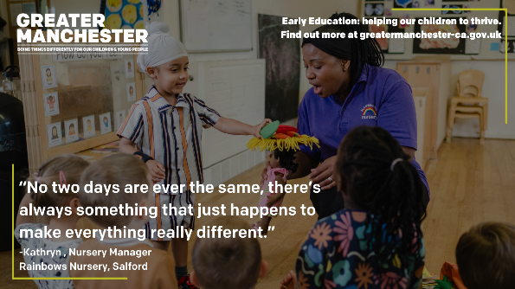 | "There’s always something that just happens to make everything really different.” -Kathryn , Nursery Manager  Rainbows Nursery, Salford  Early Education: helping our children to thrive. Find out more at greatermanchester-ca.gov.uk  Over image of an adult and a child playing with a puppet in a nursery setting.
Follow up tweet Find out more about different roles and routes into the sector 👉 https://bit.ly/GMEarlyEd

#GMEarlyEducation
"You've got that responsibility to be that great role model and give them that opportunity to learn and grow" - Kathryn, Nursery Manager  Find out more about early education in Greater Manchester 👉 https://bit.ly/GMEarlyEd  #GMEarlyEducation |  | 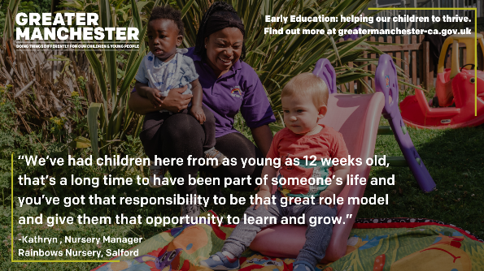 | “We’ve had children here from as young as 12 weeks old, that’s a long time to have been part of someone’s life”  Rainbows Nursery, Salford  Early Education: helping our children to thrive. Find out more at greatermanchester-ca.gov.uk  Over image of adult playing outside, holding a child and watching another child go down a slide.

Stockport – Milli, Childminder
Short form copy | Long form copy (if applicable) | Asset | Alt text
"We want parents to trust that we'll look after them as if they were our own children" - Milli, a Childminder in Stockport 👩‍👧  High quality early education is also reliable childcare which helps children and families to thrive 🌟  👉https://bit.ly/GMEarlyEd  #GMEarlyEducation |  | 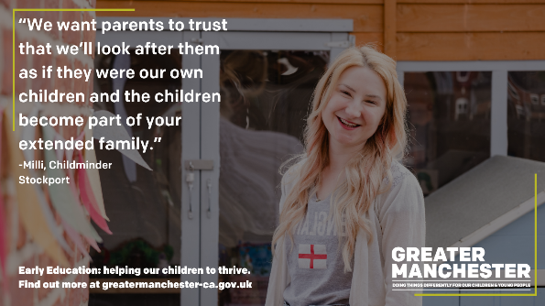 | “and the children become part of your extended family.”  Early Education: helping our children to thrive. Find out more at greatermanchester-ca.gov.uk  Over image of adult stood outside a house.
"It's a lovely profession, to see the children grow and thrive with you"-Milli, Childminder  Working in early education and childcare allows you to play a role in helping children understand their feelings and the world around them, developing their skills to interact with others. | "It's a lovely profession, to see the children grow and thrive with you" - Milli, a Childminder  Working in early education and childcare allows you to play a role in helping children understand their feelings and the world around them, developing their skills to interact and play with others 💡  Find out more 👉https://bit.ly/GMEarlyEd  #GMEarlyEducation | 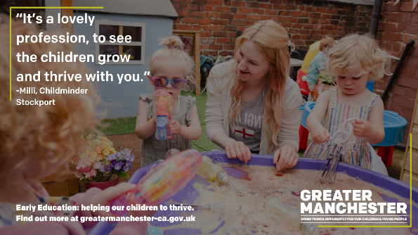 | Early Education: helping our children to thrive. Find out more at greatermanchester-ca.gov.uk.  Over image of adult playing in a sandbox with a group of children.
Follow up tweet: Find out more 👉 https://bit.ly/GMEarlyEd

#GMEarlyEducation
"I've always wanted to create this home from home environment" - Milly, a Childminder  Childminders offer professional childcare and early education, looking after small groups of children of different ages and from different families.  👉https://bit.ly/GMEarlyEd  #GMEarlyEducation |  | 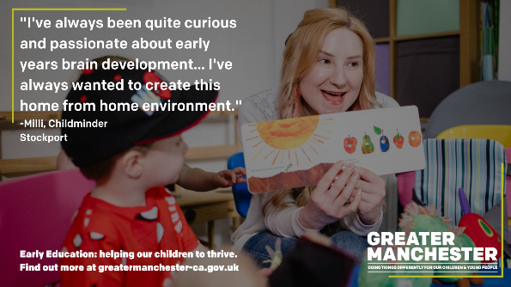 | "I've always been quite curious and passionate about early years brain development." -Milli, Childminder  Stockport  Early Education: helping our children to thrive. Find out more at greatermanchester-ca.gov.uk  Over image of an adult reading a book to a young child.

Tameside – Christopher, Deputy Manager, Yellow Door Day Nursery
Short form copy | Long form copy (if applicable) | Asset | Alt text
"We are educators, we're many things that come with that" - Christopher, Deputy Manager at The Yellow Door Day Nursery in Tameside  The first five years of a child’s life lay the foundations for health and happiness in later life. | "We are educators, we're many things that come with that" - Christopher, Deputy Manager at The Yellow Door Day Nursery in Tameside  The first five years of a child’s life lay the foundations for health and happiness in later life  However, 7 in 10 parents are unaware of the importance of the first five years of life, and research suggests parents often wait till until child is of school age to encourage development.  (State of the Nation: Understanding Public Attitudes to The Early Years)  👉 https://bit.ly/GMEarlyEd  #GMEarlyEducation | 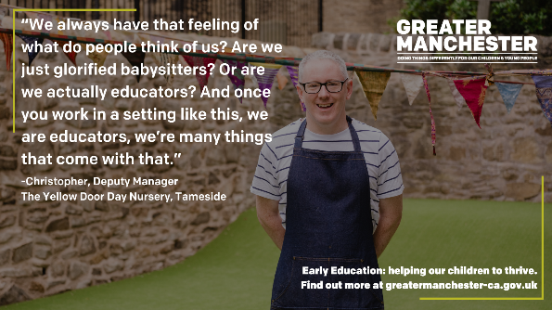 | “We always have that feeling of what do people think of us? Are we just glorified babysitters? Or are we actually educators? And once you work in a setting like this…” Early Education: helping our children to thrive. Find out more at greatermanchester-ca.gov.uk  Over image of adult stood in garden of nursery.
Follow up tweet: However, 7 in 10 parents are not aware of the importance of this period to brain development.

(State of the Nation: Understanding Public Attitudes to The Early Years)

👉 https://bit.ly/GMEarlyEd

#GMEarlyEducation
"For me as an adult, there isn't a job like this" - Christopher, Deputy Manager of a nursery  Although challenging, a career in early years is incredibly rewarding 👨‍👦  Find out more about different jobs and routes in the sector 👉https://bit.ly/GMEarlyEd  #GMEarlyEducation |  | 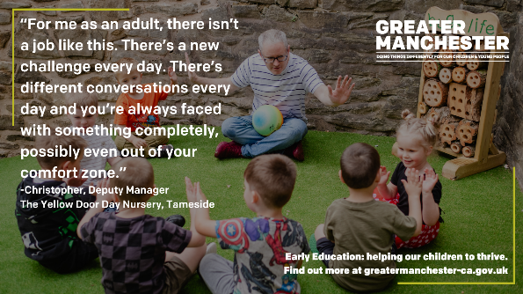 | “There’s a new challenge every day. There’s different conversations every day and you’re always faced with something completely, possibly even out of your comfort zone.” -Christopher, Deputy Manager  The Yellow Door Day Nursery, Tameside  Early Education: helping our children to thrive. Find out more at greatermanchester-ca.gov.uk  Over image of adult sat outside with a group of children playing with a ball.
"You can see the progression that the children have made" - Christopher, Deputy Manager of a nursery  Our early years workforce is invaluable in making a real difference in helping children to build resilience, develop relationships and understand emotions ✨  #GMEarlyEducation |  | 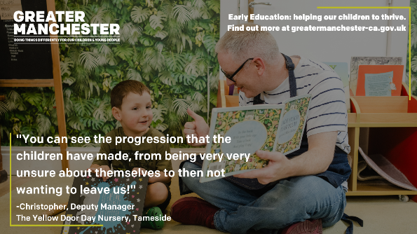 | "From being very very unsure about themselves to then not wanting to leave us!" -Christopher, Deputy Manager  The Yellow Door Day Nursery, Tameside  Early Education: helping our children to thrive. Find out more at greatermanchester-ca.gov.uk  Over image of an adult reading a book to a young child.

Trafford – Reanne, Childminder
Short form copy | Long form copy (if applicable) | Asset | Alt text
"There really is a learning opportunity in everything we do, even in the simplest of tasks" - Reanne, a Childminder in Trafford  Early education is vital in building foundations for child's lifelong learning journey. Play helps a young child to learn, develop and thrive ✨ | "There really is a learning opportunity in everything we do, even in the simplest of tasks" - Reanne, a Childminder in Trafford  Early education is vital in building foundations for child's lifelong learning journey. Play helps young child to learn, develop and thrive ✨  Find out more about the early education sector in Greater Manchester 👉 https://bit.ly/GMEarlyEd  #GMEarlyEducation  👉 | 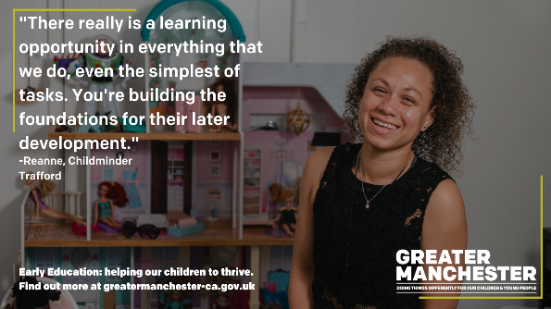 | "You're building the foundations for their later development."  Early Education: helping our children to thrive. Find out more at greatermanchester-ca.gov.uk  Over image of adult sat infront of a doll’s house.
Follow up tweet: Follow up tweet: Find out more about the early education sector in Greater Manchester 👉 https://bit.ly/GMEarlyEd

#GMEarlyEducation

Childminders offer professional, flexible childcare and early education, looking after children of different ages.  They play a vital role in supporting the early learning and development of children of all ages, working closely with parents to provide bespoke childcare. | Childminders offer professional, home-from-home childcare and early education, looking after children of different ages.  They play a vital role in supporting the early learning and development for children of all ages, working closely with parents to provide bespoke childcare.  Find out more 👉https://bit.ly/GMEarlyEd  #GMEarlyEducation | 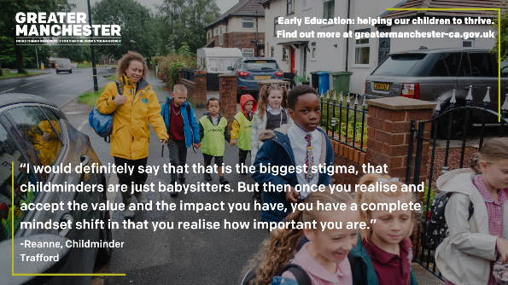 | “I would definitely say that that is the biggest stigma, that childminders are just babysitters. But then once you realise and accept the value and the impact you have, you have a complete mindset shift in that you realise how important you are.” -Reanne, Childminder  Trafford  Early Education: helping our children to thrive. Find out more at greatermanchester-ca.gov.uk  Over image of adult walking along a road with a group of young children.
Follow up tweet: Find out more 👉 https://bit.ly/GMEarlyEd

#GMEarlyEducation
"If you're prepared to put in the work, the benefits of it are fantastic" - Reanne, a Childminder  Registered childminders are usually self-employed and run their own business, offering a degree of flexibility that other roles may not have. | "If you're prepared to put in the work, the benefits of it are fantastic" - Reanne, a Childminder  Registered childminders are usually self-employed and run their own business, offering a degree of flexibility that other roles may not have.  Find out more 👉https://bit.ly/GMEarlyEd  #GMEarlyEducation | 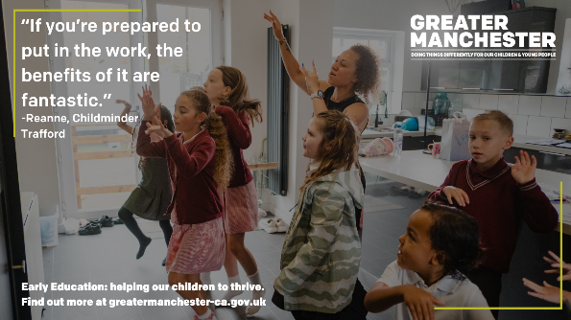 | Early Education: helping our children to thrive. Find out more at greatermanchester-ca.gov.uk  Over image of adult dancing in kitchen with a group of children.
Find out more 👉 https://bit.ly/GMEarlyEd

#GMEarlyEducation

Wigan – Sonia, Teaching Assistant (Level 2), Hindley Nursery School
Short form copy | Long form copy (if applicable) | Asset | Alt text
All young children are unique, with different needs and some may need additional support to help them meet their developmental milestones.  Each family is also unique, and members of the workforce work in partnership with parents and carers to support children to thrive ✨ | All young children are unique, with different needs and some may need additional support to help them meet their developmental milestones.  Each family is also unique, and members of the workforce work in partnership with parents and carers to support children to thrive ✨  Find out more about our childcare and early education sector here in Greater Manchester 👉 https://bit.ly/GMEarlyEd  #GMEarlyEducation | 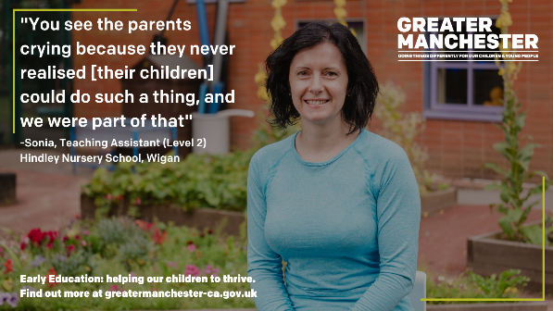 | Early Education: helping our children to thrive. Find out more at greatermanchester-ca.gov.uk  Over image of adult sat outside.
Follow up tweet: Find out more about our childcare and early education sector here in Greater Manchester 👉 https://bit.ly/GMEarlyEd

#GMEarlyEducation
"This is very, very rewarding." - Sonia, Teaching Assistant (Level 2) at Hindley Nursery School in Wigan  Working in early education and childcare is rewarding, but challenging, no 2 days are the same and you can make a real difference.  https://bit.ly/GMEarlyEd  #GMEarlyEducation |  | 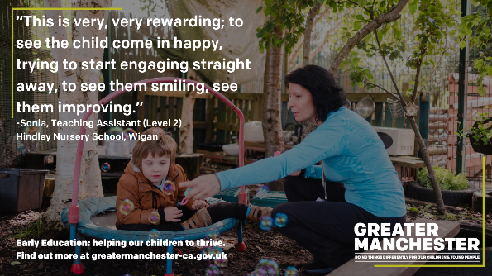 | “To see the child come in happy, trying to start engaging straight away, to see them smiling, see them improving.” -Sonia, Teaching Assistant (Level 2)  Hindley Nursery School, Wigan  Early Education: helping our children to thrive. Find out more at greatermanchester-ca.gov.uk  Over image of adult playing outside with a child and pointing at bubbles.
A career in early education and childcare offers exciting opportunities for development and progression.  Find out more about starting your career 👉https://bit.ly/GMEarlyEd  #GMEarlyEducation |  | 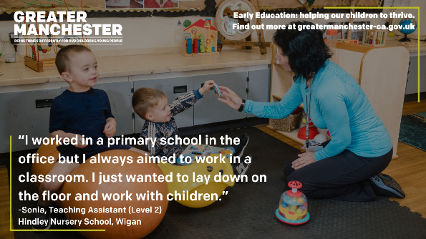 | “I worked in a primary school in the office but I always aimed to work in a classroom. I just wanted to lay down on the floor and work with children.” -Sonia, Teaching Assistant (Level 2)  Hindley Nursery School, Wigan  Early Education: helping our children to thrive. Find out more at greatermanchester-ca.gov.uk  Over image of adult kneeling on the floor and playing with two children.

General campaign messaging
Short form copy | Asset | Alt text
Children who access high-quality early education are more likely to perform better in school, with benefits extending into adulthood 👧  Find out more about early education and childcare 👉 https://bit.ly/GMEarlyEd  #GMEarlyEducation | 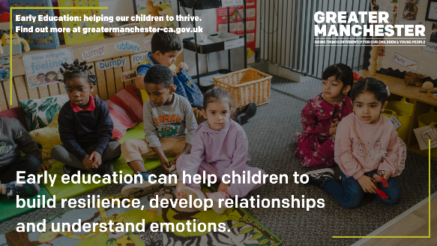 | Early education can help children to build resilience, develop relationships and understand emotions.  Early Education: helping our children to thrive. Find out more at greatermanchester-ca.gov.uk  Over image of group of six children sat on the floor of a nursery setting.
When children are healthy, safe and supported in their early years, they are better able to reach their full potential as adults 👨‍👦  👉 https://bit.ly/GMEarlyEd  #GMEarlyEducation | 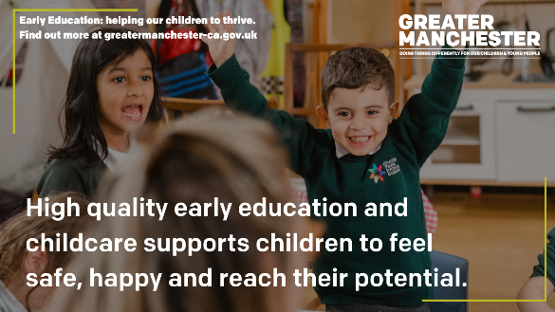 | High quality early education and childcare supports children to feel safe, happy and reach their potential.  Early Education: helping our children to thrive. Find out more at greatermanchester-ca.gov.uk  Over image of two children sat at a table in a school setting.
Across Greater Manchester, there are over 2,600 childcare providers, offering over 71,000 childcare places 👶  Find out more about the early education and childcare sector👉 https://bit.ly/GMEarlyEd  #GMEarlyEducation | 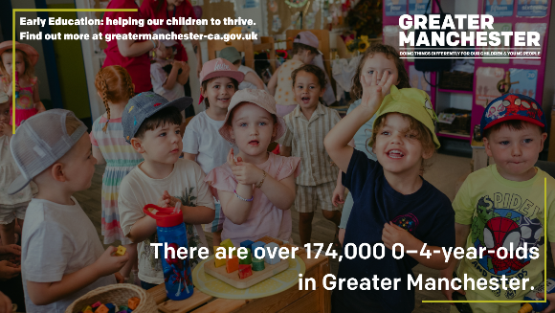 | There are over 174,000 0–4-year-olds in Greater Manchester.  Early Education: helping our children to thrive. Find out more at greatermanchester-ca.gov.uk  Over image of group of children in a nursery.
The first 5 years of a child’s life lay the foundations for health and happiness in later life  However, 7 in 10 parents are unaware of the importance of the first five years of life; research suggests parents often wait till until child is of school age to encourage development. | 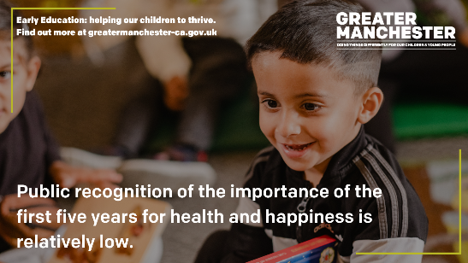 | Public recognition of the importance of the first five years for health and happiness is relatively low.  Early Education: helping our children to thrive. Find out more at greatermanchester-ca.gov.uk  Over image of young child sat smiling.
Follow up tweet: (State of the Nation: Understanding Public Attitudes to The Early Years)

👉 https://bit.ly/GMEarlyEd
#GMEarlyEducation
All young children are unique, with different needs and some may need additional support to help them meet their developmental milestones.  Find out more about provision in your area 👉 https://bit.ly/GMEarlyEd  #GMEarlyEducation | 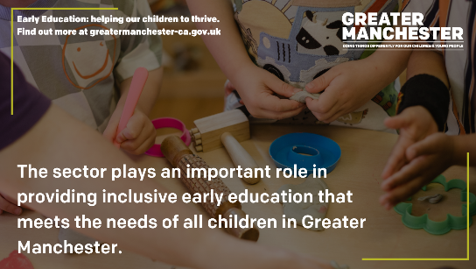 | The sector plays an important role in providing inclusive early education that meets the needs of all children in Greater Manchester. Early Education: helping our children to thrive. Find out more at greatermanchester-ca.gov.uk  Over image of hands of children playing with toys at a table.
Early education helps our youngest residents develop.  It helps them learn to share and play, understand language and feelings, learn about the world and people around them, as well as building resilience and kindness 💝  👉 https://bit.ly/GMEarlyEd  #GMEarlyEducation | 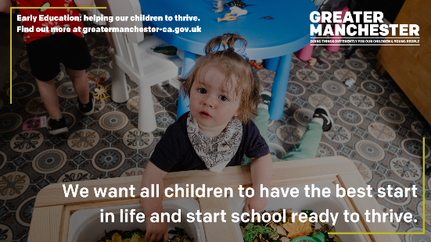 | We want all children to have the best start in life and start school ready to thrive.  Early Education: helping our children to thrive. Find out more at greatermanchester-ca.gov.uk Over image of young child playing at a table.
Research shows a large proportion of parents and carers underestimate the importance of their own interactions with their child’s early education provider.  (State of the Nation: Understanding Public Attitudes to The Early Years)  👉 https://bit.ly/GMEarlyEd  #GMEarlyEducation | 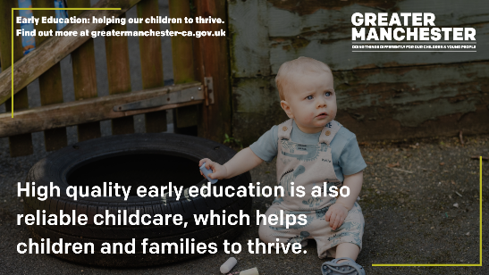 | High quality early education is also reliable childcare, which helps children and families to thrive..  Early Education: helping our children to thrive. Find out more at greatermanchester-ca.gov.uk  Over image of a baby sat outside in a garden.
Children’s language skills are connected to their overall development and can predict their educational success.  Early education builds the foundations for a child’s lifelong learning journey 💡  👉 https://bit.ly/GMEarlyEd  #GMEarlyEducation | 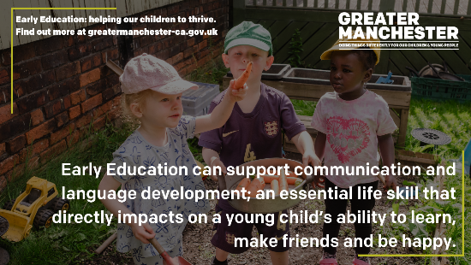 | Early Education can support communication and language development; an essential life skill that directly impacts on a young child’s ability to learn, make friends and be happy.  Early Education: helping our children to thrive. Find out more at greatermanchester-ca.gov.uk  Over image of three children playing outside with vegetables.
There is financial support available to help families in Greater Manchester access childcare and early education 👨‍👧‍👦  You can find out more via https://bit.ly/GMEarlyEd  #GMEarlyEducation | 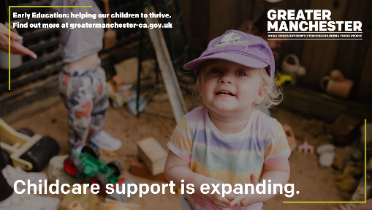 | Childcare support is expanding.  Early Education: helping our children to thrive. Find out more at greatermanchester-ca.gov.uk  Over image of young child in a nursery.
Are you a parent or carer? Did you know you can access government financial support childcare and early education?  Find out more👉 https://bit.ly/GMEarlyEd  #GMEarlyEducation |  | Financial support is available.  Early Education: helping our children to thrive. Find out more at greatermanchester-ca.gov.uk Over image of group of four children playing at a table in a nursery setting.

