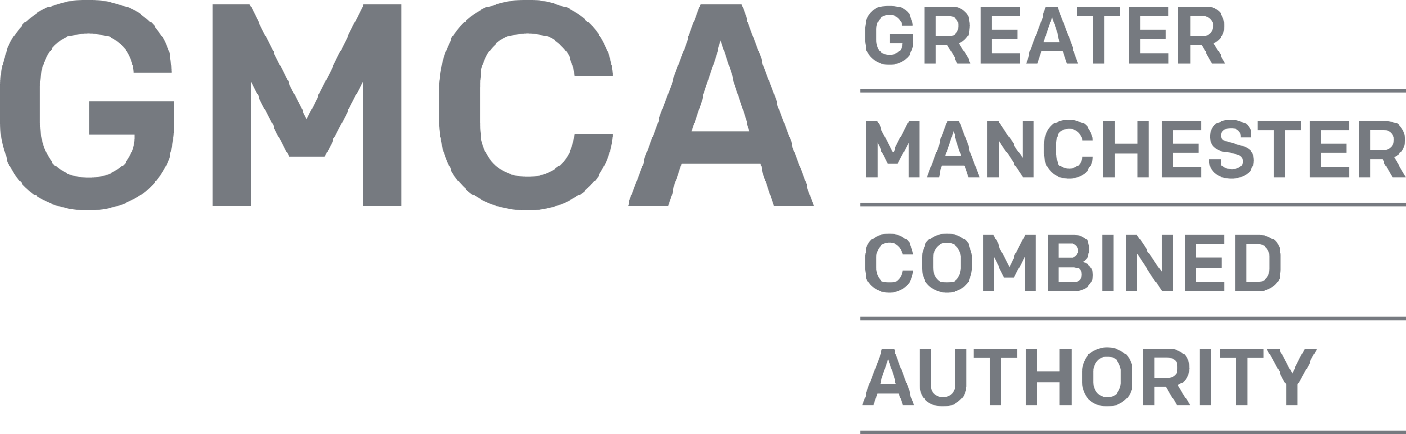

Policy on the Management of Unreasonable Complainant Behaviour

CONTENTS

- Introduction
- Policy aims and principles
- Definition of unreasonable complainant behaviour
- Examples of unreasonable complainant behaviour
- Procedure for invoking this policy
- Options for action
- Further action

Introduction

The Greater Manchester Combined Authority (‘GMCA’) is committed to dealing with all complaints in an open, fair and proportionate manner and we aim to provide a high quality service to those who make them. The GMCA has an established policy for dealing with complaints.

However, we recognise that in some cases individuals may pursue their complaints in a way that is unreasonable. Although these cases represent a small number of overall complaints, they can cause considerable disruption for staff, generate a disproportionate amount of additional work and can sometimes impact upon the wellbeing of our staff. This policy describes the type of complainant behaviour which may be considered to be unreasonable and GMCA’s approach when responding to such behaviour.

This policy has been drafted with reference to the Local Government and Social Care Ombudsman’s “Guidance note on management of unreasonable complainant behaviour” (July 2014).

Policy aims and principles

This policy is governed by the following principals –

- All complainants will be treated fairly and with respect.
- All complaints will be considered on their merits.
- Unreasonable complainant behaviour does not preclude there being a valid issue.
- The substance of a complaint will dictate the level of resources dedicated to it, rather than a complainant’s demands or behaviour.
- Staff safety and wellbeing is paramount when dealing with unreasonable complainant behaviour.
- The decision to change or restrict a complainant’s access to services as a result of their behaviour will only be made at a senior management level and in accordance with clearly defined policies and procedures.
- Senior managers will ensure relevant systems, policies and procedures are in place to manage complaints and that all staff who interact with complainants will receive training, guidance and direction about managing unreasonable behaviour.

This policy aims to describe -

- the type of behaviour which falls within the scope of this policy;
- the process for making a decision to invoke the policy, which is consistent, transparent and reasonable;
- the type of action which may be taken by GMCA in response to unreasonable complainant behaviour.

Definition of ‘unreasonable complainant behaviour’

This policy covers ‘unreasonable complainant behaviour’ which may include one or two isolated incidents as well as ‘unreasonably persistent behaviour’ which more usually involves a build-up of behaviour or incidents over a longer period of time.

For GMCA’s purposes ‘unreasonable complainant behaviour’ is behaviour of a person which, because of its nature or frequency –

- hinders GMCA’s consideration of that person’s complaint, or other people’s complaints: and/or which
- adversely affects GMCA’s ability to do its work and provide services to others.

Examples of unreasonable complainant behaviour

Some examples of behaviour which may fall within the scope of this policy are set out below. This is not an exhaustive list:

- Refusing to specify the grounds of a complaint, despite offers of help;
- Refusing to co-operate with the complaints investigation process;
- Refusing to accept that issues are not within the remit of a complaints procedure despite having been provided with information about the procedure’s scope;
- Insisting on the complaint being dealt with in ways that are incompatible with the adopted complaints procedure or with good practice;
- Making unjustified complaints about the staff who are trying to deal with the issues and seeking to have them replaced;
- Changing the basis of the complaint as the investigation proceeds and/or denying statements he or she made at an earlier stage;
- Introducing trivial or irrelevant new information at a later stage which the complainant expects to be taken into account and commented on,
- Raising many detailed but unimportant questions and insisting they are all answered;
- Electronically recording meetings and conversations without the prior knowledge and consent of the other persons involved;
- Adopting a 'scatter gun' approach: pursuing parallel complaints on the same issue with GMCA and various other organisations, for example with a Member of Parliament/a councillor/GMCA’s independent auditor/the Standards Board/local police/solicitors/the Local Government and Social Care Ombudsman.
- Making excessive demands on the time and resources of staff with lengthy or excessive phone calls, emails to numerous GMCA staff, generating detailed letters every few days and expecting immediate responses;
- Submitting repeat complaints, with minor additions/variations the complainant insists make these 'new' complaints;
- Refusing to accept the decision – repeatedly arguing the points with no new evidence and complaining about the decision (particularly when there remains scope for the complainant to escalate the complaint to the next formal stage e.g. the Local Government and Social Care Ombudsman);
- Making a complaint which in GMCA’s reasonable opinion is unfounded, unreasonable or trivial and/or is made with the intention of wasting GMCA officer time and resources and/or prevents GMCA from carrying out its business, or harasses GMCA staff, or which is otherwise made in bad faith.

In addition to the above, GMCA does not expect staff to tolerate behaviour which is abusive, offensive or threatening and may include:

- Using abusive, offensive or foul language on the telephone or in writing (including emails and social media);
- Using abusive or foul language face to face;
- Sending multiple emails to one member of staff;
- Leaving multiple voicemails for one member of staff;
- Making direct threats;
- Directly verbally insulting staff or making derogatory comments about them.

If appropriate staff may also, in considering whether behaviour is unreasonable and excessive in nature, assess other contact made with GMCA, such as through requests for information, when considering whether to treat complainant behaviour as unreasonable.

Procedure for invoking this policy

Before taking any action under this policy, staff must ensure that any complaint is being or has been investigated properly, that communications with the complainant have been adequate and that the complainant is not now providing any significant new information that might affect the organisation’s view on the complaint.

Stage 1 – issuing a warning

If staff consider that the behaviour of a complainant falls within the scope of this policy they should notify the Head of the service associated with the complaint, describing and providing sufficient examples of the behaviour concerned, why it is considered to be unreasonable and why they consider that the policy should be invoked. Emails and correspondence may be provided to the Head of the service as further evidence.

The Head of the service associated with the complaint will then consult with the Monitoring Officer of GMCA before deciding whether to issue a written warning to the complainant. Any written warning that is issued must explain why the complainant’s behaviour is considered to be unreasonable and will request that he/she change this behaviour. The complainant should also be warned that this policy will be invoked should the unreasonable behaviour continue. A copy of this policy should be included with the written warning.

If the behaviour of the complainant is so extreme or it threatens the immediate safety and welfare of staff the Head of the service associated with the complaint may proceed directly to Stage 2 without issuing a written warning. Alternatively GMCA may consider other options including police involvement or legal action and in such cases GMCA does not need to issue a written warning to the complainant.

Stage 2 – taking action

If a complainant continues to behave unreasonably following receipt of a written warning, the Head of the service area associated with the complaint, in consultation with the Monitoring Officer of GMCA, will decide what action to take to manage the unreasonable behaviour.

Any action taken should be proportionate to the nature and frequency of the complainant’s current contacts. The following options may be suitable, taking the complainant’s behaviour and circumstances into account:

- Placing limits on the number and duration of contacts with staff per week or month;
- Offering a restricted time slot for necessary calls;
- Limiting the complainant to one medium of contact (for example telephone, letter, email etc.);
- Requiring the complainant to communicate only with a named member of staff;
- Requiring any personal contacts to take place in the presence of a witness and in a suitable location;
- Requiring the complainant to enter into an agreement about their future behaviour before their case proceeds;
- Where a decision on the complaint has been made, telling the complainant that future correspondence will be read by a designated person and placed on file but not acknowledged, unless it contains material new information.

The above list is not exhaustive. Other suitable options may also be considered in light of the complainant’s circumstances.

If a decision has been made to apply restrictions to the complainant’s contact with GMCA staff, the Head of the service area associated with the complaint will write to the complainant to explain why the decision has been taken, what it means for his or her contact with GMCA, how long any restrictions will last and/or when they will be reviewed, and the right of the complainant to refer the matter to the Local Government and Social Care Ombudsman.

If, in addition to any regulation of access, a decision is taken not to pursue the complaint under the Complaints Policy, this must also be put in writing to the complainant along with the reasons for the decision.

New complaints from individuals who have are subject to action under this policy will be treated on their merits.

Further action

If the complainant fails to adhere to any conditions regulating his/ her contact with GMCA and/or uses or threatens violence against staff, then the matter should be referred to the GMCA Monitoring Officer for advice as to the most appropriate and proportionate action to be taken, which may include civil or criminal legal proceedings (e.g. ASBO and/ or injunction proceedings).

For the purposes of this policy the term ‘staff’ includes officers and members of GMCA.

