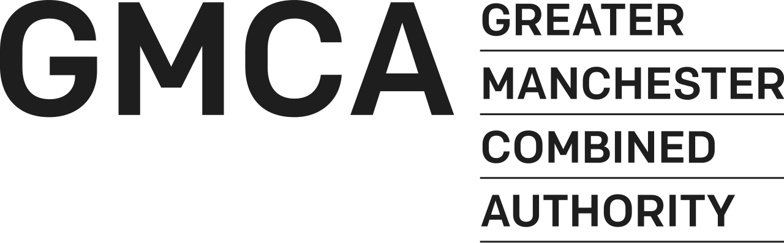

GROWN IN GREATER MANCHESTER. KNOWN AROUND THE WORLD.

The Greater Manchester Culture Fund

APPLICATION FORM

2020/2021 – 2021/2022

Name of Organisation

____________________________________________

Please return completed application forms to cultureteam@greatermanchester-ca.gov.uk

_______________________________________________________________________________________
BOLTON, BURY, MANCHESTER, OLDHAM, ROCHDALE, SALFORD, STOCKPORT, TAMESIDE, TRAFFORD, WIGAN.

DEADLINE FOR THE RETURN OF THIS FORM

5pm, 29 November, 2019

Application Form for The Greater Manchester Culture Fund 2020/2021 - 2021/2022

Can You Apply?

We can only accept your application if your organisation meets certain conditions.

- Is your group a constituted voluntary and community sector or not-for profit organisation?

- Are you a cultural or arts organisation or planning to deliver cultural activity across Greater Manchester?

- Are you based in Greater Manchester?

You must answer yes to all of the above criteria. If you say no to any of the above questions please do not continue with your application?

DETAILS OF YOUR ORGANISATION

- General Information

Name of Organisation:
(If you are applying as a partnership or consortium please name all partners indicating lead organisation)
Registered address of Organisation:
Daytime telephone:
E-mail address:
Website Address:
Contact name:
Position Held:
Second contact name:
Position Held:

- How Much Are You Requesting From GMCA?

 | 2020/21 | 2021/22 | Total
Amount of Grant Requested

If you are a current recipient of GMCA Culture and Social Impact funding and are requesting funding at a higher level from GMCA please indicate the reason for the increase in funds (no more than 500 words). Please note that increases in funding to existing recipients will only be granted in exceptional circumstances.

- Your Work

What are you applying for funding for? Tell us all about your proposed work over the next two years, why it’s needed and how what you do is going to make a difference.

- Priorities

Which of the priorities of the funding programme will the work of your organisation support?

Contribute to the recognition of Greater Manchester locally, nationally and internationally to attract new investment, new visitors and new talent to Greater Manchester;
Make a positive contribution to improving skills and employability of residents in Greater Manchester, including support for the creative education, expression and ambition of young people across Greater Manchester;
Play a strong role in developing strong and inclusive communities and an improved quality of life for residents, particularly those residents at risk of disengagement or social isolation.
Be able to evidence how the project will make a positive contribution to improving residents’ health and well-being.

How does your current and planned work meet the outlined priorities you plan to deliver against (no more than 300 words per priority)
Priority 1

Priority 2
Priority 3
Priority 4

Q5 Your proposed work
Please tell us;
- what you plan to do over the next two years
- who will benefit from your work and how they will be involved
- how you know there is a need for your work
No more than 800 words

Q6 How will you work with other organisations (including local authority partners) to enhance your work and maximise impact for Greater Manchester residents?
No more than 500 words

Q7. In which Greater Manchester Districts will you deliver activity or target audiences or participants
BOLTON | INDICATE %
BURY | INDICATE %
MANCHESTER | INDICATE %
OLDHAM | INDICATE %
ROCHDALE | INDICATE %
SALFORD | INDICATE %
STOCKPORT | INDICATE %
TAMESIDE | INDICATE %
TRAFFORD | INDICATE %
WIGAN | INDICATE %

Q8 Please describe how and why you selected the districts and % identified and how you will connect with residents in these places.
No more than 500 words

Q9 How will you monitor the impact of your work? No more than 300 words

Q10 Are there any legal, financial and technical issues/risks that you need to consider to ensure delivery of the activities? What plans will you put in place to ensure that problems are detected and addressed at an early stage?
No more than 300 words

GOVERNANCE

Q11. What is the legal status of your organisation?

A Company Limited by Guarantee |  | Registration No:
A Registered Charity |  | Registration No:
A Registered Friendly Society |  | Registration No:
A Voluntary Organisation |  | Registration No:
Not Registered but Intending to Apply
VAT Registered |  | Registration No:

Other e.g. Trusts (please specify):

Q12. Please give names and roles of your Board/Management Committee Members below:

Name | Role

Q13 Briefly describe your governance structure – Board, Committees, sub-committees, management committee etc, and how often the Board meets (200 words)?

Q14. Does your organisation have the following policies in place? (Please tick the appropriate box)

Policy | Yes | No | Date  Last  Revised | Comments
- Financial and Risk Management
If yes, please send us a copy.
If not, please outline how you
manage your finances on a separate sheet.
ii. Business Plan
iii. Recruitment and Selection
iv. Health and Safety
v. Equal Opportunities Statement
vi. Internal Grievance
vii. Complaints
vii. Induction for new:
a) Staff
b) Volunteers
- Management Committee/
Board papers
viii. Data Protection
ix. Policies on anti-fraud,
corruption and whistleblowing
x. DBS requirements
(previously called CRB checks)

FINANCIAL INFORMATION

Q15. Please identify the breakdown of expenditure for the grant on your organisation’s core costs as appropriate

Expenditure | Expected Expenditure  2020/21 (£) | Estimated Expenditure  2021/22 (£) | Total (£)
Employees (incl. NIC, Pension, etc.)
Heat and Light
Rent/Services
Business Rate
Telephone
Stationery and Postage
Publicity/Marketing
Repairs and Maintenance (specify)
Equipment/asset purchases
Insurance
Travel and Subsistence
remunerations paid to non-employees (e.g. board members)
Audit/Legal Fees
Other Budget Headings (Specify)
Total Expenditure (X)
Q16 Income

Please state in the box provided, whether any grants and contributions are secured (S) or applied for (A). For any grants/contributions not secured, state in the Budget Explanatory Notes box below the date a decision is expected. Also include here details of other grants that have been secured/applied for and their purpose.

Income | Expected income  2020/21 (£) | S/A* | Estimated Income  2021/22  (£) | S/A* | Total Estimated income
GMCA Grant
Other Local Authority Grants (specify districts)
Other Public:
-Arts Council (regular)
-Arts Council: (project)
-Sport England
-DCMS
-National Lottery
-HLF
-Other public (specify)
EU Funding (specify)
Commercial Sponsorship
Charitable Trusts & Foundations (specify)
Other Income:
-Sponsorship
-Private giving
-Box Office
-Catering
-Sales
-Membership or Participation Fees
-Fundraising
-Any other earned income (specify e.g. project delivery)
TOTAL INCOME (Y)
SURPLUS (DEFICIT) (Y-X)

Q17. Budget Explanatory Notes: Detail any explanatory notes relating to the Expenditure and Income tables in the box below including any additional funding, its purpose and period (max 200 words).

BALANCING CRITERIA

We want to develop the most balanced investment portfolio possible and the below balancing criteria will be used to inform discussion and decision. Please provide information under the following headings that you think would aid our decision.

B1. We want our investment to benefit organisations throughout Greater Manchester. Which GM District which are you are based in? | NO MORE THAN 150 WORDS
B2. We want our investment to reach the greatest possible diversity of Greater Manchester. How will work to ensure your work reaches and reflects the greatest diversity of GM residents? | NO MORE THAN 150 WORDS
B3. We want our investment to support a variety of artforms. What is your primary artform? How will your work contribute to the development of this artform? | NO MORE THAN 150 WORDS
B4. We want our investment to support organisations of various sizes and scales. What is your total annual income and how will you work with partners to maximise the impact of our investment? | NO MORE THAN 150 WORDS

DECLARATION

The declaration below must be completed by the Chair or Deputy Chair of your Board/Management Committee, not a member of staff.

On behalf of the organisation, I confirm that:
  - the organisation/project operates on a non-profit basis and provides a facility used by, or which is for the benefit of, residents of Greater Manchester, and
  - the information given in this application form is true and correct.

I undertake to inform GMCA of any changes in the project/organisation’s circumstances that would affect this application.

Name (BLOCK LETTERS)
Position in Organisation | Chair / Deputy Chair  (please delete as appropriate)
Signature
Date

Please note by signing this declaration, you are allowing us to consult with your partners and stakeholders. We reserve the right to ask any applicant to provide additional information or clarification over and above what is submitted in your application as part of our appraisal process.

Thank you for filling in this form. Please check it carefully before returning to cultureteam@greatermanchester-ca.gov.uk . You must include the following documents and confirm that you have included them by ticking the relevant box(es). If any of these documents are available online please provide a reference link to the website rather than a hard copy.

1. | A copy of your latest Audited /Independently Verified Accounts for your organisation.
2. | Financial Management Policy
3. | One copy of your current staff structure indicating name, job title and hours  (F/T, P/T)
4 | Constitution or Memorandum of Articles of Association
5. | Certificate of Incorporation

