Industry labour market and skills intelligence report
  - Digital and technology – Appendix A

December 2020

Contents

Mapping to Technical Occupational Maps 3
Digital Occupational Clusters 4
Digital Marketing 4
Creative Marketing 6
Data and Analytics 9
User Experience 12
Development 14
Software Delivery 16
Information Technology (IT) 17
Cyber Security/ Information Security 19
Future Digital roles 21

Digital occupational clusters and progression pathways in the digital Industry
Manchester Digital supported in this work based on their rich understanding of the digital sector and involved their employer forum who added further skills intelligence and wider narrative around skills needs in these different areas of digital. The objective of this work was to understand from an employer perspective how to break down job areas within the digital sector and better understand progression routes.
Alongside this work KPMG and Geek Talent have been working with GMCA to understand where the key skills and occupational gaps are in these pathways.
It should be noted that for many of these areas despite employers agreeing these clusters are the best that can be achieved there is a great amount of overlap in occupational clusters and roles within them. Role structures will vary vastly within the sector and in businesses of different types and different sizes. Job descriptions have been added to support where roles fit within wider teams.
For some areas for example cyber employers actively warned against promoting clear pathways within the sector and therefore the occupational cluster diagrams need to be considered with the wider intelligence and narrative around the sector.
It should also be noted that in GM there are many great Tech Returners programmes and Coding bootcamps as a way to enter the digital industry, the focus here is on formal qualification pathways and in this document this alternative provision has not been mapped but is reported on in the main document.
This document sets out 10 occupational clusters of job roles as agreed by employers.
- Along with role names each cluster includes the following intelligence:
- Progression pathways
- Average salary information
- Wider skills need
- Anecdotal employer intelligence
- Qualifications and training

Areas of skills need, and priority based on employer conversations include:
Figure 1 shows the 10 areas of digital occupational clusters in Greater Manchester developed with employers.
More Digital marketing skills needed in wider sectors due to digital transformation
Within Creative marketing roles there needs to be individuals with a good mix of technical and content skills. There was also the need for good quality copy writers but in small numbers.
Technical sales roles require individuals with better data analysis skills, creating “data Champions” for this area of digital.
A nationwide cloud skills shortage is preventing businesses from hiring the people they need to progress cloud projects.
At scale more developers and software delivery skills all with cyber skills
Senior roles within IT especially network engineers and wider cloud skills
Cyber skills were needed at more senior roles, but also cyber and information security skills within wider digital and non-digital roles due to digital transformation.

Mapping to technical occupational maps
As the occupational clusters are focused on an employer view of the industry in Greater Manchester they do not necessarily map simply to the Institute for Apprenticeships and Technical Education’s (IfATE) national Occupational Maps developed by route panels made up of industry experts. These Occupational maps show how apprenticeships and T Levels are based on occupations and show where technical education can lead.
This mismatch between the employer led Occupational maps and our GM developed Occupational Clusters reflects the complexity in how different stakeholders narrate the industry. This mismatch needs to be considered when using this intelligence to support different stakeholders in understanding and navigating progression pathways in Digital.
Based on the IfATE Occupational Maps there are 3 pathways in Digital:
- Digital Business Services – maps to occupational cluster areas including:
  - Cyber/information security
  - Information Technology
- Digital Production, Design and Development Pathway – maps to occupational cluster areas including:
  - Information Technology
  - Creative Marketing
  - User Experience
  - Software delivery
- Digital Support and Services – maps to occupational cluster areas including:
  - Information Technology
  - Future Digital roles
  - Data and Analytics
  - Cyber and information security

Digital occupational clusters

Digital Marketing
Digital Marketing is the promotion of ideas, products and services, influencing people, and conveying messages. Digital marketing professionals use the internet and a wide range of digital platforms to effectively advertise. Marketing teams are trained to be driven by deadlines, outcomes, and results while the creative teams are pushed to be innovative, engaging and bring new ideas. There is crossover with Creative Marketing and people often come into a team with a broader degree and the take short courses to specialise. In smaller organisations these job roles may overlap.
There is a lot of client handling skills involved and taking more responsibility for managing clients increases with the seniority of roles. The role involves lots of content creation which can vary widely including: Panel events, blog posts, press releases and thought leadership events.
Job roles in this area involve working with a wide variety of people including creative specialists such as videographers and motion designers to evaluators and journalists as well as the clients themselves.
Roles in this area are continually changing as social media develops and people who progress successfully in the industry need to continually learn about new trends in the social media space and be willing to continually adapt.
Greater Manchester employers praised the apprenticeship route into this role.

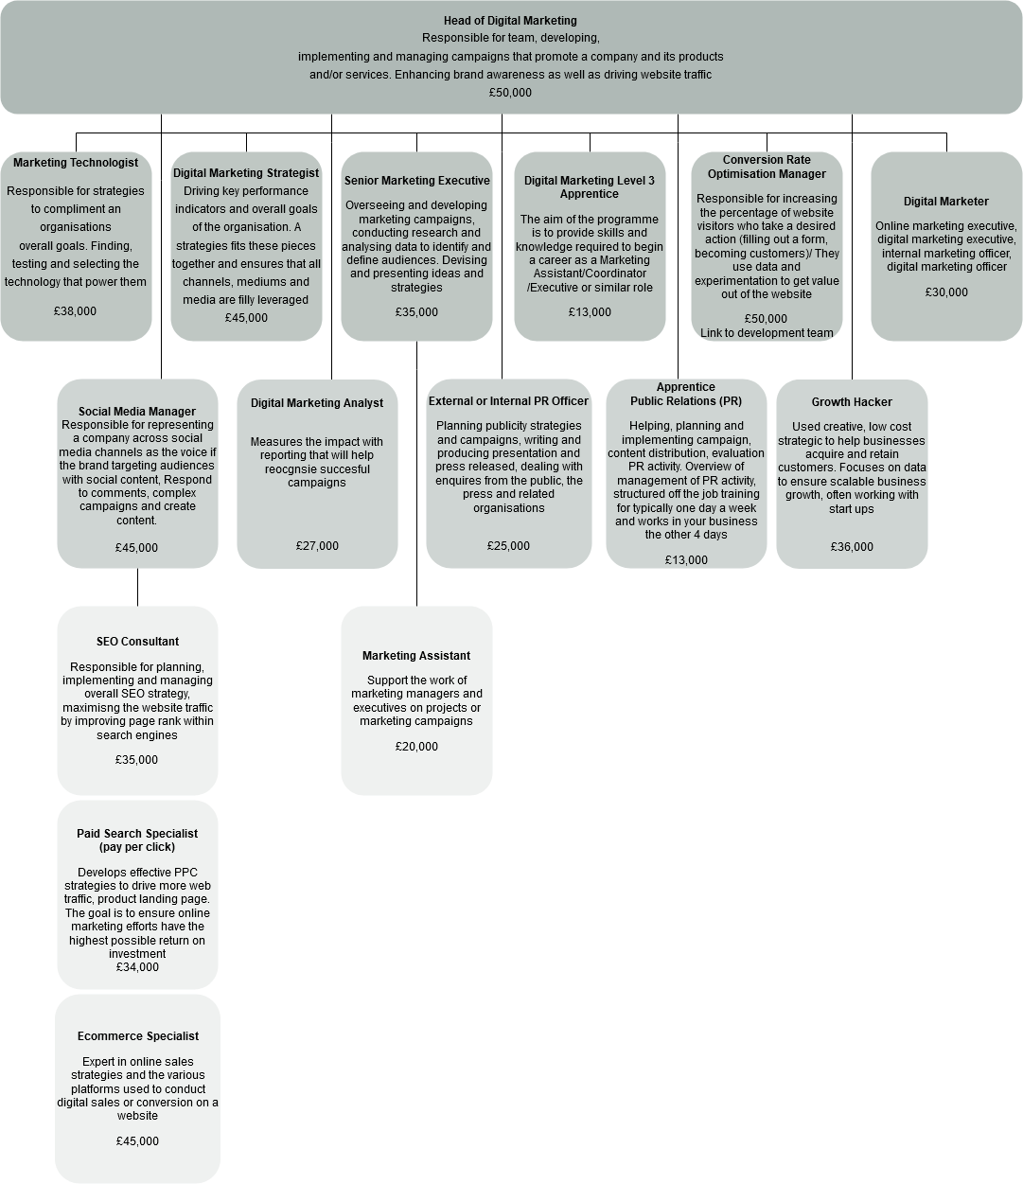
Figure 2progression pathways for the occupational cluster of Digital Marketing.
Employers felt COVID had accelerated digital transformation leading to a bigger need in this area across the digital industry but more than ever across all sectors and an acute need for the marketing and sales skills needs reported by SMEs.
Skills and competencies employers stated were important:

- Client handling – listening to the client understanding their pressures and what they want to achieve
- Good people management skills to work as a team and with people in different roles
- Data analysis
- Attention to detail
- Ability to manage workload and be organised
- Good communication skills
- Creative thinking, but this does not mean you have to be a good artist.

Industry Pathways:

- Level 2 Certificate in the Principles of Marketing
- Level 3 Diploma in Digital Marketing
- Level 4 Digital Community Manager (for leadership roles)
- Level 4 PR Apprenticeship
- Level 6 – Digital Marketer - Digital Marketer advanced or degree apprenticeship (You usually require 4 or 5 GCSEs at grades 9 to 4 (A* to C) and A levels, or equivalent, for a higher or degree apprenticeship)

For a career in Digital Marketing the following degrees are recommended:

- Digital marketing BSc Hons
- Marketing Communications BA Hons
- Digital Marketing and Social Media – BA or BSc Hons
- Digital Video Production and Marketing BA Hons
- Advertising and Marketing Communications BSc Hons

Data gathered in 2019 from Burning Glass Labour Insights showed that 53% of digital marketing roles required a degree and 1% a post -grad degree

Creative Marketing
Creative Marketing requires Creative and analytical thinkers needing good copywriting and visual storytelling skills, alongside strong people skills that allow them to communicate effectively across all areas of a business. Creativity is critical to the marketing industry and enables brands to deliver engaging and entertaining campaigns that make them stand out from their competitors. The UK’s creative industries are hugely important to the economy – not only do they employ three million people, but they contribute more than £80 billion a year to the economy: making it massively important to our society. This is the sector that is responsible for all the content you consume online, on the TV or even listen to or read.
There are multiple routes into these roles with employers suggesting as well as various graduate routes there were lots of opportunities for career switchers from various other industry backgrounds such as: Creative writing, journalism, advertising and even estate agents.
Employers felt it was difficult to find candidates with a good balance of technical skills and good content skills. They felt there were a lack of good copy writer skills but that this was not a skill need at scale and most teams just needed one quality copywriter.
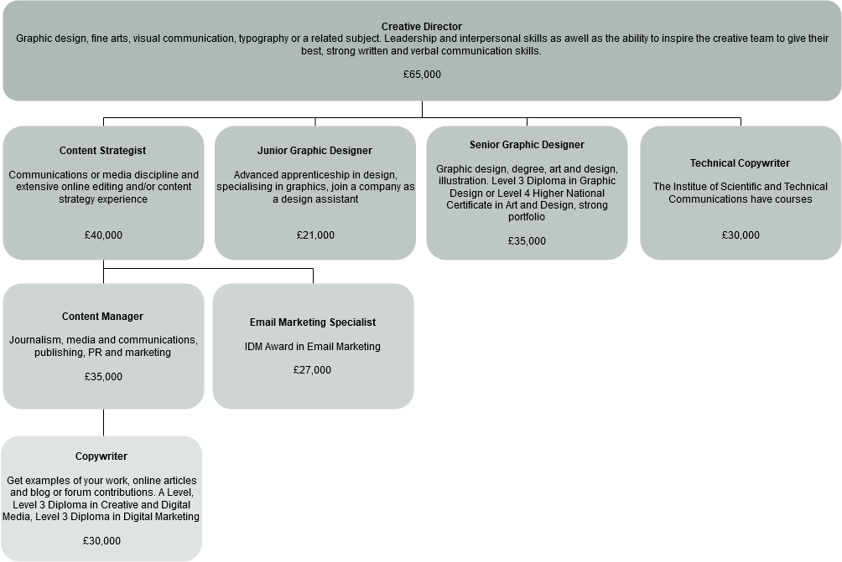
Employers identified a provision gap for junior graphic designers and felt the apprenticeships standard didn’t meet their needs. However, apprenticeships are starting to grow on the content production side and Juice Academy are an example of good practice
Figure 3 progression pathways for the occupational cluster of Creative Marketing

Skills and competencies employers stated were important included:
- Ability to be collaborative – need to work with a variety of other disciplines such as researchers and designers
- Copywriting
- Ability to put user needs first; good listener and ability to take other ideas on board
Industry pathways:

- Art and Design A level
- English A level
- Level 3 – Advertising and Media Executive
- Level 3 Junior Content Producer
- Level 3 – Broadcast Production Assistant
- Level 3 – Digital Marketer
- Level 4 – Junior 2D Visual Effects - Visual effects (VFX) is the term used to describe any imagery created, altered, or enhanced for moving media.
- Level 6 Creative Digital Design

For a career in Creative Marketing the following degrees are recommended:

- Creative Advertising
- Creative Computing
- Creative Writing
- Creative Studies
- Digital Media
- Digital Media Design
- Media Production
- Digital Media Computing
- Digital Media and Web Technologies

- Technical Sales

In an IT sales team, you'll use your technical knowledge along with sales skills to provide advice and support on a range of products, for which a certain level of technical expertise is needed. You'll assist colleagues with bids and tenders for new clients. You'll usually work with commercial clients, finding the right technological hardware and software products to suit their business needs. This may involve demonstrating features of a product. Opportunities are endless with FinTech and software as a service (SaaS) among others evolving all the time.
Employers felt people usually fell into this role from wider multi-disciplinary roles as many people don’t know they want to go into sales.
The apprenticeship route was praised by employers and many were clear to point out that when taking on new entrants they would simply ask for degree- level or equivalent training but be happy to provide the technical skills once recruited. They attributed this to the range in backgrounds and mindsets building diverse teams with people who can think differently and that was important to their businesses.
Employers stated they would like to see candidates with strong data analysis skills.
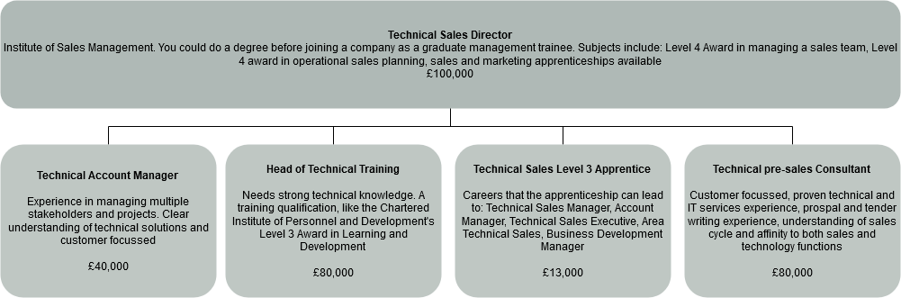
Figure 4 shows progression pathways for the occupational cluster of Technical Sales.
Industry Pathways:
- Level 3 Technical Salesperson Apprenticeship
- Level 4 Award in Managing a Sales Team
- Level 4 Award in Finance for Sales Manager
- Level 4 Award in Operational Sales Planning
- Sales and Marketing Management – BA (Hons) Degree
- Microsoft Partner Sales training and Certification MCSA (Microsoft Certified Solutions Associate)– similar is available for all technology stacks (CompTIA Network+ and/or Cisco CCENT/CCNA, CompTIA Cloud Essentials and/or Amazon Web Services (AWS)
- Pareto Law (and other sales training providers) run multiple technical sales courses and many organisations take graduates onto Graduate Sales Academy programmes
Data gathered in 2019 from Burning Glass Labour Insights showed that 93% of technical sales roles required a degree and 2% a post -grad degree

Data and Analytics
Business analytics is the process of examining data to help boost business performance. Business analysts help increase revenue, improve efficiency, optimise services, and respond to market trends. Analysts often use specialist systems and software in their job but need great communication skills so they can ask the right questions and facilitate meetings. Analysts are usually also excellent critical thinkers and problem-solvers.
In GM employers needing data skills include large companies like TalkTalk, Manufacturing SMEs as well as a range of public sector agencies such as NHS digital. Skills needs in this area have been accelerated because of the pandemic and skills in demand across different industries as businesses race to take advantage of technology related to big data. Manchester Digital’s annual digital skills audit 2020 reported 15% of companies believe data science will be an area of growing importance in their business over the next 3 years.
This demand for talent was clear when we spoke to employers who are keen to foster this new technology and the skills and talent needs required with most agreeing this is an excellent time to enter and build a career in this growing sector.
There are various routes into the industry including an emerging trend for intense short courses through alternative provision, however some employers insist on PHD level and most roles require a high level of technical expertise.
Employers felt the need here was for data literacy in wider digital roles as a core competency. They spoke about creating “data champions” to benefit talent development across the industry.
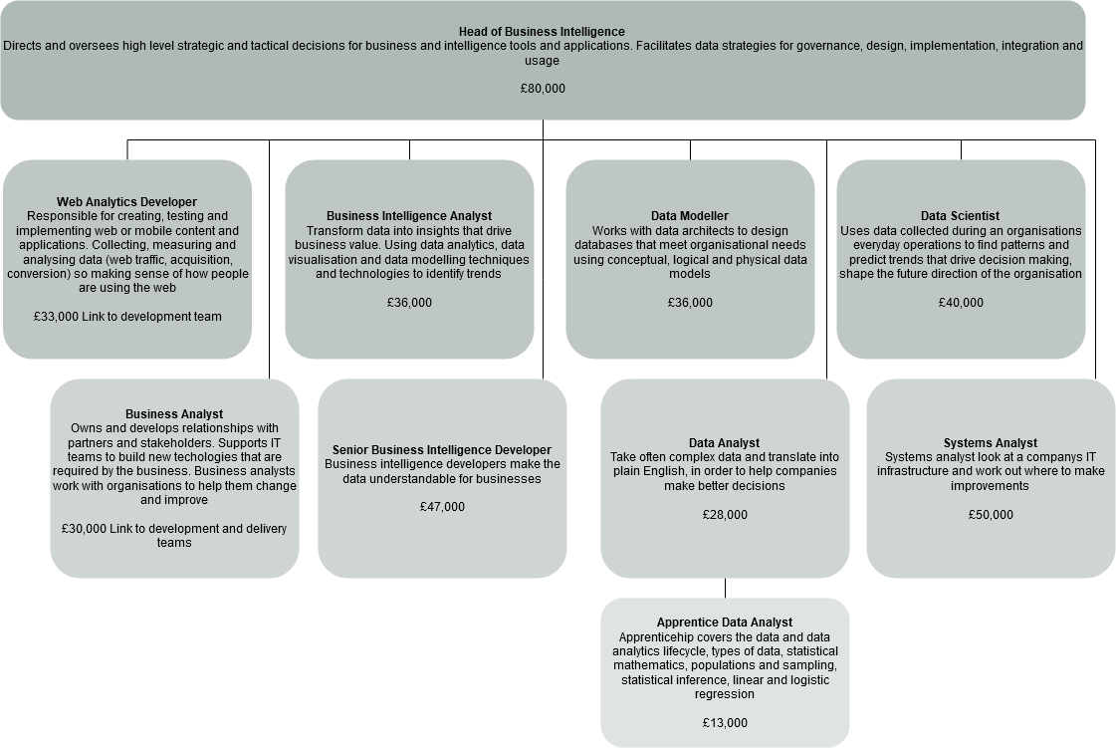
Figure 5 shows progression pathways for the occupational cluster of Data and Analytics.
Skills and competencies employers stated were important:

- Problem solving – curious mind and continually questioning and digging further into problems
- Love of building things
- Attention to detail
- Passion for continuous learning
- Good personal organisation and time management
- Ability to notice trends and patterns
- Passion for solving business problem with statistical methods
- Analytical mind
- Technical skills: (although some employers are happy to recruit on competencies and teach technical skills)
- Linear algebra
- Understanding of different type of statistical analysis
- Programming languages such as python and SQL
- Databases such as SQL and other non-SQL
- Big data tools: Apache Spark, Hadoop
- Cloud Platforms
- Azure, AWS, Google Cloud, Databricks

Industry Pathways:
- Maths A Level
- Level 3 - Data Technician
- Level 4 - Data Analyst – Level 4 Apprenticeship
- Level 6 - Data Scientist (degree) Level 6 (equivalent to bachelor's degree)
- Masters or PHD in Data Science

For a career in Data and Analytics the following degrees are recommended:

- Business information systems
- Information Science
- Applied Maths
- Computing and systems development
- Computer science
- Computer Studies

There are multiple certifications that can support specific business needs:
- Microsoft’s Certified Solutions Expert in Business Intelligence.
- The BCS International Diploma in Business Analysis - Experienced senior business analysts who actively contribute to the development and promotion of the business analysis profession.

- Data gathered in 2019 from Burning Glass Labour Insights showed that 71% of data and analytics roles required a degree and 9% a post -grad degree

User Experience
User experience (UX) professionals make websites, mobile apps and online services as easy as possible for everyone to use, by thinking about how people use and interact with products and services. People who are great problem solvers, interested in how things look, or are interested in psychology make great user experience professionals.
Employers felt provision was well catered for in this area. Talent development through alternative provision for quick upskilling courses for User Experience skills was praised for helping to meet the talent needs in recent years. There are lots of flexible ways to learn to get into this role with many online and smaller certifications available. Both Open University and Future learn were given as good options. Employers agreed this is an area where individuals could very much be self- taught with lots of online and face to face community sharing and meet ups, recommended reading, and blogs.
MMU doing a lot of work around this area and offering a new L6 degree level apprenticeship and employers were keen to see how this develops.
Some of those in the industry did communicate the challenges facing interested individuals at finding entry level roles and perhaps entering related roles which utilise the skills of User Experience in wider sectors could be a good route in. These roles can be across all sectors of the economy and an example was given around the NHS developing COVID testing.
Employers were clear that User Experience could be part of many roles with lots of different job titles between different companies and there could be lots of overlap User Experience skills and competencies could sit in roles such as: Designers, Interaction Designers, Front End Developer, Contents Strategy, UX Researcher, UX Analysts, Service Designers. This has the potential to be quite confusing for individuals looking to get into UX.
Advice by employers for people who were interested weas to learn more about User Experience as a discipline rather than worry from the outset which specific role you want to go into as that could be overwhelming. Employers gave reassurance that individuals finding their niche as they went along was a good approach with different types of digital roles and some more business facing.
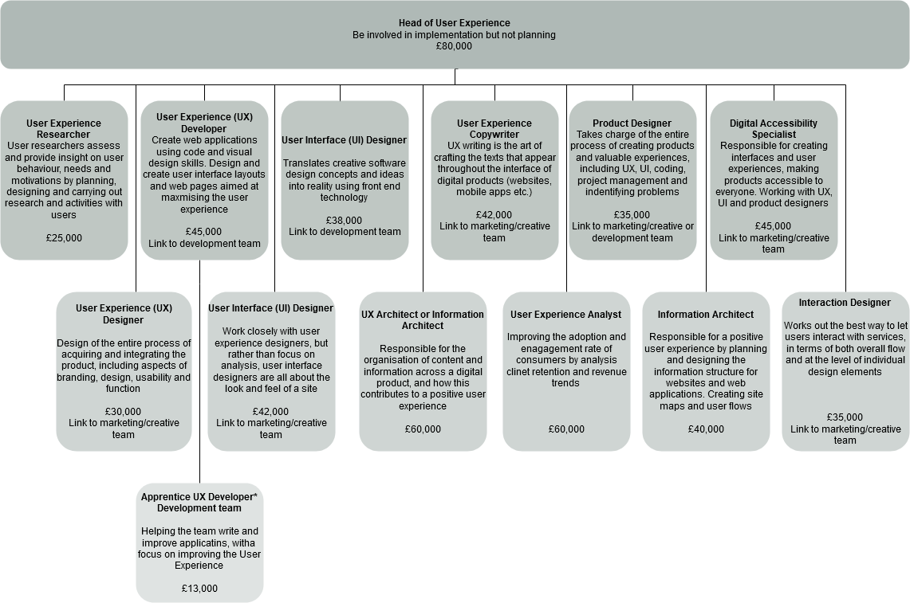
Figure 6 progression pathways for the occupational cluster of User Experience.
Skills and competencies employers stated were important:

- Good knowledge of Research methodology
- Good communication skills
- Ability to design from a user perspective (but don’t have to be a good artist)
- Ability to present research
- Analytical mindset (but not necessarily high-level maths skills)
- Curious mindset
- Awareness of psychology and human behaviour or interest
- Teamwork
- Organisational skills
- Good project management and leadership (increasingly important at more senior positions)
- Understanding of agile project management
- Good organisation and time management

Industry Pathways:
- A level in Computing or Graphic Design
- T level in Digital Production, Design and Development
- Level 4 Certificate in Digital Media Design
- Level 6 UX Apprenticeship Degree

For a career in User Experience the following degrees are recommended:

- Psychology
- Human computer interaction (HCI)
- Digital marketing
- Product design
- Graphic design

There are multiple specific UX courses, would suit people already working in a design or development role - UX Beginner Courses at UX Beginner.com (and other providers)
Data gathered in 2019 from Burning Glass Labour Insights showed that 80% of user experience roles required a degree and 8% at Level 4+

Development
A software developer engages in identifying, designing, installing, and testing a software system they have built for a company from the ground up. It can range from creating internal programmes to apps and websites. They help the world be more efficient to producing systems to be sold on the open market. There are many Computer programming languages - HTML5, CSS3, JavaScript, jQuery, Bootstrap, Express.js, React.js, Node.js, Database Theory, MongoDB, MySQL, Command Line, Git, and many more.
Employers unanimously agreed this was a priority area for skills needs in the digital sector. Software developers is the number one area where we consistently have skills shortages.
They felt that bootcamp style programmes were supporting talent development, but these often focus on front end development, many reported that there was still a gap in tackling the more technical areas involved in back end development and would welcome more in this area.
Employers felt this was a specific area to focus on lower down in education in terms of inspiration and fostering individual’s talent by spotting this as young as 13 – 14 years old in high school.
It was felt that there are often negative perceptions and stereotypes around this area of digital including the perception it is “too hard”. There was also the issue that many young people particularly girls do not even have sight of software development as an option if their schools don’t offer computer science don’t get the chance to even try it.
Information security and cyber employers also stated development roles as great talent pipelines for cyber specific roles for examples DevSec Ops Developer.
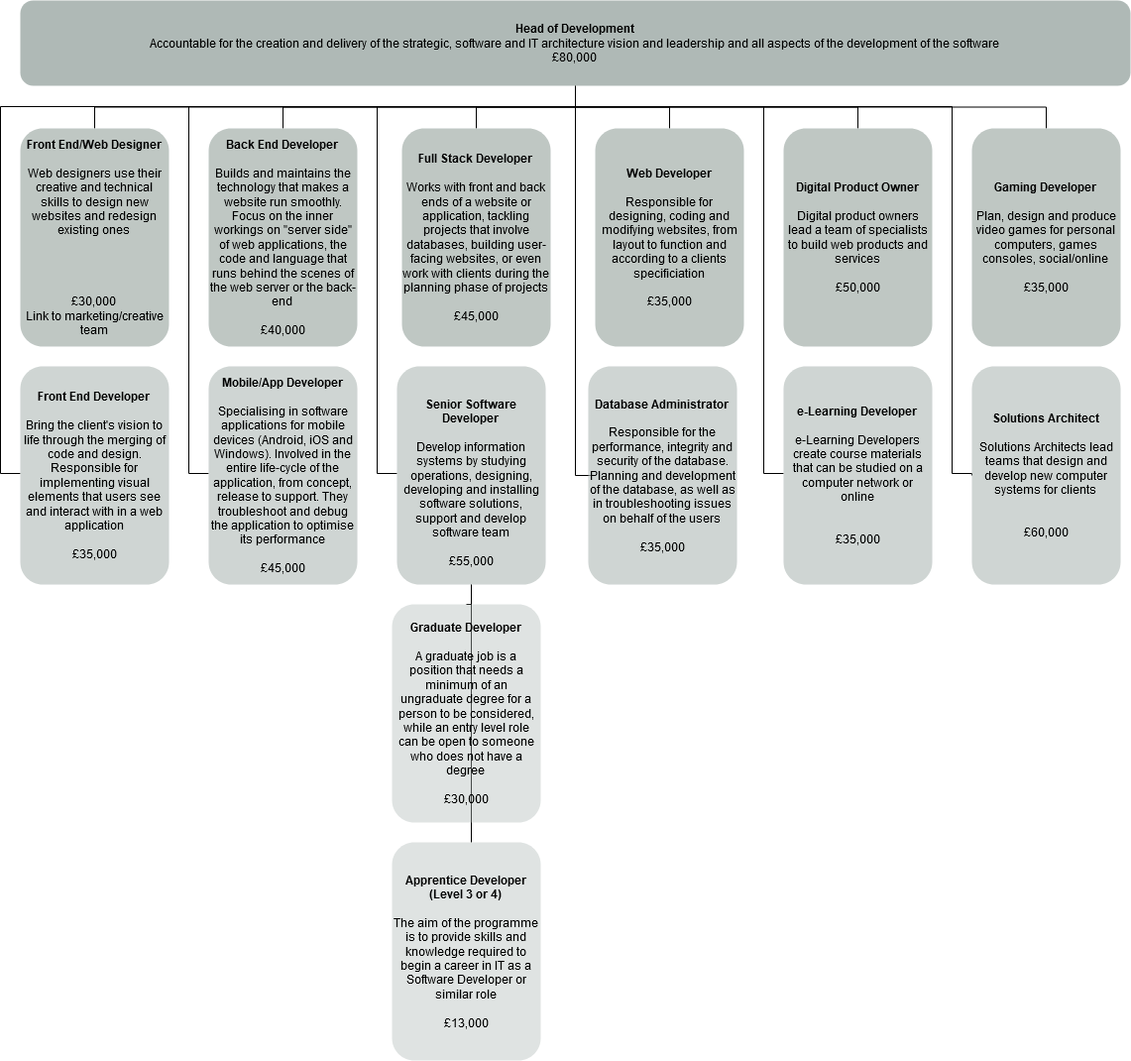
Figure 7 shows progression pathways for the occupational cluster of development.
Skills and competencies employers stated were important:

- Good communicator
- Good team player
- Good problem-solving skills
- Demonstrate that you can go the extra mile to get the job done
- Willingness to continue learning
- Data analysis
- Ability to write a report
- Not scared to ask for help
- Ability to organise workload

Industry Pathways:

- A level in Computing
- Level 3 Software Development Technician
- Level 4 Software Developer
- Level 4 Dev Ops Engineer
- T level in Digital Production, Design and Development
- Higher National Certificate in Computing
- Digital & Technology Solutions Degree Apprenticeship
- Level 3 AWS IT Solutions Technician (Software)
- Level 3 Azure IT Solutions Technician (Software)
- Level 4 Azure Software Developer

For a career in development the following degrees are recommended:

- Computer science
- Information technology
- Software development/engineering
- Financial technology

Software Delivery
Software delivery covers a range of roles to ensure software is delivered to market. You need to be a good communicator, have problem solving skills and work as part of a team using industry specific collaboration methodologies. Scrum is a framework that helps teams work together. Much like a rugby team (where it gets its name), Scrum encourages teams to learn through experiences, self-organise while working on a problem, and reflect on their wins and losses to continuously improve. Quality Assurance Testing ensures a great end product and can require multiple touchpoints across a company. DevOps is a cutting-edge way of developing software or IT solutions quickly. Born out of the agile movement, and taking inspiration from Lean IT ideas, DevOps emphasises continuous delivery, short iterations, collaboration, communication, and elimination of waste.
Employers agreed this was an area where there are skills needs in Greater Manchester. Graduates are still the main route into the industry, but the employers we engaged with welcomed the new DevOps Engineer Level 4 apprenticeship standard. They felt that this level 4 qualification may need to be an interim to bridge to support the jump into employment.
Employers felt graduates were lacking skills to be able to test site reliability without further mentoring and on the job training.
Employers felt this area linked with the need to address skills challenges in cloud and infrastructure engineering another growing area of the industry.
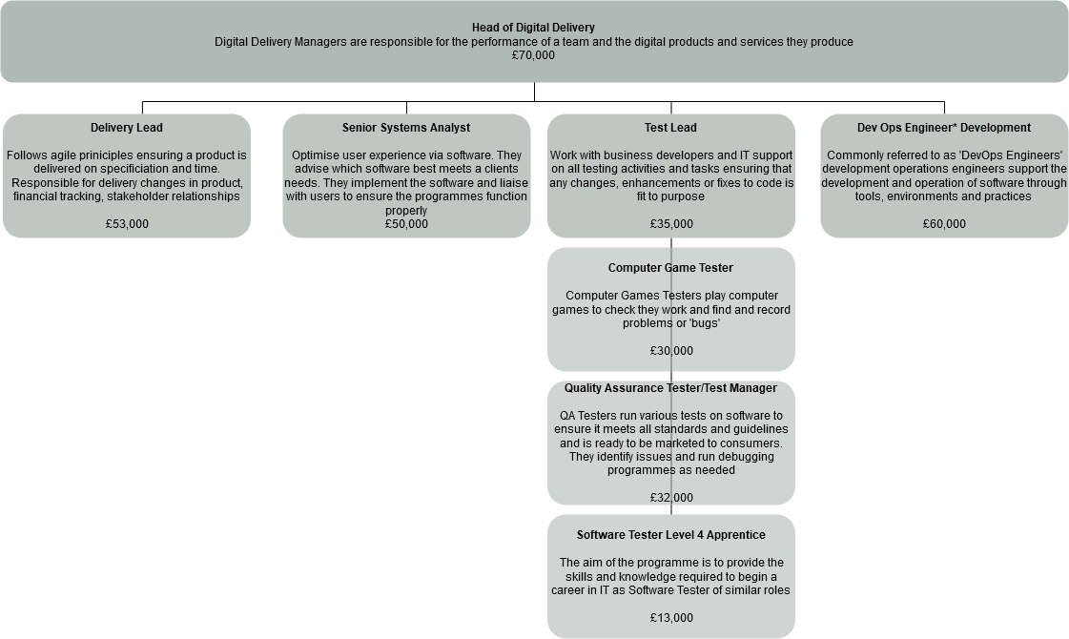
Figure 8 shows progression pathways for the occupational cluster of Software Delivery.
Industry Pathways – there will be some crossover with development:

- Level 4 Software Tester Apprentice
- Level 4 DevOps Engineer
- There are multiple Certifications with 3 tracks for Scrum and Agile qualifications dependant on your role:
- Scrum Team Member
- Agile Leadership
- Scrum Coach or Trainer

For a career in Software Delivery the following degrees are recommended:

- Computer science
- Business information technology
- Software development/engineering
- Math

Information Technology (IT)
The IT department oversees the installation and maintenance of computer network systems within a company. The primary function is to ensure that the network runs smoothly. With multiple roles and continually evolving technology you will never be short of new opportunities. Within this also sits Pro services - the people who go to site to install / implement / maintain equipment. And Managed services – a support team that looks after customers infrastructure under MSP agreement (managed service provider). As well as deciding which sector of IT you wish to specialise in, you can also make the decision of whether to go contract or permanent.
Employers reported greatest priority around senior roles in general in this area. At entry level there is a definite need for more Network Engineers.
Cloud skills are in need at scale because of the speed of this emerging technology and there were concerns about whether graduate courses are practical enough. It was felt there was the need to develop cyber skills needs around cloud security.
A nationwide cloud skills shortage is preventing businesses from hiring the people they need to progress cloud projects. Up-skill existing staff with recognised qualifications and cloud apprenticeships. Apprenticeship programmes, like the Network Engineer, align well to cloud roles, especially when including training and certifications from cloud providers. Cloud apprenticeships also exist and are built to align with the cloud skills required by vendors, like Microsoft Azure, Google Cloud or Amazon Web Services (AWS). By upskilling existing staff through training and IT apprenticeships, UK businesses can quickly bring in the cloud skills they’re missing.
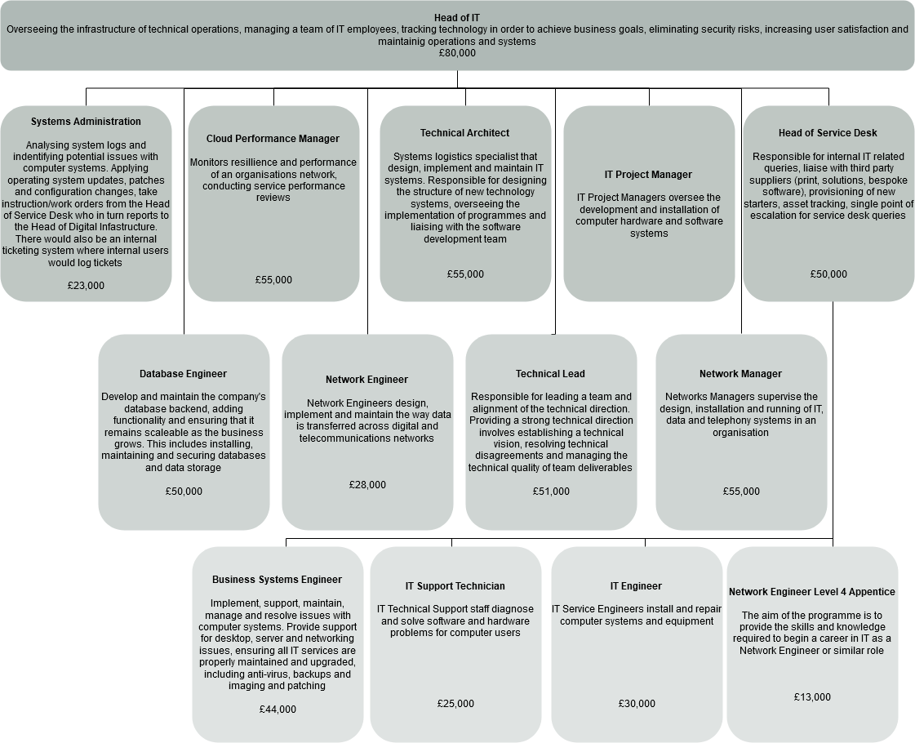
Figure 9 shows progression pathways for the occupational cluster of Information Technology (IT).
Industry Pathways:

- Level 3 Azure Infrastructure Technician
- Level 4 Azure Network Engineer
- Level 3 Google Cloud Infrastructure Technician
- Level 3 AWS IT Solutions Technician (Hardware)
- Level 3 IT Solutions Technician
- Level 4 Network Engineer
- Level 4 Certificate in Networking and Architecture,
- Level 4 Certificate in Network Services
- Level 4 Diploma in Network Security

Role specific Level 4 apprenticeships Network cable installer advanced apprenticeship, a network engineer higher apprenticeship, business analyst higher apprenticeship, or a digital and technology solutions degree apprenticeship.
For a career in IT the following degrees are recommended:

- Computer Science
- Information Technology
- Software Development
- Software Engineering for Business
- Maths

Data gathered in 2019 from Burning Glass Labour Insights showed that 54% of information technology roles required a degree and 24% GCSE

Cyber Security/ Information Security
Cybersecurity plays a crucial role in any business as it involves the protection of hardware, software and electronic data from theft or damage. Cybersecurity professionals are usually inquisitive, excellent problem solvers, patient and persistent. It’s an exciting and evolving career with a critical need to keep up to date with the latest certifications. One role that plays a key part in business protection is Red Team / Blue Team – this is different from Pen Testing and uses real world techniques, Red Teams actively attacks a network while Blue team actively defends.
GM employers in line with national reports highlight cyber skills shortages. There are real opportunities for GM residents but there are challenges in employers being able to articulate the specific jobs they are short of and preferred progression pathways for the industry in terms of training and skills development.
Employers reported there is a specific need for upskilling in SMEs where IT specialists will already be managing a wide variety of tasks or where a non- technical manager or director is solely responsible for managing information security within the business.
What is common across information security and cyber in businesses of all types and sizes is employers report both a lack of technical skills and a lack of industry specific softer skills and mindsets. Roles employers reported as hardest to fill were: Cyber Security, Analyst Penetration Tester, Cyber Security Architect, Cyber Security Researcher, and DevSecOps Developer.
In GM lots of different training exists with varying quality. Many in the industry have upskilled through informal online forums and meet ups as an example. Most employment opportunities in Cyber related to experienced talent and entry level roles are likely to be individuals with existing IT skills and moving in from other areas of digital.
Where entry level opportunities do exist, they are still overwhelmingly graduate opportunities. One employer who has had great experience of delivering apprenticeships described this as a “bugbear” which prevents young people and career switchers in considering wider routes to enter the sector.
Employers often cited a need for more long-term mentoring and support from the industry to retain talent and or help graduates navigate the next steps in their learning and finding employment suited to their needs.
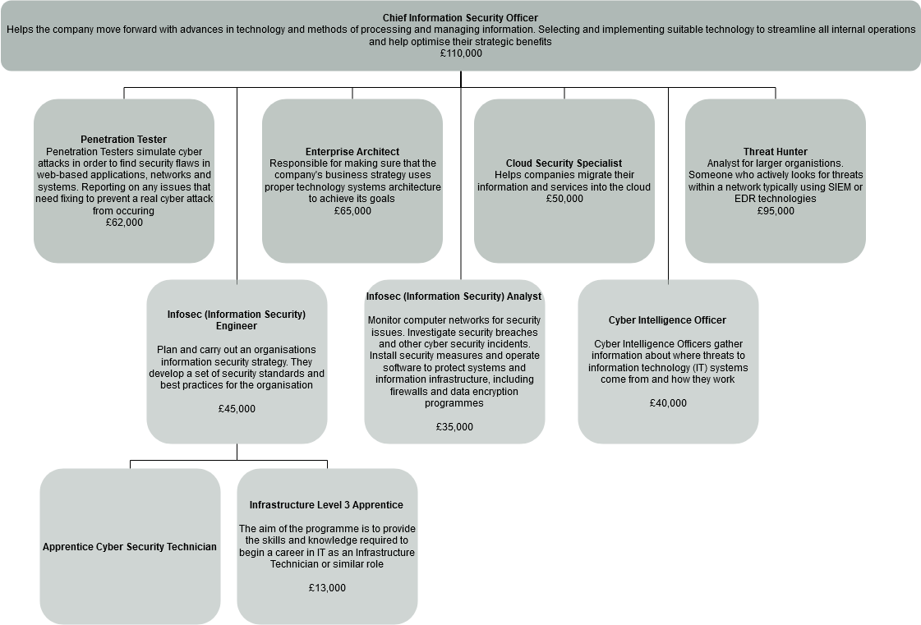
Figure 10 shows progression pathways for the occupational cluster of Cyber Security/Information Security.
Industry Pathways:

- Level 4 Azure Cyber Security Technologist
- 11 - 19-year olds (CyberFirst)
- Level 3 Cyber Security Technician
- Level 4 Cyber Intrusion Analyst
- Level 4 Cyber Security Technologist
- Level 6 Cyber Security Technical Professional Degree Apprenticeship

For a career in Cyber Security the following degrees are recommended:

- Forensic computing and security
- Computer science
- Cyber security
- Digital forensics
- Mathematics
- Network engineering and security

There are also role specific professional qualifications, that mean graduates can specialise:
CompTIA Security+, Certified Information System Security Professional (CISSP) Certified Information Security Manager (CISM) Certified Cloud Security Professional (CCSP), NCSC Ethical Hacking and Penetration testing training, Advanced Infrastructure Hacking, CREST registered penetration tester. These are often costly.
Data gathered in 2019 from Burning Glass Labour Insights showed that 73% of cyber security/ information security roles required a degree.

Future Digital roles
Artificial intelligence (AI) and Machine Learning and increasing ability of machines to learn and act intelligently will absolutely transform our world and our jobs. New technologies such as augmented reality (AR) look set to reshape our lives still further, with AR apps blending the “real” world with internet information. This means there will always be new roles in the tech sector that we need to learn about and upskill for. Keep up to date and interested with latest trends and breaking news in technology and act quickly to upskill and certify – there are always articles online about Artificial intelligence (AI) and Machine Learning, Computer vision and facial recognition, 5g, Big Data, Blockchain and Cryptocurrencies, The Internet of Things (IoT), Wearable technology, Digital twins, Voice control and chatbots, Drones and unmanned aerial vehicles to mention a few.
Future skills and talent need across all sectors often have digital skills at their heart. Innovation in areas such as health, modern methods of construction, advanced materials and advanced manufacturing also require new digital skills.
Employers welcomed masters in AI being offered in GM and they would like to see more modules in AI at undergraduate level. There is a potential opportunity for employers to form links with the GM AI Foundry and other similar models could be adopted in other areas in the future.
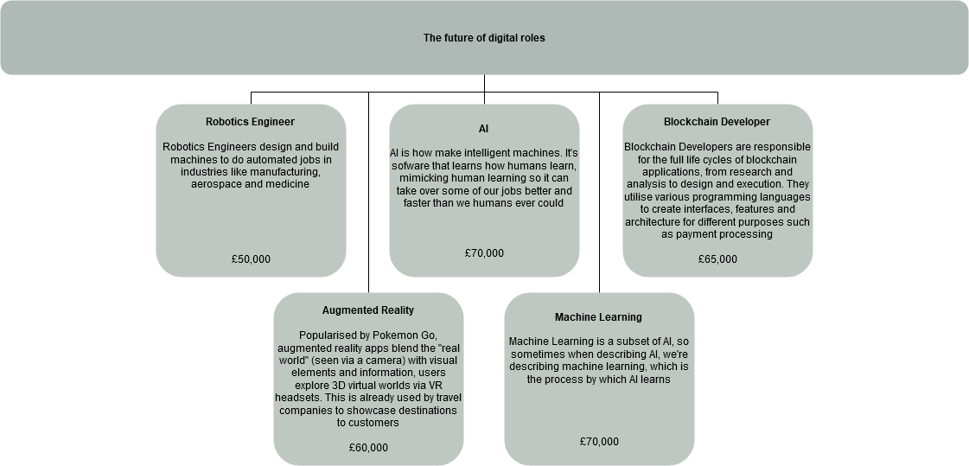
Figure 11 progression pathways for the occupational cluster of future digital roles
Industry Pathways Robotics:

- Level 3 Certificate in Robotics and Automation
- Higher National Certificate in Electrical or Electronic Engineering
- Degree in:
- Artificial intelligence and robotics
- Mechatronics
- Robotics engineering
- Computer science
- Mathematics

AI:

- BSc Artificial Intelligence
- Level 7 - Artificial Intelligence (AI) Data Specialist (equivalent to master’s degree)
- Artificial intelligence and robotics
- BCS Essentials Artificial Intelligence and Machine Learning

AR/VR:
- MA/MSc Virtual & Augmented Reality

Blockchain/ Crypto Currency:
- A degree in software engineering, computer science or a similar subject area will be essential. Blockchain-specific training would be required, Blockchain Expert Certification, Blockchain Developer Certification, Blockchain Architect Certification

IfATE - occupational map, digital

