Putting Greater Manchester’s waste to good use
SUEZ social value update July 2022
SUEZ Recycling and Recovery UK manage the waste sites on behalf of the Greater Manchester Combined Authority (GMCA), managing 1.1 million tonnes of waste arising from nearly 2.3 million residents.
In Greater Manchester, we have 54 social value commitments centred around 9 social outcomes and we’ll be keeping you updated on progress each month. Our goal is to help create a circular economy in which nearly all waste materials are reused, recycled, or recovered for their energy.

Re-use
Earlier this month we launched online sales via our ebay page – renew market. This allows customers to shop for refurbished and upcycled household items and collect them from the Renew Hub at Trafford Park - https://www.ebay.co.uk/str/renewgreatermanchester
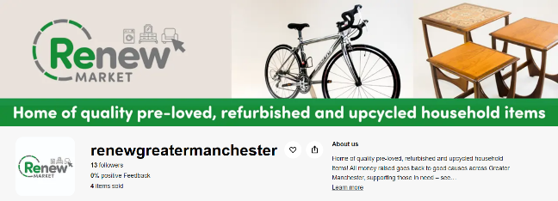
The money raised works in the same way that the shops do, with £100,000 going to the Greater Manchester Mayor’s Charity every year and a minimum of £220,000 to the Recycle for Greater Manchester Community Fund.
This month we have also donated preloved children’s toys, arts and crafts and sports equipment to 4CT Grange Community Centre - lead organisers of the Holiday activity fund.
Alongside our partners Manchester Bike Kitchen, we have also donated bikes and scooters to Chorlton Park Nursery and to Ukranian refugees.

Community events
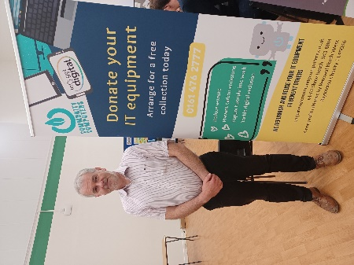
We attended the Bee Green Education Summit to promote our Renew shops and Hub. We were joined by Renewal North West - a Recycle for Greater Manchester Community Fund awardee to promote their refurbished IT equipment to schools.

Compost
7 community organisations have benefitted from the free compost scheme in June 2022, each receiving 1 tonne of peat free compost; a total of 154 organisations since its launch on the 28th Feb 2022.

Litter picks
20 litter pickers were loaned from Adswood Recycling centre to West Didsbury Primary school. These are a free resource available to collect from any recycling centre and bookable via Recycle for Greater Manchester.

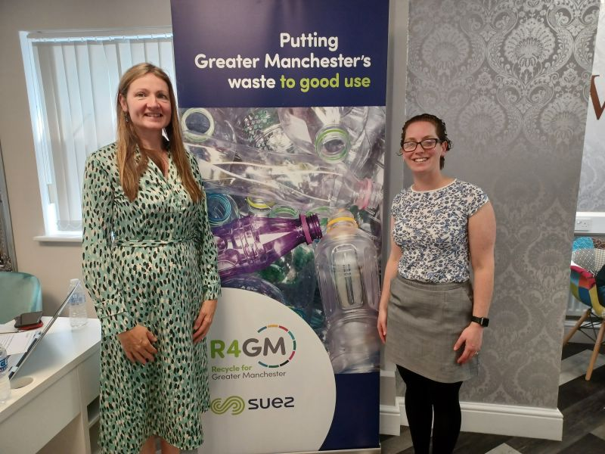
One Manchester Green Futures event
We attended an event promoting careers at SUEZ and job opportunities within the green economy, including roles at our reuse shops.
One Manchester secured funding from the Government's Community Renewal Fund to create jobs for people who are unemployed, helping them to develop skills in the green economy. We have several staff employed within our reuse operation through the funding already which has proven to be successful.

Social value
Social value is all about securing wider social, economic and environmental benefits from the work that we do. This is a core part of the SUEZ business. To achieve maximum impacts, we have tailored our social value approach to Greater Manchester’s specific vision – to create a greener, fairer, more prosperous city region.
We are committed to 54 social value actions centred around:
- employing local people and treating them fairly
- being a responsible business and working with other local businesses
- working with the third sector
- enabling communities to support themselves, and
- protecting the local environment

