# Putting Greater Manchester’s waste to good use SUEZ social value update September 2022

SUEZ Recycling and Recovery UK manage the waste sites on behalf of the Greater Manchester Combined Authority (GMCA), managing 1.1 million tonnes of waste arising from nearly 2.3 million residents.

In Greater Manchester, we have 54 social value commitments centred around 9 social outcomes and we’ll be keeping you updated on progress each month. Our goal is to help create a circular economy in which nearly all waste materials are reused, recycled, or recovered for their energy.

## Re-use

At the end of September, we welcomed new Parliamentary Under Secretary of State for the Department of Environment, Food and Rural Affairs at the Department for Environment, Trudy Harrison MP to the Renew Hub. This was her first official visit in post and it was fantastic to see how enthusiastic she was about reuse and its positive impact on the environment. This followed a visit earlier in September from Chair of the APPG for Environment, Chris Skidmore MP, who is leading a review into the Government’s delivery of its climate commitments.

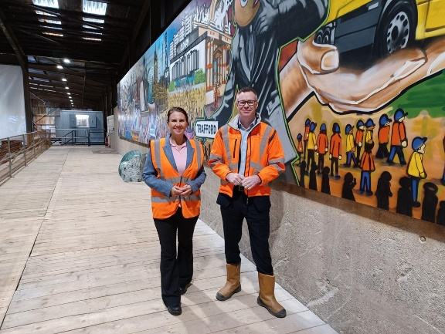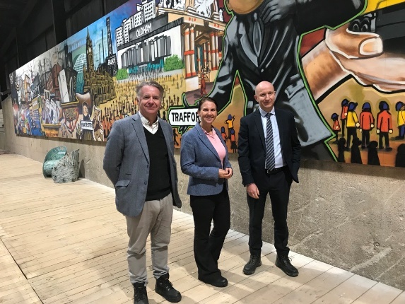

It was also announced that the Renew Hub has been shortlisted for two awards at this year’s National Recycling Awards, taking place in December. The Hub has been shortlisted in categories for both social value and contributions towards the circular economy.

Continuing with reuse and leading the way, Bury Council donated 30 good quality bunkbeds from Burrs Country Park which we were able to pass on directly to Bolton Community Furniture – a registered charity providing furniture for those most in need.

Litter picking

## Operatives from our South East region joined 22 residents in Heald Green, Stockport, for a community litter pick on the 17th September. Alongside loaning litter picking equipment to community groups, our teams regularly support community litter picks in areas around the sites in an effort to improve biodiversity in the area.

## A large group of people in high viz jackets are stood together outside some shops with litter pickers and bin bags, with their arms in the air

SUEZ corporate charity partner

## Throughout September, our teams held coffee mornings at various sites to raise money for our corporate charity partner Macmillan.

In Greater Manchester, we raised £377.56, with a special coffee morning for staff at the Renew Hub giving them the chance to see the facility.

## Social value

Social value is all about securing wider social, economic and environmental benefits from the work that we do. This is a core part of the SUEZ business. To achieve maximum impacts, we have tailored our social value approach to Greater Manchester’s specific vision – to create a greener, fairer, more prosperous city region.

We are committed to 54 social value actions centred around:

* employing local people and treating them fairly
* being a responsible business and working with other local businesses
* working with the third sector
* enabling communities to support themselves, and
* protecting the local environment