Putting Greater Manchester’s waste to good use
SUEZ social value update October 2022
SUEZ Recycling and Recovery UK manage the waste sites on behalf of the Greater Manchester Combined Authority (GMCA), managing 1.1 million tonnes of waste arising from nearly 2.3 million residents.
In Greater Manchester, we have 54 social value commitments centred around 9 social outcomes and we’ll be keeping you updated on progress each month. Our goal is to help create a circular economy in which nearly all waste materials are reused, recycled, or recovered for their energy.

Re-use
During October we hosted a range of local and national media titles, including radio stations HITS and Global, at the Renew Hub with the aim of showcasing what we are doing in Greater Manchester to reduce waste, increase reuse, and help to support residents with the cost of living.
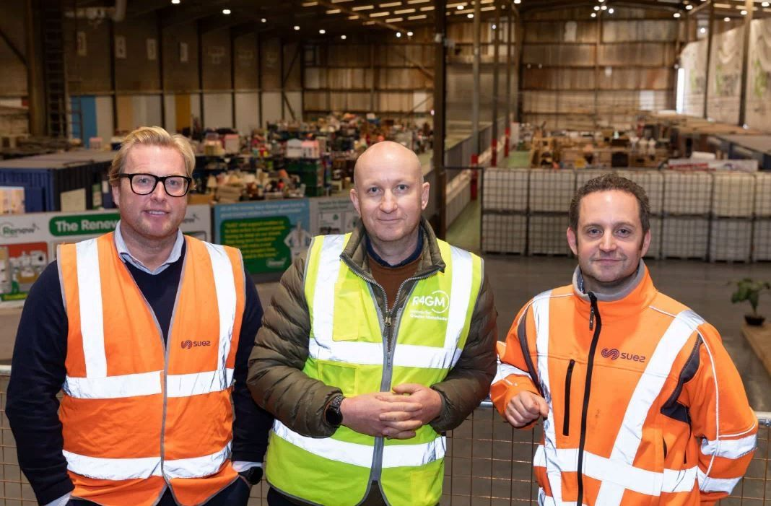
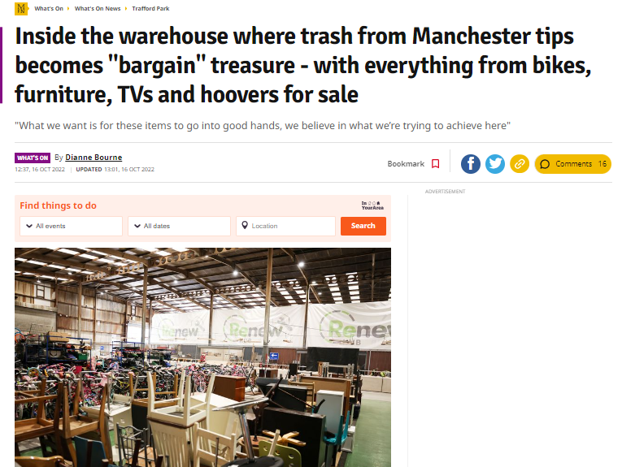

We also showcased reuse at the Greater Manchester Green Summit, with an exhibition stand advertising the Renew Hub and shops, and spokespeople on two panels focused on sustainable lifestyles and sustainable consumption.

Apprenticeships and supporting employees
We are delighted that one of the upcyclers who originally started at the Renew Hub on a temporary contract through Groundwork with Government funding to get people into work in green skills is now employed on a permanent contract with SUEZ and begins an apprenticeship in furniture restoration in the new year.
We have a new assistant administrator in social value who started in October, employed through the ‘UK Year of Service’ scheme. The new young people’s ‘UK Year of Service’ scheme launched in June and provides 9 month traineeships for young unemployed people post covid pandemic, supported by the placement and training provider, Catch 22.
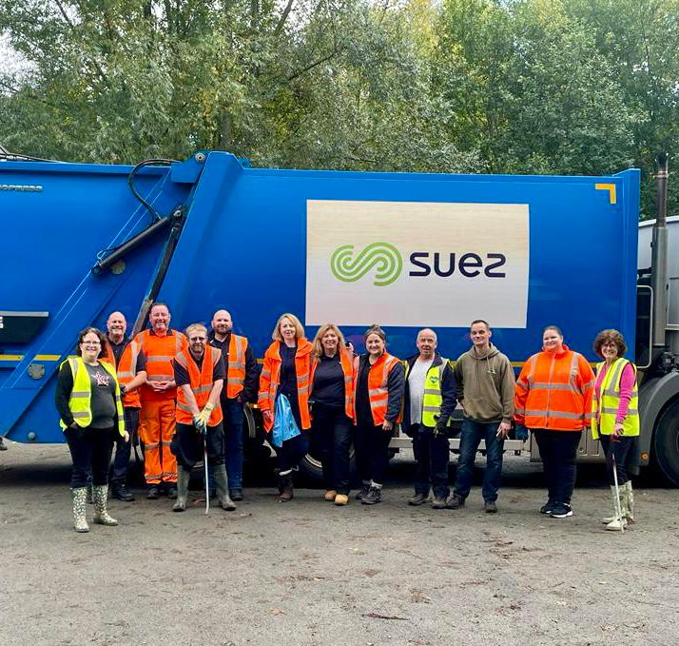
We are also paying for one manager to study BEng (Hons) Mechanical and Manufacturing Engineering which began in October.

Litter picking
During October, 12 SUEZ volunteers were joined by 4 residents in a litter pick with Friends of Tame Valley in Denton. They collected 71 bags of waste, a shed, tyre and a fire extinguisher totalling 656kg.

Social value
Social value is all about securing wider social, economic and environmental benefits from the work that we do. This is a core part of the SUEZ business. To achieve maximum impacts, we have tailored our social value approach to Greater Manchester’s specific vision – to create a greener, fairer, more prosperous city region.
We are committed to 54 social value actions centred around:
- employing local people and treating them fairly
- being a responsible business and working with other local businesses
- working with the third sector
- enabling communities to support themselves, and
- protecting the local environment

