Cost of living social media toolkit
This is the updated social media toolkit for the GMHSCP and GMCA cost of living campaign for February 2023. The original was circulated in December 2022.
These suggested social media posts highlight advice and support available, with a focus on the mental health impact of the cost of living. The theme of the posts are:
- Mental health
- Bills
- Childcare
- Food
- Get online
The text provided fits all social media platforms and the images are provided in two sizes.
There is also outdoor advertising across Greater Manchester. For any outdoor advertising artwork or any other queries please email Ellie Caddick ellie.caddick@greatermanchester-ca.gov.uk
IMAGE PREVIEW | IMAGE TITLE | TEXT
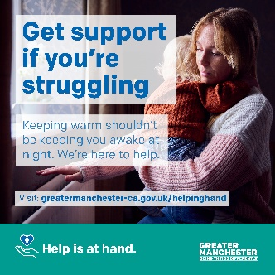  Alt text: Get support if you’re struggling. Keeping warm shouldn’t be keeping you awake at night. We’re here to help. greatermanchester-ca.gov.uk/helpinghand | Mental health 2 | If you’re struggling to make ends meet, don’t struggle alone. ❤  There is support available for things like paying bills, accessing food and improving how you feel. 🏠  Help is at hand👇  greatermanchester-ca.gov.uk/helpinghand  #HelpingHandGM
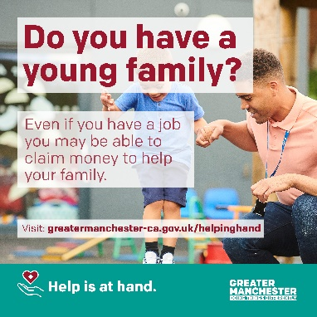  Alt text: Do you have a young family? Even if you have a job you may be able to claim money to help your family. Visit greatermanchester-ca.gov.uk/helpinghand | Childcare | Free childcare hours and benefits are available to parents of young children.  Even if you are working, you may entitled to support, including:  👶15 hours free childcare for 2yr olds  👶Universal credit support  Find out what you can claim👇  greatermanchester-ca.gov.uk/helpinghand  #HelpingHandGM
Alt text: Get support for your mental health. Feeling anxious, stressed or overwhelmed? We’re here to help. Visit greatermanchester-ca.gov.uk/helpinghand | Mental health 1 | Feeling anxious, stressed or overwhelmed? 😟  Get support for your mental health and wellbeing  Everyone struggles from time to time. Help is at hand  greatermanchester-ca.gov.uk/helpinghand  #HelpingHandGM
Alt text: Struggling with your bills? Don’t struggle alone. Advice and support is available to help you. Visit greatermanchester-ca.gov.uk/helpinghand | Bills | Need help with energy bills?  Advice and support is available to help you with rising energy costs like support with your bills and making your home energy efficient 🏠  Don’t struggle alone – help is at hand 👇  greatermanchester-ca.gov.uk/helpinghand  #HelpingHandGM
Alt text: Support to feed your family. If you’re stressed about the cost of food you can access the wide variety of support across Greater Manchester. Visit greatermanchester-ca.gov.uk/helpinghand | Food | Keeping everything together for your family is stressful 😟  Everyone struggles from time to time – we can help you support your family ❤  Help is at hand from foodbanks, food projects and community cafes 👇  greatermanchester-ca.gov.uk/helpinghand  #HelpingHandGM
Alt text: Get online. Reduce isolation. We can help you get online, get connected and boost your online skills. Visit greatermanchester-ca.gov.uk/helpinghand | Get online | We know a lack of digital access, affordability & skills can make you feel isolated 🙁  @gmcadigital has launched #GetOnlineGM to help everyone get online, build digital skills and increase your support network 👏  Visit greatermanchester-ca.gov.uk/GetOnlineGM  #HelpingHandGM

