# Census 2021 Briefing

# Households



**GMCA** **Research**

May 2023

**Dataset:** Households in Greater Manchester

**Datalink**: The data used in this briefing can be found at [Housing: Census 2021 in England and Wales - Office for National Statistics (ons.gov.uk)](https://www.ons.gov.uk/releases/housingcensus2021inenglandandwales). The data can also be found at [2021 Census - Census of Population - Data Sources - home - Nomis](https://www.nomisweb.co.uk/sources/census_2021)

**Definition**: a household is defined as one person living alone, or a group of people (not necessarily related) living at the same address who share cooking facilities and a living / sitting room or dining area. Further information on household definitions in the Census can be found at [Families and households statistics explained - Office for National Statistics (ons.gov.uk)](https://www.ons.gov.uk/peoplepopulationandcommunity/birthsdeathsandmarriages/families/articles/familiesandhouseholdsstatisticsexplained/2021-03-02#how-households-are-classified)

**Census day**: The 2021 census was held in England and Wales on 21 March 2021. Census 2021 was undertaken during the Covid-19 pandemic so may not show normal population and household patterns due to temporary changes in living circumstances during the pandemic for certain households.

The Office for National Statistics (ONS) states the following concerning the census and Covid-19 pandemic (see [here](https://www.ons.gov.uk/peoplepopulationandcommunity/populationandmigration/populationestimates/methodologies/qualityandmethodologyinformationqmiforcensus2021)):

“The coronavirus pandemic may have affected some people's choice of usual residence on Census Day, for example, students and in some urban areas. These changes might have been temporary for some and more long-lasting for others. [Conducting a census during the coronavirus pandemic](https://www.ons.gov.uk/peoplepopulationandcommunity/populationandmigration/populationestimates/methodologies/qualityandmethodologyinformationqmiforcensus2021#quality-summary) explains what this means for the data.”

## Key points

* The 2021 Census estimated that there were 1,178,246 households in Greater Manchester – an increase of just over 50,000 (4.4%) since 2011. Nationally, the increase was larger, at 6.2%.
* The number of households increased in all ten of the Greater Manchester districts between 2011 and 2021, ranging from an increase of 11,560 in Salford (up 11.2%) to 1,785 in Trafford (up 1.9%). The percentage increase in Salford was more than double the growth rate in any of the other Greater Manchester districts.
* The average number of residents per household across Greater Manchester increased from 2.34 in 2011 to 2.39 in 2021. The largest increase was in Manchester, with the average household size changing from 2.34 to 2.46 residents per household. Wigan was the only Greater Manchester district where average household size fell, albeit only slightly, from 2.32 to 2.28 residents per household.
* The Census was undertaken during the coronavirus pandemic and the number, makeup and distribution of households may not have reflected normal patterns.

## Main Findings

There were 1,178,246 households in Greater Manchester in 2021. The number of households increased by 50,180 between 2011 and 2021, representing growth of 4.4%. This was below the average growth rate for England of 6.2%, and nearly half the 8.4% growth seen in Greater Manchester between 2001 and 2011.

Although the number of households increased in all ten of the Greater Manchester districts between 2011 and 2021, there was considerable variance. Salford saw a much higher increase than the other districts, with 11,560 additional households by 2021; this equated to a growth rate of 11.2%, more than double that in the districts with the next largest percentage increases (Manchester, Tameside and Wigan), and the second highest of the North West districts. Conversely, amongst the ten Greater Manchester districts, Trafford saw the lowest growth in both numeric and percentage terms, with 1,785 additional households over the period, a 1.9% increase.

The increase in the number of households in Manchester and Salford combined (an additional 21,325) accounted for 42.5% of the overall increase across Greater Manchester between 2011 and 2021.

**Number of households, 2011 and 2021**

|  |  |  |  |  |
| --- | --- | --- | --- | --- |
| *District* | 2011 | 2021 | Household change  2011-2021 | Percentage change  2011-2021 |
| Bolton | 116,371 | 118,790 | 2,419 | 2.1% |
| Bury | 78,113 | 80,697 | 2,584 | 3.3% |
| Manchester | 204,969 | 214,734 | 9,765 | 4.8% |
| Oldham | 89,703 | 93,140 | 3,437 | 3.8% |
| Rochdale | 87,552 | 90,223 | 2,671 | 3.1% |
| Salford | 103,556 | 115,116 | 11,560 | 11.2% |
| Stockport | 121,979 | 126,648 | 4,669 | 3.8% |
| Tameside | 94,953 | 99,527 | 4,574 | 4.8% |
| Trafford | 94,484 | 96,269 | 1,785 | 1.9% |
| Wigan | 136,386 | 143,102 | 6,716 | 4.9% |
| Greater Manchester | 1,128,066 | 1,178,246 | 50,180 | 4.4% |
| North West | 3,009,549 | 3,153,404 | 143,855 | 4.8% |
| England | 22,063,368 | 23,436,086 | 1,372,718 | 6.2% |

*Sources: Office of National Statistics (ONS), Census 2011,* *[Nomis-2011 Households](https://www.nomisweb.co.uk/query/construct/summary.asp?reset=yes&mode=construct&dataset=605&version=0&anal=1&initsel=); ONS, Census 2021,* [*Custom dataset – 2021 Households*](https://www.ons.gov.uk/filters/36de5a51-5cf5-4c05-a5b8-fad075758514/dimensions)

The district-level averages hide variance at the more local level. Within all ten of the Greater Manchester districts, there were areas that saw growth in the number of households between 2011 and 2021 (shown in the darker green shades on the map below), and other areas that saw a decline (shown in lighter green). In general, in areas where the number of households fell, the decrease was small. In contrast, some of the areas where the number of households increased saw higher growth, particularly so near central Manchester and either side of the boundary with Salford.

**Change in the number of households across Greater Manchester, 2011-2021**

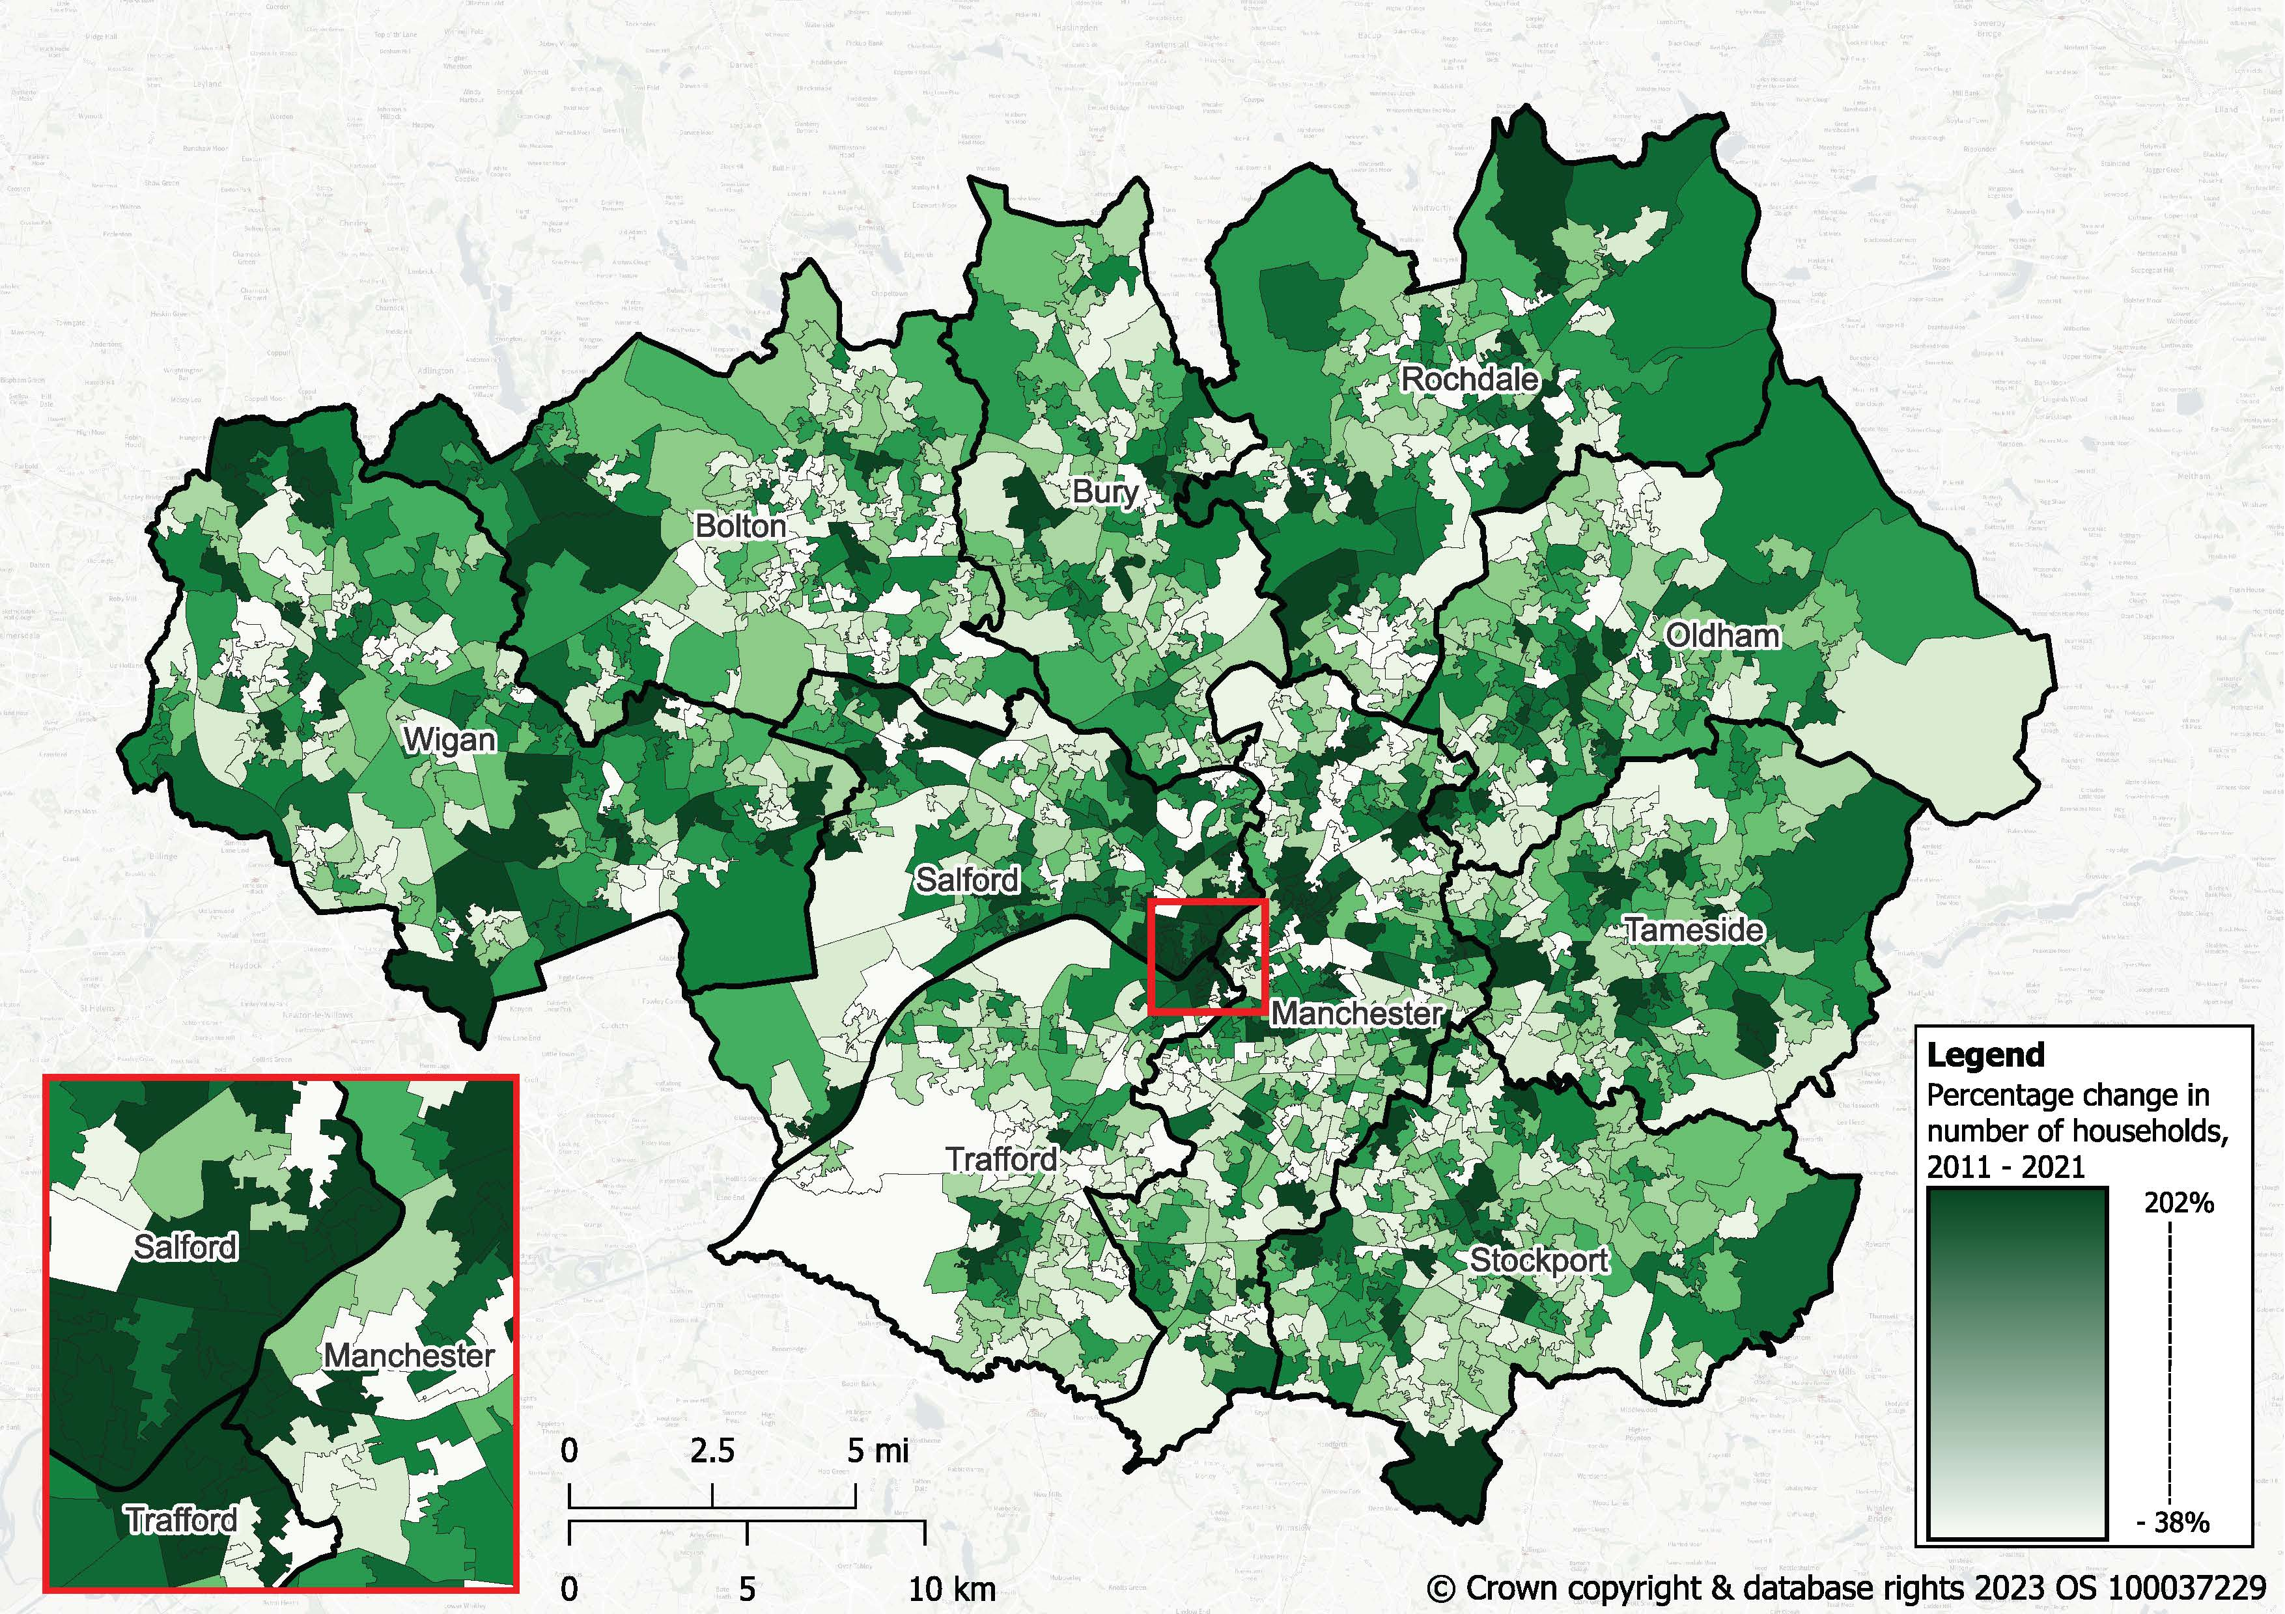

*Sources: ONS, Census 2011,* [*Nomis – KS105E Household composition*](https://www.nomisweb.co.uk/query/construct/summary.asp?reset=yes&mode=construct&dataset=605&version=0&anal=1&initsel=)*; ONS, Census 2021,* [*NOMIS TS003 – Household composition*](https://www.nomisweb.co.uk/query/construct/summary.asp?reset=yes&mode=construct&dataset=2023&version=0&anal=1&initsel=)

### Average household size

The average number of residents per household across Greater Manchester increased marginally between 2011 and 2021, from 2.34 to 2.39. Increases were seen across all of the Greater Manchester districts with the exception of Wigan, where average household size fell slightly, from 2.32 to 2.28 residents per household. Manchester saw the largest increase, with average household size changing from 2.34 to 2.46 residents per household over the period. Oldham had the largest average household size in 2021 (2.56), with Salford and Wigan having the smallest (2.28). Across Greater Manchester, the larger households mostly comprise single families with dependent children (this household type accounts for 70.2% of all households with four or more residents in Greater Manchester), rather than multi-adult households.

**Average household size, 2011 and 2021**

Bar chart showing average household size in the ten districts of Greater Manchester 2011 and 2021 with comparisons to the rates for Greater Manchester, North West and England.  The preceding text highlights the key messages.

*Sources: ONS, Census 2011,* [*QS406EW (Household size) - Nomis*](https://www.nomisweb.co.uk/census/2011/qs406ew)*; ONS, Census 2021,* [*TS017 - Household size - Nomis*](https://www.nomisweb.co.uk/datasets/c2021ts017)

### Reflections

Over the period from 2011 to 2021, no Greater Manchester district saw the number of households grow in percentage terms by as much as England (up 6.2%), with the exception of Salford. Salford’s growth rate (11.2%) was higher than any other North West district, reflecting the large amount of development in Salford over the last ten years, much of which is adjacent to the substantial development seen in Manchester City Centre.

There was a slight increase in the average size of Greater Manchester households. As might be expected, those districts with younger populations (particularly Manchester and Salford) showed the highest growth in household size, and those with an increasingly ageing population (Bury, Stockport and Wigan) saw lower growth or a slight decrease. Changes in household size may also have been influenced by the timing of the Census, which was undertaken during the COVID-19 pandemic when some people were not living at their usual address. For this reason, care should be taken when interpreting results. At the time of the Census, COVID-19 restrictions will also have had some impact on the number of households in different areas of the city region and relative change in household size and composition.