# Census 2021 Briefing

# Total population

**GMCA** **Research**

May 2023

**Dataset:** Total population

**Datalink**: The data used in this briefing can be found at [Age by single year - Office for National Statistics (ons.gov.uk)](https://www.ons.gov.uk/datasets/TS007/editions/2021/versions/2). It can also be found at [TS007 - Age by single year - Nomis - Official Census and Labour Market Statistics (nomisweb.co.uk)](https://www.nomisweb.co.uk/datasets/c2021ts007)

**Definition:** Population of usual residents – a usual resident is anyone who on Census Day, 21 March 2021, was in the UK and had stayed or intended to stay in the UK for a period of 12 months or more; or anyone who had a permanent UK address and was outside the UK and intended to be outside the UK for less than 12 months.

**Census Day**: The 2021 Census was held in England and Wales on 21 March 2021. Census 2021 was undertaken during the COVID-19 pandemic so may not show normal population and household patterns due to temporary changes in living circumstances during the pandemic for some households.

**Ethnicity**: In this briefing, we have followed the terminology used in the Census, in line with the government’s [Writing about Ethnicity](https://www.ethnicity-facts-figures.service.gov.uk/style-guide/writing-about-ethnicity)guidance and[Style Guide](https://www.gov.uk/guidance/style-guide/a-to-z-of-gov-uk-style#ethnic-minorities). Where we have reported aggregated data that group different ethnicities together (Asian, Black, Mixed and ‘Other’ populations), we have used the term 'ethnic minority'. However, we recognise that people may not see themselves as minorities, and that ethnic minority residents represent the majority group in some Greater Manchester districts, with a population that is larger than White British residents. It is also important to acknowledge the negative consequences of aggregating data for specific ethnicities together into broader groupings, as there are significant differences both between and within these groups. Whilst doing so is often necessary due to small numbers, and can be useful in assisting understanding of broad trends in the data, we recognise that it can result in the loss of detailed insight into specific ethnic groups.

## Key points

* Greater Manchester’s resident population was 2,867,769 in 2021, representing an increase of 185,241 (up 6.9%) compared to the 2011 Census estimate. The population of England (56,490,047) grew by a slightly smaller proportion (up 6.6%).
* Manchester’s population increased by 48,811 since 2011, and over the last three decades (1991 to 2021) has grown faster than other major English cities (36.3%). Salford’s population grew by 15.4% between 2011 and 2021, the highest growth rate in the north of England over the period.
* Children aged 0-15 and residents aged 66 and over have become a larger proportion of the Greater Manchester population, whereas the working-age population (aged 16-65) share has decreased. There were different trends of change across the Greater Manchester districts, with Manchester, Oldham and Salford having younger age profiles.
* Residents from Asian, Black, Mixed and ‘Other’ populations accounted for 28.7% of the Greater Manchester population in 2021, an increase compared to the 20.2% share in 2011, and making Greater Manchester slightly more ethnically diverse than England as a whole. Three quarters of the Greater Manchester increase was driven by people born outside of the UK who arrived here over the last ten years, with natural change due to births exceeding deaths accounting for the remainder.

## Main Findings

In the 2021 Census, Greater Manchester had a population of 2,867,769. The population growth rate in Greater Manchester between 2011 and 2021 was 6.9% (185,241 more residents), higher than both England (6.6%) and the North West (5.2%). Amongst the ten Greater Manchester districts, Manchester had the largest number of residents in 2021 (551,943, up by 9.7% compared to 2011), and Wigan the second largest (329,329, up 3.6%). Bury had the smallest population of the ten districts (193,851, up 4.8%).

**Population of the ten Greater Manchester districts, 2011 and 2021**

Bar chart showing the population of the Greater Manchester districts in 2011 and 2021.  The chart shows that Manchester has the largest population followed by Wigan and then Bolton, with all districts showing population increases over the period. Sources: ONS, Census 2011, [KS102UK (Age Structure) - Nomis](https://www.nomisweb.co.uk/census/2011/ks102uk); ONS, Census 2021, [TS001 - Number of usual residents in households and communal establishments - Nomis](https://www.nomisweb.co.uk/datasets/c2021ts001)

### Population change by Greater Manchester district

Manchester and Salford have seen higher population change over recent decades compared to the other Greater Manchester districts. Regeneration of the two cities has been the main factor behind this increase and was the central driver of overall growth in Greater Manchester’s population, marking a turnaround following declines in the 1970s and 1980s. Manchester’s population growth rate since 1991 of 36.3% was higher than other major cities in England, which had average growth of 20.2% (only Leicester saw similar growth to Manchester). Between 1991 and 2021, Salford’s population increased by 22.4%, a higher growth rate than the national average (20.2%) and most major cities. Population growth in Salford was particularly high in the last decade, with an increase of 15.4% between 2011 and 2021, the highest rate in the north of England.

Population increases were also seen across other Greater Manchester districts, but (as shown in darker green shading on the map below) with the highest percentage growth concentrated particularly in Manchester city centre and parts of Salford (Salford Quays, and eastwards to the border with Manchester city centre, including the Chapel Street area). At the time of the 2021 Census, almost 85,000 people lived within one mile of Piccadilly Gardens in Manchester, compared to around 11,300 in 1991.

Most of the other major town centres across Greater Manchester also saw population increases. Where the population declined in local areas (shown by the lighter green areas on the map), this was generally in some of the less densely populated areas towards the periphery of Greater Manchester, and only by a small percentage.

**Population change across Greater Manchester, 2011-2021**

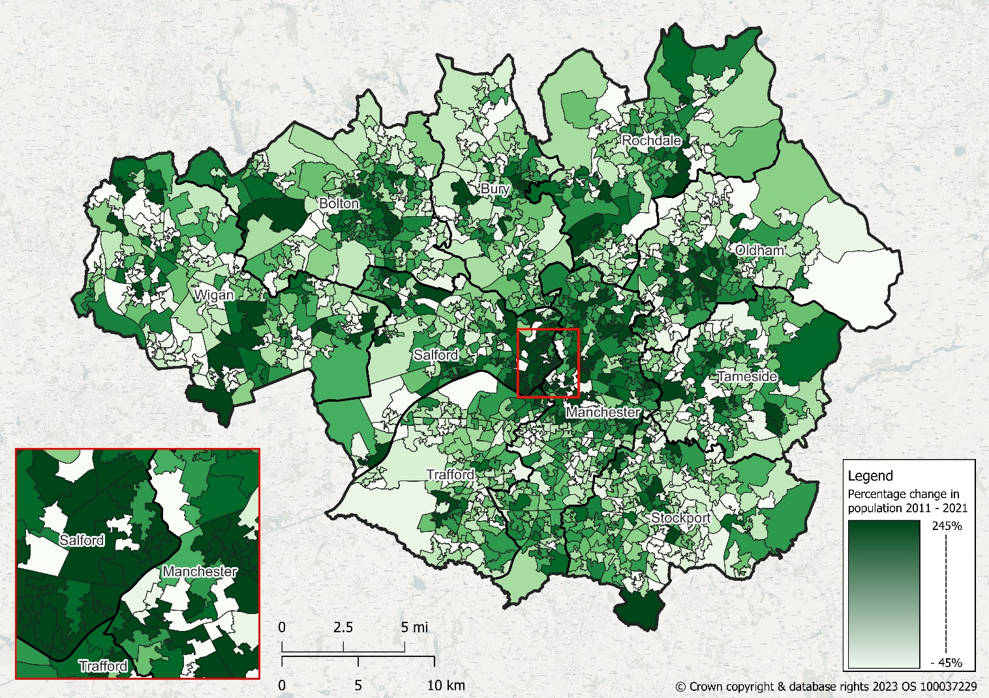

Sources: ONS, Census 2011,[KS102UK (Age Structure) - Nomis](https://www.nomisweb.co.uk/census/2011/ks102uk); ONS, Census 2021, [TS001 - Number of usual residents in households and communal establishments - Nomis](https://www.nomisweb.co.uk/datasets/c2021ts001)

The chart below shows population change over a more extended period, between 1981 and 2021, ‘indexed’ to a common starting point of 100 in 1981 to allow for easier comparison between places. Population growth in Manchester over the period (26.1%) outstripped that for England (23.4%), with high growth between 2001 and 2011 after a period of declining population from 1981 to 2001. Overall growth across Greater Manchester over this period (11.4%) was considerably below the national average. Growth in Salford (11.8%) was similar to Greater Manchester but more concentrated in the decade 2011 to 2021, driven by new residential development around Salford Quays and areas in Salford close to Manchester city centre such as Chapel Street. The smallest percentage change over the 30-year period occurred in Stockport (2.0%); the remaining seven Greater Manchester districts are not charted for ease of interpretation, but saw change within a more clustered range (from 6.4% in Trafford to 13.7% in Bolton).

**Population change, 1981-2021, indexed (1981=100)**

A line chart showing percentage change in the population between 1981 and 2021 for selected areas: Manchester, Salford, Stockport, Greater Manchester, North West and England.  All areas have been set to an indexed value of 100 in 1981, to assist comparison.

Manchester's population increased rapidly in the last two decades, and Salford's population has grown particularly fast in the last decade. For Stockport, the population in 2021 was only slightly larger than it was in 1981.

Sources: OPCS, Census 1981, [Nomis](https://www.nomisweb.co.uk/query/construct/summary.asp?reset=yes&mode=construct&dataset=66&version=0&anal=1&initsel=); OPCS, Census 1991, [Nomis](https://www.nomisweb.co.uk/query/construct/summary.asp?reset=yes&mode=construct&dataset=38&version=0&anal=1&initsel=); ONS, Census 2001, [Nomis](https://www.nomisweb.co.uk/query/construct/summary.asp?reset=yes&mode=construct&dataset=1801&version=0&anal=1&initsel=); ONS, Census 2011**,** [KS102UK (Age Structure) - Nomis](https://www.nomisweb.co.uk/census/2011/ks102uk); ONS, Census 2021, [TS001 - Number of usual residents in households and communal establishments - Nomis](https://www.nomisweb.co.uk/datasets/c2021ts001)

### Population and age

Compared to the national average in 2021, Greater Manchester was younger: 20.4% of the population was aged 0-15 (18.6% for England), and 14.9% was aged over 65 (17.4% nationally). There was some variance across the Greater Manchester districts, with a considerably younger population in Manchester (91.2% of residents aged 65 and below), and older populations in Stockport and Wigan. Oldham had the highest proportion of 0-15 year olds amongst the ten districts (22.7% of its total population), and Wigan the lowest (18.4%).

**Percentage of the population by broad age band, 2021**

Bar chart showing for each Greater Manchester district and England the proportion of the population in each area that were aged 0 to 15, 16 to 65 and 66 or more in 2021.  There was variation across Greater Manchester - for example, Manchester had a smaller proportion of older residents, but a higher proportion of those of working age.

Source: ONS, Census 2021, [Year of age data table](https://www.ons.gov.uk/datasets/TS009/editions/2021/versions/2)

Across Greater Manchester, the increase in the number of people aged 66 or more accounted for a third (33.5%) of overall population growth between 2011 and 2021, compared to nearly a half (48.6%) for England as a whole. However, growth in the older population was a much bigger factor in some districts, most notably Wigan (the increase in people aged 66 or more was larger than that in the overall population, compensated for by a reduction in the number of working-age people). At the other end of the age spectrum, growth in 0-15 year olds accounted for around a quarter (27.4%) of Greater Manchester population change, more than double the proportion for England (13.2%). Growth in the 0-15 age group was a particularly important driver of population change in Bolton, Manchester, Rochdale and Trafford, accounting for more than a third of growth over the last decade. The working-age (16-65) population accounted for nearly three quarters (71.0%) of population growth in Salford, whereas the older (66+) population in Salford and Manchester accounted for a much lower share of overall growth (between 7% and 8%) than the other Greater Manchester districts.

**Contribution to population growth, by age, 2011-2021**

Bar chart showing percentage change in population between 2011 and 2021 for the broad age bands, 0-15, 16-65 and 66 and above.  Data are shown for the ten Greater Manchester districts, along with the Greater Manchester and England averages, and key findings are set out in the narrative above.

Source: ONS, Census 2011 [QS103EW – Age by single years, NOMIS](https://www.nomisweb.co.uk/query/construct/summary.asp?reset=yes&mode=construct&dataset=503&version=0&anal=1&initsel=), Census 2021 [Single year of age data table](https://www.ons.gov.uk/datasets/TS009/editions/2021/versions/2)

The average age of Greater Manchester residents increased from 38.3 years in 2011 to 39.0 in 2021; in comparison, England saw an increase from 39.8 years to 41.1, a larger increase to an older average age. Unsurprisingly, the district-level data reflect the age profiles discussed above: the average age of Wigan residents rose from 40.1 years in 2011 to 41.8 in 2021, driven by growth in its over-66 population, and the largest increase amongst the nine Greater Manchester districts that saw their average age go up over the period (Stockport had a higher average age at 42.2 years in 2021, but a smaller increase from 41.3 in 2011). Salford was the only Greater Manchester district that saw a reduction in average age (from 37.9 years in 2011 to 37.1 in 2021), but Manchester’s population remained younger (34.3 years in 2021, up from 33.7 years in 2011).

Greater Manchester had 4.3 working-age residents for every resident aged 66 and over in 2021, a reduction compared to 2011 (4.9); nationally, the ratio was 3.7 in 2021, also lower than 2011 (4.3). There was considerable variance across the Greater Manchester districts, from 8.0 in 2021 in Manchester to 3.3 in Stockport.

It is important to caveat these figures in light of the likely impact of the COVID-19 pandemic on normal population and household patterns, given that some people’s usual place of residence on Census day 2021 will have changed (particularly likely for young adults and older residents). For example, analysis by Manchester City Council suggests that residents were missing from the Census data in Manchester city centre and surrounding wards, particularly where there are houses in multiple occupation and student accommodation; this may also be an issue in other areas of Greater Manchester with similar household and population profiles.

### Population and ethnicity

Population increases across virtually all ethnic minority groups have been a big factor in the growth of Greater Manchester’s total population. In 2021, there were some 281,000 more residents from Asian, Black, Mixed and ‘Other’ populations in Greater Manchester than in 2011, an increase of 51.9%. In contrast, Greater Manchester’s White British population decreased by nearly 96,000 (4.5%) over the period. The Asian population grew the most (up 117,000, or 43%), followed by the Black population (up 60,000, 81%). People born outside of the UK who arrived here over the last ten years accounted for more than three quarters (77.4%) of the growth in Greater Manchester’s ethnic minority population since 2011, with the remaining increase (22.6%) due to natural change – births exceeding deaths.

The increase in Greater Manchester’s Asian, Black, Mixed and ‘Other’ populations between 2011 and 2021 was mainly driven by growth amongst 0–15 year olds (up 158.6%) and the working-age population (up 258.6%). There was less growth amongst older ethnic minority residents (up 19.0%), in contrast to the White British population, where the increase in residents aged 66 and over (up 81.0%) has been the main driver of population growth.

Across the ten Greater Manchester districts between 2011 and 2021, Manchester saw the largest increase in the actual number of residents from Asian, Black, Mixed and ‘Other’ populations (up 78,000), but the smallest percentage rise (38.3%). Salford’s ethnic minority population increased the most in percentage terms (up 92.7%, 34,000).

### Reflections

The population growth seen in Greater Manchester between 2011 and 2021 (particularly in Manchester and Salford) is a continuation of trends experienced in the two decades either side of the Millennium. A generation ago, urban core regeneration was focused largely on Manchester city centre, but this has extended into Salford, which has seen high population growth in the last decade (for example, the population of Ordsall ward increased by some 85% between 2011 and 2021). The scale of population growth across Greater Manchester since the early 1990s outstripped earlier population losses in the 1970s and 1980s, providing continued evidence of the attractiveness of Greater Manchester as a place to live and work.

For Greater Manchester as a whole, the key population trends are similar to those nationally – an overall ageing population, but with population growth amongst nearly all ethnic minority groups that is concentrated amongst working-age residents (largely through net international migration). In Manchester, Oldham and Salford, increases in the working-age population have been greater than increases in those aged 66 and over, but for the other Greater Manchester districts, the reverse is the case. The reduction in the ratio of working-age to older residents has implications in terms of the ability to deliver and fund services for older people.