Census 2021 Briefing

Economic Inactivity

GMCA Research
July 2023
Dataset: Economic Inactivity by sex and age
Datalink: The data used in this briefing can be found here.
Definition: ‘Economically inactive’ people do not have a job, have not sought work in the last four weeks, and/or are not available to start work in the next two weeks. Inactive people do not participate in the labour market.
Census day: The 2021 census was held in England and Wales on 21 March 2021. It was undertaken during the Covid-19 pandemic so may not show ‘normal’ population and household patterns due to temporary changes in living circumstances during the pandemic.

Key points

- Excluding full-time students, 19.3% of 16-64 year olds were ‘economically inactive’ in Greater Manchester in 2021 compared to 17.3% in England.

- Inactivity rates among working age people (16-64 year olds) were higher in 2021 than they were at the time of the previous census in 2011, both in Greater Manchester and nationally.

- Inactivity in Greater Manchester is driven in particular by higher rates of ill-health and disability and by larger numbers of people with caring responsibilties.

- Although the over fifties have featured in much commentary about the impact of the Covid-19 pandemic on inactivity, rates of inactivity among 50-64 year olds were actually lower in 2021 than in 2011. However, they were higher among 35-49 year olds.

- There were different patterns of inactivity among ethnic groups. People whose ethnic classification was ‘white’ were more likely to be inactive because they were retired. However, people from Asian backgrounds were more likely to be inactive due to caring responsibiltles and to participating in full-time education.

Main Findings

People who don’t work and are not looking for work are known as being ‘econonically inactive’. In Greater Manchester, just under a fifth of working-age people were inactive in 2021 (19.3% of 16-64 year olds excluding students in full-time education, or 352,354 people). This proportion was similar to the wider North West region (19.2%), but higher than for England as a whole (17.3%).
Only two districts of Greater Manchester - Trafford and Stockport - had rates of inactivity lower than the English average (15.8% and 16.5% respectively). Oldham had the highest rate of inactivity at 23.2% - about six percentage points above the English average. Rochdale and Bolton were not far behind (22.4% and 21.4% respectively). The chart below shows all inactive adults, working-age adults including students and working age adults excluding students. The inclusion of students has a particularly powerful effect on Manchester’s inactivity rate due to its large student population.
Proportion of economically inactive population, 2021 (Total inactive (16+), 16-64 inactive (including full-time students) and 16-64 inactive (excluding full time students))
Source: ONS, Nomis – 2021 Census. Note: f-t refers to full-time students

Age
Although there were higher rates of inactivity in Greater Manchester across the age spectrum than compared with the general pattern for England, the largest differences were not among younger or older people; instead, the biggest discrepancies were actually among ‘mid-life’ 35 to 49 year olds (a difference of one percentage point).
Economic inactivity within 16-64 population split by age group, 2021
Source: ONS, Nomis – 2021 Census. Note: GM refers to Greater Manchester

Reasons

There are several reasons for being inactive including being retired, disabled, in full-time education or holding caring responsibilities. The district of Manchester stands out both for its student population and relatively low numbers of retired people. However, if students and retired people are set to one side the key explanations for higher rates of inactivity in Greater Manchester appear to be to do with ill health and disability (5.3% of inactivity in Greater Manchester compared with 4.1% in England) as well as a larger number of people with caring responsibilities (5.4% compared to 4.8%). Oldham had the hightest rate of inactivity due to caring responsibilities(7.4%) while Manchester had the highest rate due to sickness or disability.
Economic inactivity by reason (16+ population), 2021
Source: ONS, Nomis – 2021 Census

Reasons for inactivity by ethnic group
The reasons for inactivity can be broken down by the ethnicity classifications of the census. Some 39.6% of white people were inactive, with the reason often being to do with retirement (22.5%); relative age and wealth may partly explain this finding. Black people were less likely to be inactive (34.2%), but more likely to be studying full time. Meanwhile, among people of Asian and ‘other’ ethnic backgrounds, caring responsibilities are notably more prevalent – especially in north eastern parts of the conurbation (for example, 18.1% of Asian people in Oldham were inactive due to caring responsibilities, while for Rochdale the proportion was 16.6%).
Reasons for economic inactivity by ethnic group, Greater Manchester 2021
Source: ONS, Nomis – 2021 Census

Change from 2011

Change in working age inactivity can be tracked using the previous census from 2011. The 2011 census took place during the aftermath of the financial crisis and subsequent recession, whereas the 2021 census took place during the Covid-19 pandemic. In Greater Manchester, economic inactivity among the working age population has increased across most districts since the previous census of 2011. Both the North West and England as a whole also experienced rises in inactivity – but to a lesser extent than in Greater Manchester.
The largest increase among the districts was seen in Oldham where the economic inactivity rate increased from 20.6% to 23.2% (a difference of 2.6 percentage points), followed by Rochdale (21.4% to 22.4%). The only districts that experienced a decrease in economic inactivity were Wigan and Salford, where economic inactivity reduced from 18.6% to 18.4% and 19% to 17.9% respectively.
The rise in inactivity was especially notable among people aged 35 and 49. In particular Oldham experienced a large jump in inactive people within this age range from 16.5% in 2011 up to 23.7% in 2021. However, all districts – and indeed England as a whole – also saw a rise among this age cohort. By contrast, among 50-64 year olds, inactivity in 2021 was lower than in 2011 in all districts. This finding puts a new light on current commentary: since the pandemic heightened rates of inactivity among older working age people has been a significant news story.
Economic inactivity rates, 16-64 year olds, 2011 and 2021 (excluding students)
Source: ONS, Nomis – 2021 and 2011 Census

Inactivity by detailed geography
The map below shows economic inactivity in Greater Manchester at the level of small geographical units known as lower super-output areas (LSOAs) - smaller than wards. The map shows that there are pockets where inactivity rates are high scattered across the conurbation, but with the most sizeable concentrations to be found in Manchester, Oldham, Rochdale and Bolton.
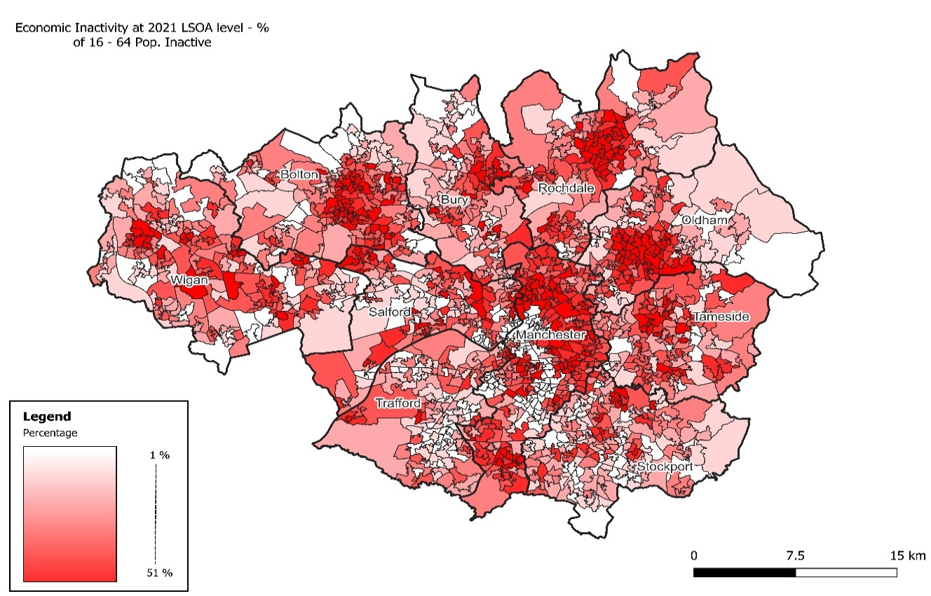
Economic inactivity in Greater Manchester by LSOA, 2021
Source: ONS, Nomis – 2021 and 2011 Census Note: Students excluded from map

Reflections
Working age inactivity rates have major implications for economic prosperity: areas where many people are inactive (but are not students) are likely to be poorer. Economic in activity is higher in Greater Manchester than in England as a whole – and it has increased slightly more than the English average over 2011-2021 decade.
A rise in economic inactivity was one of the main stories to emerge from the Covid-19 pandemic, but the census enables a longer time horizon and more detailed data. If students and the retired are removed, the notable groups that generate elevated rates of inactivity are people who are disabled, unwell or have caring responsibilities.
Contrary to much commentary during and after the Covid-19 pandemic, the census shows that the main population group driving the change are not people over 50, but those who are slightly younger – in the 35-49 age range.
Patterns also appear to be driven partly by cultural norms. For example, caring responsibilities seem to be far more prevalent in certain communities than others.

‘Other’ reason is defined by ONS as: “This could include people who choose alternative lifestyles, for example being self-sufficient and growing your own food. As there is no official job, it would count as economically inactive.”
‘Other’ ethnic backgrounds do not fit into the main ethnicity categories used and may include, for example, people who identify as Arab or Kurd or Latino/Latina.

